Buoyant river outflows as a control on microplastic fate and transport: sources, transformations, dispersion and sinks

Co PI – Grace Saba

Funding agency: NOAA

Period of Performance: 05/11/20-06/10/22

Total budget: $639,552

Project Summary

Use field observations, laboratory experiments and numerical simulations to assess the role thatcirculation and biological processes at river plume fronts impact the fate and transport of microplastics in the coastal ocean. Results will advance our understanding of processes that lead to the loss of microplastics in surface waters and point to regions where they are trapped and accumulated. These results can help inform management practices that focus on mitigation strategies targeting plastics sources through our ongoing involvement with stake holders in the regions such as the Delaware River Basin Commission.

Project Location: Outflow of the Delaware bay plume into coastal waters.

Project duration: 24 months Federal Funds Requested: $319,776

Non-Federal Match: $319,776

Plastics are frequently observed marine debris1, 2 and there is growing concern about microplastic ecotoxicity3-5 and growth of biofilm6, 7 on microplastic surfaces. Rivers are considered a major source of plastic marine debris.8-12 However, the fate and transport of microplastics from land based sources (e.g., storm water runoff, wastewater effluents, and remobilization of shoreline stranded debris) to the coastal and deep ocean is poorly understood thus limiting our ability to develop best management practices.13 We hypothesize that physical and biogeochemical processes in estuarine and river plume systems act to trap microplastics and that this trapping is strongly controlled by frontal systems. We expect that away from frontal systems microplastic abundances are low and plastic distributions are well dispersed. In contrast, in frontal systems we expect elevated concentrations of positively buoyant microplastics that coincide with elevated biological activity.14 Consequently, we hypothesize that river plume fronts represent a vector whereby microplastics are assimilated into the food chain via zooplankton ingestion and are predominately repackaged into zooplankton fecal pellets with rapid setting velocities. This would radically alter their transport pathways. An example of material accumulating in a river plume front is depicted in Figure 1. The frontal system is visually evident in the top photograph with particulate laden river water appearing brown in contrast to blue ocean water. The schematic below it shows the converging flows accumulating plastics and zooplankton at the front, which is consistent with acoustic images of a front passing a moored current meter (lower panel). Frontal systems, due to their tendency to concentrate material (i.e. food), are often associated with elevated biological activity.14 Thus, as frontal systems accumulate plastics they may be locations where microplastics both enter the food chain through zooplankton consumption and are repackaged into sinking material that would tend to be transported back into the estuary by gravitationally driven landward flows at depth.15 Thus, we suggest that estuaries are a sink for microplastics, and the strength of this sink varies seasonally with winds, river discharge and zooplankton phenology. Our work will also allow us to understand how these processes may vary by microplastic particles characteristics (i.e., polymer, morphology, size). An integrated field and modeling approach is proposed to:

**O1:** Compare plastic particle distribution, composition, morphology, and abundance across a range of salinity gradients at the mouth of the Delaware Bay during high and low flow conditions.

**O2:** Determine the role of frontal systems as an entry point for microplastics into the food chain **O3:** Determine the impact that packaging microplastics in zooplankton fecal pellets has on effective settling velocity of microplastics.

**O4:** Determine the impact that variable settling velocities of microplastics has on transport and trapping of the various microplastics in estuarine and coastal systems.

To achieve these aims an interdisciplinary team has been assembled including members with expertise in the physics of estuarine and coastal systems, zooplankton ecology, water quality engineering, and polymer chemistry. The proposed study will be performed in the Delaware River plume, which includes discharge from the highly urbanized Philadelphia metropolitan area. Our team has experience studying transport pathways in urban river plumes16-19 and in the abundance and distribution of microplastics in such systems.20 This work will provide critical insight into the spatial controls on microplastic uptake into the food chain by marine biota and in turn how that impacts the fate and transport of microplastics. These

results can inform management practices that focus on mitigation strategies targeting plastic sources reaching frontal areas and cleanup efforts focused on these areas of increased uptake.

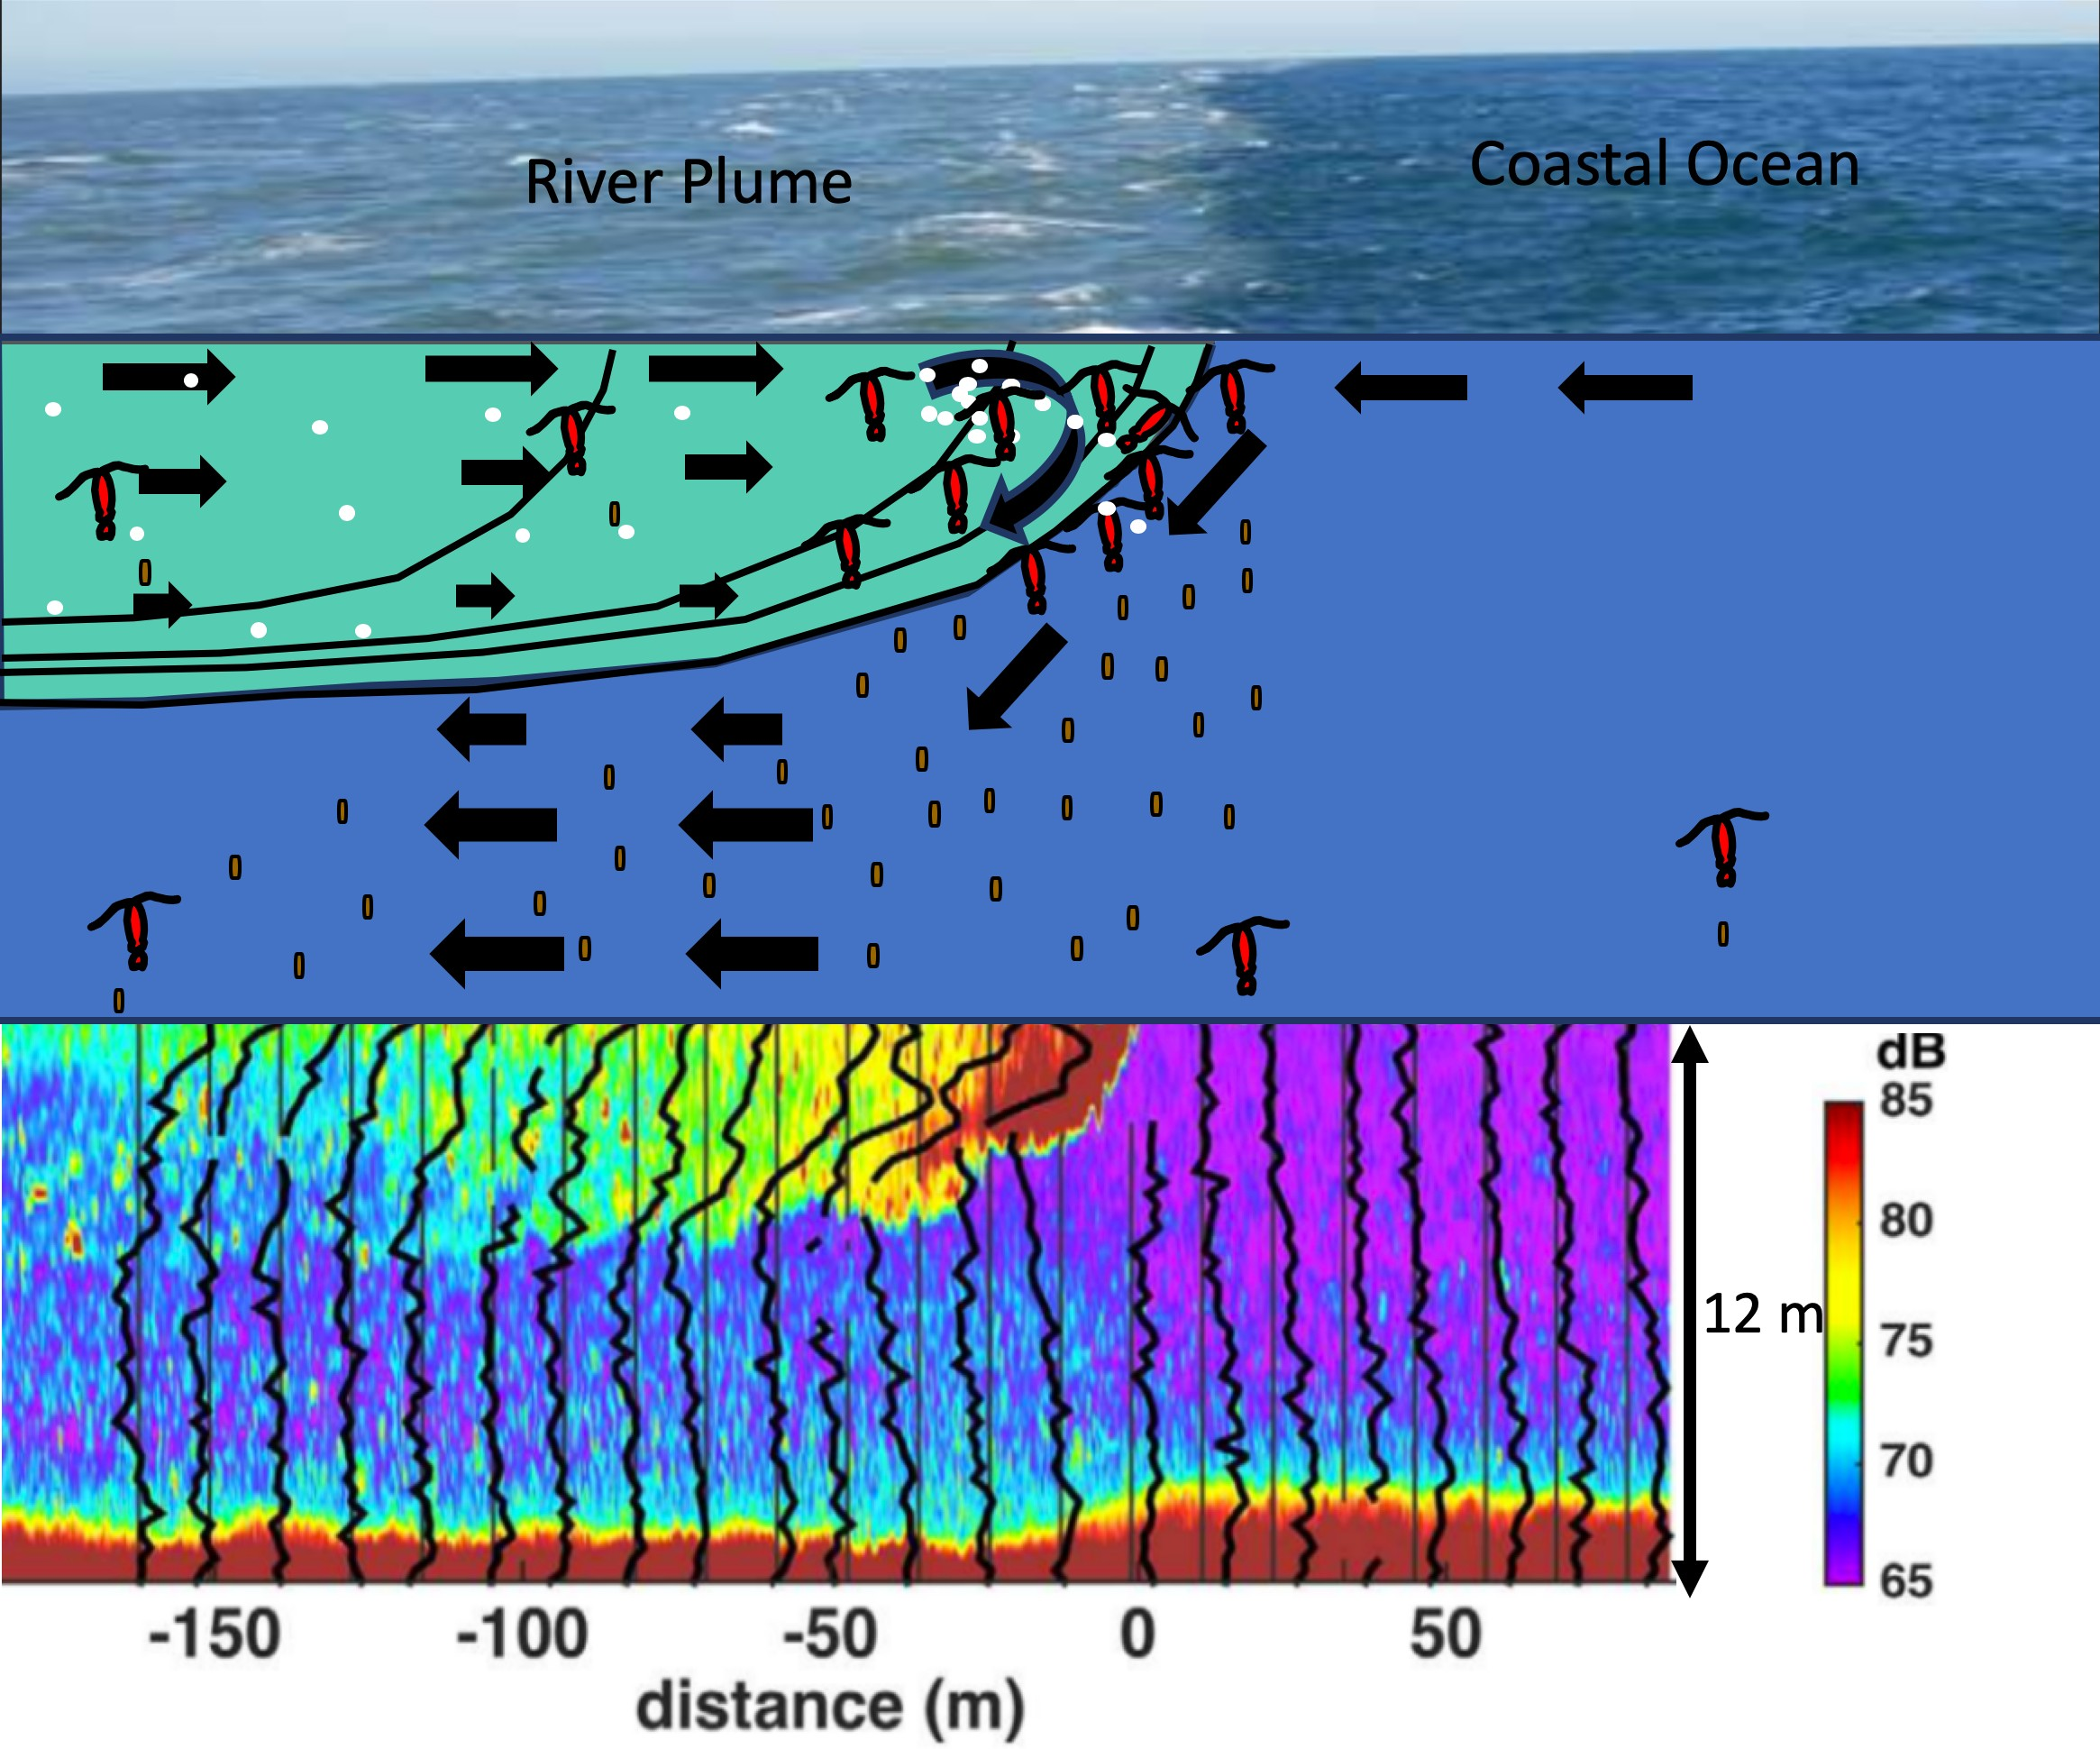

**Fig. 1.** Upper panel shows photo of a river plume front showing sharp color gradient between plume water (brown) and ocean water (blue). Middle panel shows schematic of plume front including isohalines (black lines) current velocity (arrows) zooplankton (large red), micro-plastics (white) and sinking fecal pellets (small red). Schematic shows both zooplankton and buoyant microplastics accumulate at plume front where flow converges and is driven downward. Lower panel shows acoustic backscatter image of passage of Hudson River plume past a mooring along the New Jersey Coast. High backscatter (red) is associated with elevated particulate load and is elevated at plume front (surface at a distance of 0). There is also elevated backscatter near the bottom associated with settling particles. Thick lines show along-shore velocity with thin vertical line the origin (0 cm/s) for each profile. Thin lines are separated by 50 cm/s. Image from Mazzini and Chant (2016).21