**Indicators of Habitat change affecting three key commercial species of the U.S. Northeast Shelf: A design to facilitate proactive management in the face of climate change**

Funding Agency: NOAA

Partners: NOAA NEFC, University of Rhode Island, MARACOOS

Period of Performance:

Total Budget: $1,311,171 (Rutgers $747,743)

Project summary

The productivity and/or distributions of many living marine resources (LMRs) within the U.S. Northeast Shelf (U.S. NES) have been changing in concert with warming ocean temperatures. However, most operational models used for the assessment of LMRs to inform fisheries management assume that the effects of the environment on distribution, population productivity, and natural mortality are implicit or fixed in space and time. As a result, assessment projections of stock size used for developing fisheries management regulations assume past ecosystem conditions will be sustained in the future. The few studies that have incorporated climate change into LMR models have used empirical relationships between the environment, distribution, and abundance derived from field studies. These studies are in essence “environmental correlations” but are limited in their description of ecological relationships because: 1) Abundance and distribution patterns in the field can be poor proxies for habitat suitability because there can be time lags between changes in habitat and an organism’s response; 2) Broad-scale distribution models do not do a good job at local scales nor at locations where habitat gradients are steep; and 3) Species-environmental relationships derived from statistical analyses of existing survey data are of unknown quality in terms of an organism’s responses to novel environmental conditions that might arise with climate change. Laboratory- based studies of physiological responses that can be used to calibrate species niche models with a basis in fundamental eco-physiological mechanisms are likely to produce more accurate projections that can include future environmental states. Three commercial species will be the focus of this proposal: black sea bass (*Centropristis striata*), longfin squid (*Doryteuthis pealeii*), and spiny dogfish (*Squalus acanthias*). The Mid-Atlantic Fishery Management Council currently has substantial interest in these species due to existing and potential changes in habitat.

Achieving improved habitat metrics based on laboratory studies of these three species can produce hindcast simulations and climate change projections of habitat quantity and quality and ultimately guide existing and future management decisions.

***Summary of Work***: The research will be organized into the following four tasks: **1)** *Laboratory studies of thermal optima*: We will use temperature-controlled swim tunnels with intermittent respirometry to determine the metabolic functional response of our target species to temperatures. **2)** *Simulate contemporary habitat using an existing ROMS hindcast*: With the data generated from the laboratory studies, we will produce thermal response curves combined with fine-scale bottom topography (for black sea bass) and apply them to an existing 50-year, three- dimensional hindcast of the U.S. NES (ROMS). **3)** *Habitat metric assessment:* We will use the hindcast simulations to develop and assess habitat metrics with respect to changes in population distribution, size, and variability. **4)** *Habitat projections under climate change:* We will project habitat quality and quantity and calculate relevant habitat metrics over various climate change scenarios. This will involve the use of high-resolution global climate models at NOAA GFDL.

***Relevance to Option 1***: Habitat hindcasts and projections of black sea bass, spiny dogfish, and longfin squid will advance our understanding of climate (variability and change) on three economically important LMRs that may already be changing. These hindcasts will be based on metabolic theory, thus building upon the population-climate modeling done in the region previously.

***Relevance to NOAA’s NGSP***: This proposal directly addresses the goal “Improved scientific understanding of the changing climate system and its impacts” because: 1) our improved habitat metrics will result in climate change projections (and hindcasts) of suitable thermal habitat for three commercial species; 2) these improved metrics can produce climate-ready management that will consider variable and changing thermal habitat in population biomass assessments.

**Statement of Work**

*Statement of the Problem*

Over the past 20 years, ocean surface temperature in the United States Northeast Shelf (U.S. NES) has warmed at a substantially higher rate than the global average (Fig. 1). Since the year 1900, western boundary regions like the U.S. NES have warmed in the surface layers two to three times faster than the global average (Wu et al. 2012). In concert with warming ocean temperatures, the productivity and/or distributions of many living marine resources (LMRs) within the U.S. NES have been changing (Nye et al., 2009; Lucey and Nye, 2010; Pinsky et al., 2013). Observations based on survey data suggest a shift in species assemblages to those that prefer warmer water (Lucey and Nye, 2010). These observed shifts combined with the many studies that have projected LMR productivity changes with warming ocean temperatures (Fogarty et al. 2008; Hare et al. 2010, 2012) demand climate-based ecosystem and LMR assessments that produce sustainable fisheries management in the face of climate change.

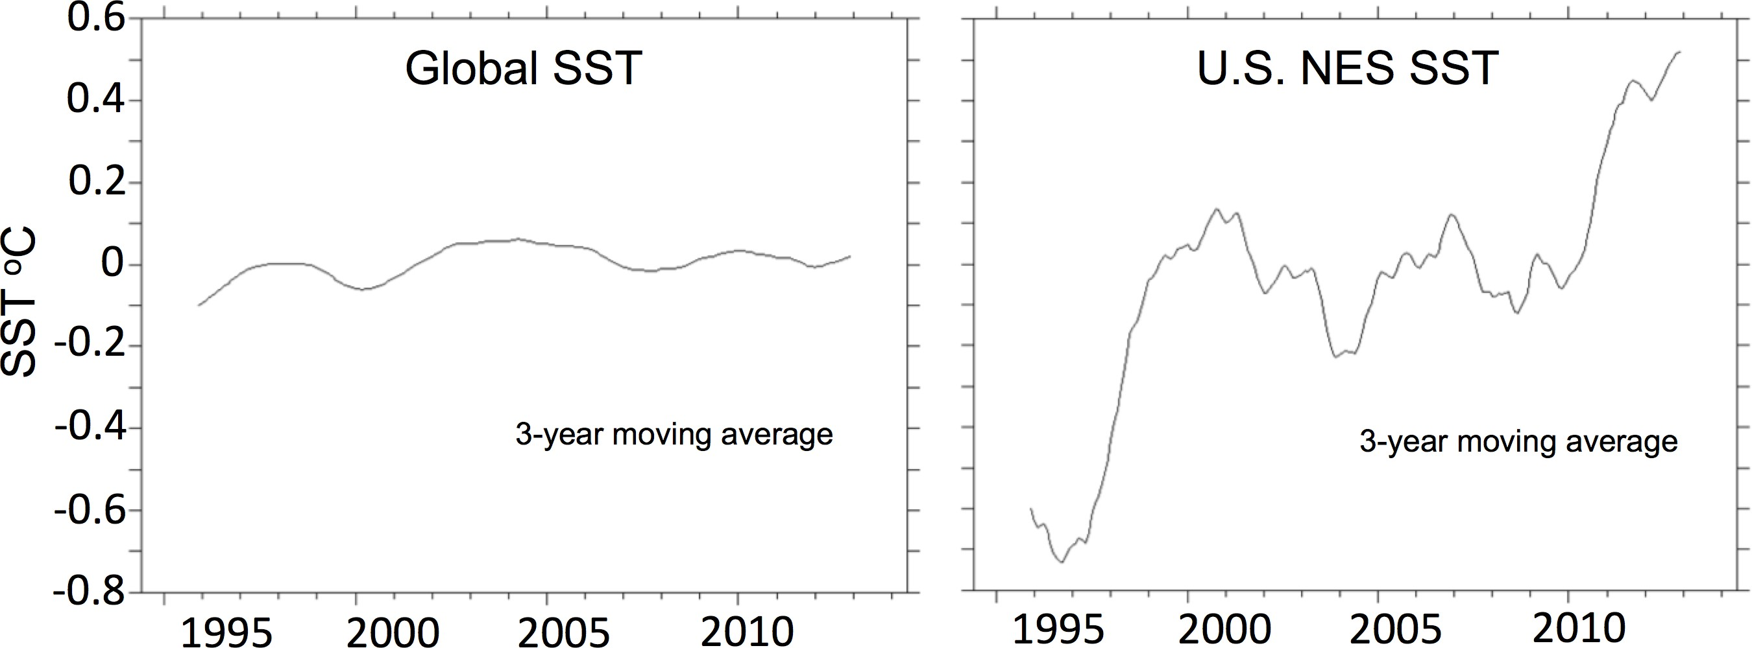

*Figure 1*. NOAA Reynold’s sea surface temperature (SST) anomalies from 1994 to 2014 in the global ocean versus the U.S. NES. Anomalies are based on the mean SST (daily, 25-km) from 1994 to 2014.

Most operational models used for the assessment of LMRs to inform fisheries management assume that the effects of the external environment on population distribution are fixed and do not exhibit significant temporal trends. As a result, assessment projections of stock size used for fisheries management regulations assume that ecosystem conditions of the past will occur in the future. Numerous studies have shown that the environment is changing and as a result, population distribution and productivity of LMRs is also changing. Most models coupling environment to resource population dynamics have used empirical relationships developed from field survey data. This is a necessary first step and is still a valuable approach, but we must take the next step and develop more mechanistic models that are based on ecological theory and not solely on statistical relationships. A more process-based approach overcomes three weaknesses of the empirical field based approach: 1) Abundance and distribution patterns in the field can be poor proxies for habitat suitability because there can be time lags between changes in habitat and an organism’s response; 2) Broad-scale distribution models perform poorly at local scales or at locations where habitat gradients are steep. 3) Species-environmental relationships derived from statistical analyses of existing survey data are of unknown quality in terms of an organism’s responses to novel environmental conditions that might arise with climate change.

While using field data has continued value, laboratory-based studies of physiological responses that can be used to calibrate species niche models with a basis in fundamental eco- physiological mechanisms are the next step in improving the accuracy of projections that can include changing environmental states due to climate. Such studies can provide detailed thermal- response curves and can also provide an aerobic scope for locomotion (using swim tunnels). The thermal-response curves derived from laboratory studies can then be used to produce thermal habitat models that can both hindcast and project (under various greenhouse gas emission scenarios) habitat quality and quantity within the U.S. NES. Although no laboratory data was used, thermal habitat models were designed for butterfish (*Peprilus triacanthus*) using field data such that the proportion of butterfish thermal bottom habitat that was sampled by the Northeast Fisheries Science Center (NEFSC) bottom-trawl spring and fall survey was estimated from 1973- 2012 (NEFSC, 2014). The study found that a little over half of butterfish thermal bottom habitat was sampled in the spring surveys whereas the fall surveys sampled up to 75% of the habitat.

This sampling bias led to underestimates of butterfish population size within the U.S. NES and the revised population size estimates resulted in the opening of a butterfish commercial fishery in 2014.

The butterfish habitat suitability index (Fig. 2) was based on both survey data and fisheries landings but did not use laboratory studies of butterfish thermal optima. This model was constructed by training a parametric thermal response function with a mechanistic basis using data from 7 field surveys conducted during spring and fall of the same years throughout the Northwest Atlantic. The approach assumed that, on average, concentrations of butterfish in the field reflected thermal habitat suitability. Evaluation of the model using data not included in training indicated that patterns of butterfish occupancy were reasonably well explained by the model. In theory, the macro-ecological approach (Brown, 1995) applied produced a population level response curve that potentially captured the integrated effects of temperature on habitat selection, population growth, and mortality to the degree that patterns of abundance at a broad scale emerged from and thus reflected these important population level processes. The degree to which the emergent property of regional abundance patterns reflected on average temperature effects on population processes ultimately linked to metabolism is unknown. One way to evaluate this is to take a bottom up laboratory approach to use temperature dependent measures of metabolic scope for aerobic activity to develop niche model parameters. Such an approach may provide more precise niche models, particularly for animals whose lifestyle produces patterns of abundance that may not reflect habitat suitability (e.g. black sea bass).

Three commercial species that currently have substantial interest to the Mid-Atlantic Fishery Management Council due to existing and potential changes in thermal habitat are black sea bass (*Centropristis striata*), longfin squid (*Doryteuthis pealeii*), and spiny dogfish (*Squalus acanthias*). These three species differ with respect to the strength of association with the seabed and water column, and serve as important prey and predators in the U.S. NES marine ecosystem. Developing improved habitat metrics based on laboratory studies of these three species can produce hindcast simulations (as done for butterfish) and climate change projections of habitat quantity and quality within the U.S. NES, and ultimately guide existing and future management decisions.

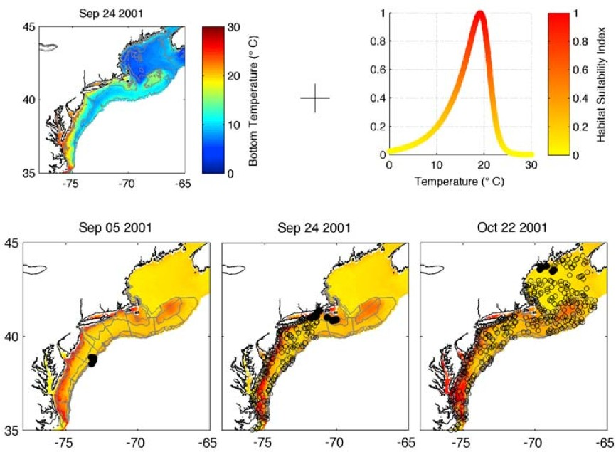

*Figure 2*. Butterfish thermal habitat suitability was projected in space and time by coupling the niche model rescaled from 0 (unsuitable habitat) to 1 (highly suitable habitat) to daily hindcasts of bottom temperature. De-biased Regional Ocean Model System (ROMS) bottom water temperature hindcast for the median date of the 2001 fall NEFSC survey (September 24th; top left) was coupled to a realization of the thermal niche model (top right) to produce a daily hindcast of thermal habitat suitability for butterfish for September 24th, 2001 (bottom middle). The habitat suitability projections were used to calculate the proportion of the total habitat suitability in the regional sea sampled at each station on the day of sampling. These values summed across survey stations to estimate the availability of the butterfish stock to the survey as a function of the total available thermal habitat sampled. Reproduced from NEFSC, (2014).

*Black Sea Bass*

The northern stock of black sea bass in the Northwest Atlantic ranges from Cape Hatteras, North Carolina to southern New England. Since the late 1960’s, the annual commercial and recreational landings of the northern stock have been relatively stable averaging between 1000 and 1500 MT each such that the recreational landings represent 50% of the total landings over the past 20 years (NEFSC, 2012). However, if the time-series of commercial landings is considered back to 1939, there was a period of substantial yield between the late 1940’s and late 1950’s when landings were as a high as almost 10,000 MT in the early 1950’s (Fig. 3a).

Concurrent with the peak landings of the late 40’s and 50’s was a warm ocean temperature regime in the U.S. NES such that surface ocean temperatures were almost as warm as they are today (Fig. 3b). However, a major difference between the cotemporary warming and the warming of the 40’s and 50’s is that contemporary winter ocean temperatures have not warmed as much as summer temperatures whereas the previous warming occurred in both winter and summer (Fig. 3b). Similar peaks in the landings and sightings of many warm water species, including black sea bass, white sharks, menhaden, American lobsters, and silver hake were reported within New England waters during the warm period of the 40’s and 50’s (Taylor et al. 1957).

Because black sea bass are a warm water, demersal species, they cannot tolerate the cold, inshore winter waters of the U.S. NES. These Serranidae are protogynous hermaphrodites such that they are all born female and switch to male between the ages of 2 and 5 years. These fish undergo a fall migration when inshore waters begin to cool. The fall migration of the northern stock is directed toward the outer shelf waters south of New Jersey where the population overwinters and then returns to the coastal waters of the U.S. NES in the spring when bottom temperatures warm. Adults are omnivorous and typically feed on a suite of fish and invertebrates (Steimle et al. 1999). The Mid-Atlantic Fishery Council and the Atlantic States Marine Fisheries Commission jointly manage the northern stock.

In the summer, adult black sea bass of the northern stock are typically found in bottom waters that have structures such as artificial reefs, mussel beds, rocky sediments, and shipwrecks. Adult (> 19 cm TL) thermal habitat during the winter may be limited by bottom water temperatures that are warmer than 7.5 oC (Neville and Talbot, 1964). Survey data from the NEFSC bottom trawl survey indicates that adult black sea bass are typically caught in bottom water temperatures between 9-12 oC in the winter and spring (Fig. 4). Their summer thermal habitat distribution appears to be bimodal with peaks at both 10 oC and 25 oC. Fall thermal distribution also appears to be bimodal with peaks at both 13-21 oC and 25-27 oC. Laboratory studies of the impacts of temperature on growth of adults suggests that 25.6 oC is the optimal temperature for growth (Sullivan and Tomasso, 2010). Fingerlings (weight = 9 g) also grew faster at 25 oC than at warmer or cooler temperatures (Cotton et al, 2003). However, these studies did not account for oxygen consumption and locomotion at various temperatures.

A major issue associated with bottom trawls of fish that prefer bottom structure is that the gear tends to get tangled in three-dimensional bottom habitat and thus many surveys avoid these areas. Therefore, the NEFSC and State survey data is not fully inclusive of all black sea bass benthic habitat and is thus biased to smoother bottom habitat. Physiological laboratory studies of black sea bass will reduce the uncertainty in thermal habitat associated with the survey data that cannot sample the rigid bottom habitat that is apparently critical to these fish.

The NEFSC survey data of black sea bass (fall, winter, and spring) show high variability in the catch per tow and the age structure (NEFSC, 2012), which may be a product of insufficient habitat sampling by the survey. State survey data from Connecticut, Rhode Island, and Massachusetts all suggest an increase in black sea bass catch per tow (NESFC, 2012). These data along with fishermen reports of increased abundance of black sea bass in Gulf of Maine waters suggest that the northern stock within the U.S. NES may be shifting further north, a shift that could be similar to the reports from the 1940’s and 1950’s (Taylor et al. 1957) when ocean temperatures were almost as warm as today. Finally, stock quotas of black sea bass are allocated on a state-by-state, geographic basis. Failure to consider changes in climate on black sea bass stock distribution, as well as productivity, can lead to quota misallocations, conflicts, and economic loss to the fishing industry.

*Longfin Squid*

Longfin inshore squid are a schooling species within the U.S. NES and are typically distributed between Cape Hatteras and Georges Bank. Up to 1986, commercial landings of squid were from both domestic and foreign fleets and thus observer coverage was very poor leading to high uncertainty in landings data (NEFSC, 2011). From 1987-2009, U.S. landings of both

longfin and shortfin (*Illex illecebrosus*) squid averaged 16,610 MT (Fig. 4). Both the fall and spring NEFSC trawl survey show very high interannual variability in the catch per tow and thus no trends can be discerned (NEFSC, 2011). Pre-recruits are less than 8 cm (mantle length) while recruits are greater than 9 cm such that the fishery can exploit only those of the recruit size-class (Jacobson, 2005).

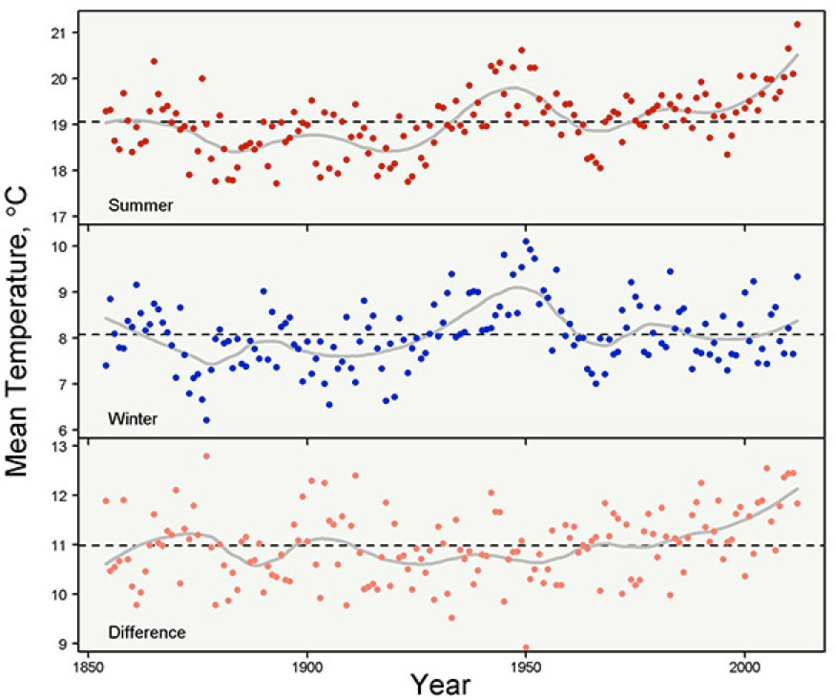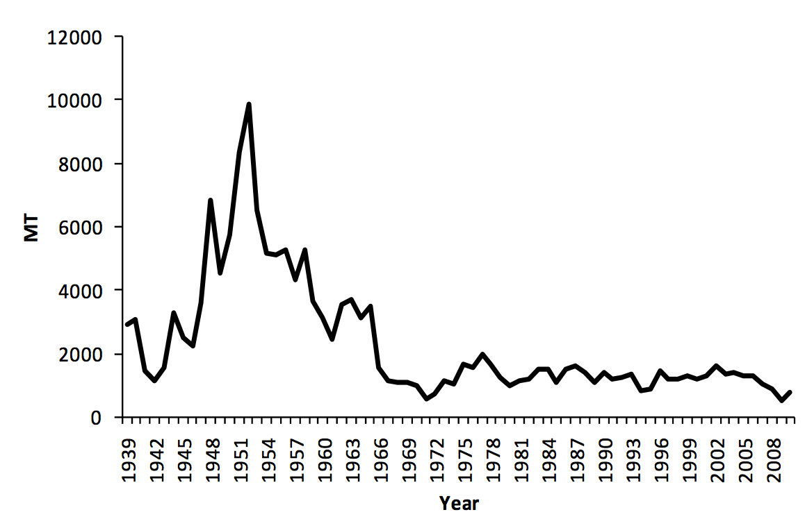

*Figure 3*. a) Commercial black sea bass landings from the northern stock since 1939 (NEFSC, 2012). b) Sea surface temperature (NOAA erSSTv3) within the U.S. NES in the summer, winter, and the difference between summer and winter from the 1860’s to 2012.

Although longfin squid can spawn year-round, spawning peaks in May (inshore waters) and larvae hatch in July. Eggs are demersal and commonly attach to rocks, aquatic vegetation, and muddy bottoms (Jacobson, 2005). Larvae are pelagic and can inhabit water temperatures between 10-26 oC and salinities between 31.5-34.0 ppt. Spring (fall) survey data show that pre- recruits are typically caught in water temperatures between 8-14 oC (10-19 oC) and salinities between 34-36 ppt (32-33 ppt) (Jacobson, 2005). Larger squid (recruits) typically occupy spring (fall) water temperatures between 7-13 oC (10-15 oC) and salinities between 34-35 ppt (32-33 ppt) (Jacobson, 2005).

Small immature squid feed on plankton while the larger adults typically feed on euphausiids and fish during the spring (offshore) but will almost exclusively feed on fish during the fall (inshore). Those that are offshore in the fall will feed on both fish and other squid.

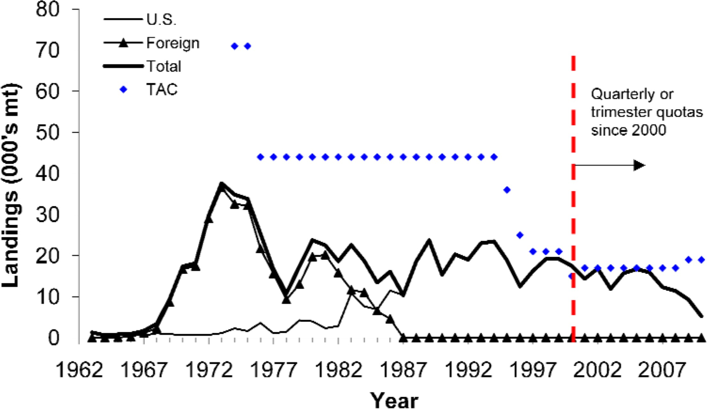

*Figure 4*. U.S. foreign, and total longfin squid landings from 1963-2010 and Total Allowable Catches (TACs) from 1974-2010. The 2010 landings are preliminary and incomplete (NEFSC, 2011).

Similar to black sea bass, longfin squid migrate offshore to the continental shelf edge and parts of the slope during the fall when waters begin to cool and then return to inshore waters in the spring. Their seasonal movements are related to bottom temperature and they can inhabit water temperatures warmer than 9 oC (Jacobson, 2005). Given the similar temperature preferences and seasonal migrations, there is likely considerable overlap between longfin squid and black sea bass preferred thermal habitat. A northern extension in the range of these squid during the summer months has been suggested (Jacobson, 2005), which may be related to the continued warming of summertime ocean temperatures within the U.S. NES (Fig. 3b). Dawe et al., (2007) performed an analysis suggesting that the expansion of long-finned squid population in 2000 into Canadian waters associated with warm local water temperatures and an unusual eastward displacement of the atmospheric features associated with the North Atlantic Oscillation (NAO).

*Spiny Dogfish*

Spiny dogfish are small sharks that inhabit the U.S. NES between Cape Hatteras, NC and Nova Scotia. They are the most abundant shark in the Northwest Atlantic and are highly migratory (Stehlik, 2007). In the late 1960’s and early 1970’s, foreign fleets dominated the Northwest Atlantic commercial landings of spiny dogfish and the annual catch was as high as 25,000 MT (Fig. 5) (Rago and Sosebee, 2013). After foreign fleets diminished resulting in only

U.S. and Canadian fisheries, the total catch dropped to under 10,000 MT up until the 1990’s when the U.S. commercial fishery intensified and annual landings were as high 28,000 MT (Fig.

5) (Rago and Sosebee, 2013). Federal and State management plans imposed on the commercial fishery after 2000 resulted in the substantial catch reduction since that time (Fig. 5) (Rago and Sosebee, 2013). However, U.S. landings have increased to ~10,000 MT in 2011 and 2012 whereas landings from Canada averaged only 77 MT since 2009 (Fig. 5) (Rago and Sosebee,

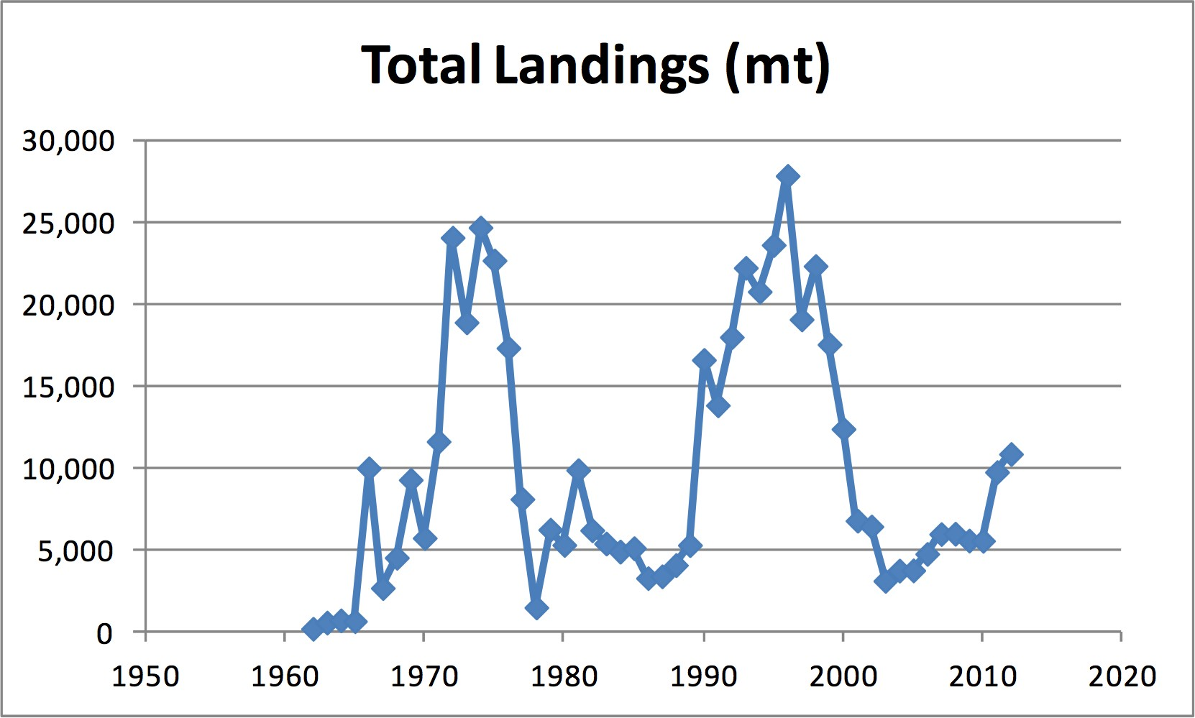2013). Discards (bycatch) of this species are extremely high and can exceed landings. For example, discards were estimated to be 11,626 MT in 2012 (Rago and Sosebee, 2013).

*Figure 5*. Estimated total landings (MT) of spiny dogfish in Northwest Atlantic NAFO Areas 2 to 6, 1962*-­‐‑*2012. Reproduced from Rago and Sosebee, 2013.

Within the U.S. NES, it is assumed that spiny dogfish migrate north and south as well as onshore and offshore migrations with seasonal temperature changes. A recent study of 40 satellite tagged adults showed that seasonal migrations were actually more local and were a function of deployment site between the Gulf of Maine and southern North Carolina (Carlson et. al., 2014). The study indicated two distinct home ranges for sharks in the southern versus northern U.S. NES, as well as diel vertical movement patterns suggesting that the species may actually be less benthic than previously assumed.

They are long-lived, and late to mature such that most females mature at 12 years [78 cm length] and most males mature at 6 years [60 cm length] (Burgess, 2002). Spiny dogfish mate in the fall followed by a gestation period that can last 18-22 months (NEFSC, 2006). Females give birth to 6-7 pups on average but larger females can give birth to larger litters (Burgess, 2002).

These sharks are highly opportunistic feeders and can consume a wide variety of prey items, which appear to be a function of geographic location and can change through time (Stehlik, 2007). Survey data suggest that spiny dogfish and skates have effectively replaced cod and haddock as the dominant piscivores within the U.S. NES (Link and Garrison, 2002). During the spring (fall) juveniles are caught in water temperatures between 6-13 oC (8-14 oC) and salinities between 33-35 ppt (32-34 ppt) (Stehlik, 2007). Adults are caught in similar range of temperatures and salinites.

As with the previous two species, there is considerable interannual variability among fisheries-independent survey data for spiny dogfish (Rago and Sosebee, 2013). There was a significant decline in pup (< 36 cm) biomass in the NEFSC spring survey in the late 1990’s and early 2000’s but the biomass then increased to record high levels in the past few years (Rago and Sosebee, 2013). The most recent report by Rago and Sosebee (2013) suggests that the inconsistent nature of suitable pup habitat sampled by the NEFSC survey is likely responsible for the significant variability in the abundance indices. Climate variability may very well be linked with variation in spiny dogfish thermal habitat availability that is not being captured by the survey.

A recent study used survey data from the U.S. NES to build spiny dogfish size-based generalized additive models (GAMs) as a function of both biotic and abiotic factors (Sagarese et al., 2014). The study found that while seasonal distribution was a function of bottom temperature and depth, trends in the distributions of various size classes were also a function of prey abundance, which included longfin squid. Sargarese et al. (2014) went further and assessed potential climate change impacts on the distribution of mature females and pups during the spring. They found that regional changes in distribution were a function of bottom temperature such that a more northern distribution or both females and pups were associated with warmer than average bottom temperature. However, the GAMs used to predict distribution changes with temperature were parameterized using NEFSC survey data, which is suggested to be inconsistently sampling spiny dogfish habitat from year to year (Rago and Sosebee, 2013).

Incorporating laboratory-based studies of spiny dogfish thermal optima could improve or the GAMs that were based on survey data to reduce the uncertainty of this organisms response to climate change. To date, no laboratory studies of spiny dogfish temperature or salinity tolerances exist.

*Global Climate Model Resolution*

Presently, the global models used to project climate change impacts on LMRs within the U.S. NES (cod, cusk, croaker; Fogarty et al. 2008; Hare et al. 2010, 2012) have coarse ocean resolutions that are about 1o x 1o (100-km) global average. These coarse models do not resolve the fine-scale bathymetry of the U.S. NES, which are critical components to water mass circulation and phytoplankton biomass within the ecosystem (Saba et al., in review). Moreover, the position of the northern wall of the Gulf Stream in many of these coarse global climate models is too far to the northwest and essentially stretches directly over the U.S. NES (Delworth et al., 2012). Similar biases are evident regarding the position and intensity of the Labrador Current (Delworth et al., 2012). However, resolving the position and strength of these two currents, as well as resolving the fine-scale bathymetry (i.e. Georges Bank, Nantucket Shoals, Northeast Channel, Shelf Break and Slope) of the U.S. NES can be achieved using high- resolution global climate models (Saba et al., in prep.).

High-resolution global climate models from NOAA’s Geophysical Fluid Dynamic Laboratory are currently being assessed for their use in the U.S. NES (Saba et al., in prep.). Recent analyses show that both SST and bottom temperature (Fig. 6) within the U.S. NES are projected to warm at a higher rate in response to increased CO2 emissions when compared to projections using the standard coarse models (Saba et al., in prep.). The higher rate of warming in the high-resolution models is due to a synergy of enhanced radiative forcing (i.e. global warming) and higher proportion of Gulf Stream water (Atlantic Temperate Slope Water) entering the deep Northeast Channel in the Gulf of Maine (Saba et al., in prep.). This suggests that previous analyses using coarse global climate models may be underestimating climate change impacts on LMRs within the U.S. NES. It also stresses the importance of model resolution on resolving the Gulf Stream and Labrador Current as well as the models’ ability to resolve fine- scale bathymetry. Therefore, it is imperative that high-resolution global climate models are evaluated for their use in LMR climate impact studies for the U.S. NES.

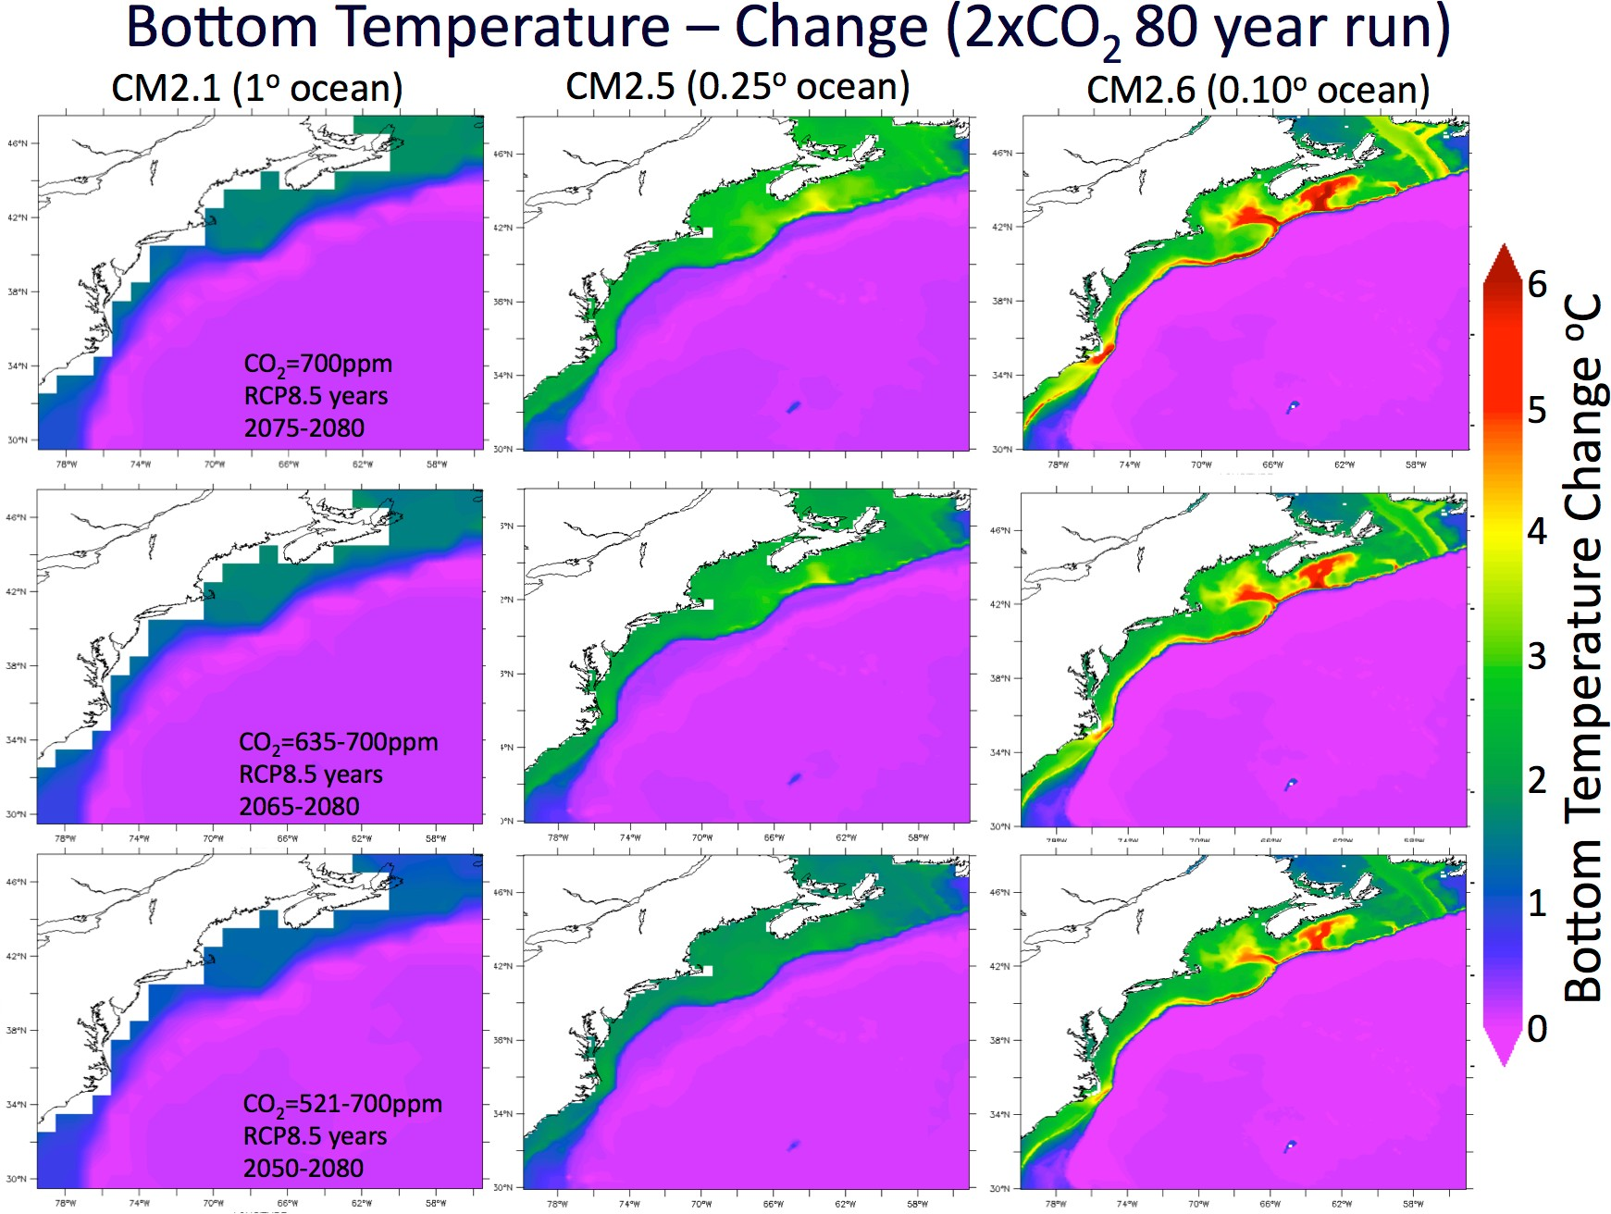

*Figure 6.* U.S. NES ocean bottom temperature projections from three global climate models developed at the NOAA Geophysical Fluid Dynamic Laboratory (Saba et al., in prep.). Each models differs in resolution such that CM2.6, CM2.5, and CM2.1 have an average ocean resolutions of 10-km, 25-km, and 100-km respectively. The three CO2 emissions scenarios for each model are represented as their equivalent to the IPCC representative concentration pathway (RCP) 8.5 scenario year ranges.

*Main Problem Summary*

It is clear that these three commercial species are key components (in terms of predators and/or prey) of the U.S. NES marine ecosystem and may already be shifting north with warming ocean temperatures. A consistent overarching problem with all three stock assessments of these species is the uncertainty in the proportion of suitable habitat sampled by fisheries-independent survey time-series data (Fig. 7); an uncertainty that must be reduced in order to make these assessments climate-ready to account for both natural climate variability and climate change within the U.S. NES. Additionally, changes in stock productivity may occur if the overall amount of available habitat or degree to which habitat is fragmented has changed or changes in the future. It is critical to assess changes in suitable thermal habitat in space and time to produce more precise estimates of abundance and evaluate impacts on population productivity, which can help produce sustainable fisheries management actions in the face of climate change. The rapid warming of the U.S. NES is likely already shifting and changing the volume of suitable habitat, both spatially and temporally, rendering uncertainties in survey-based estimates even more challenging to measure. Laboratory-based studies of these three species’ thermal optima will produce the habitat metrics required to simulate and project habitat quality and quantity with changing climate conditions. Moreover, the use of high-resolution global climate models, which

project an even higher rate of ocean warming than standard IPCC-class models, are critically needed to project fine-scale thermal habitat change as a function of climate change.

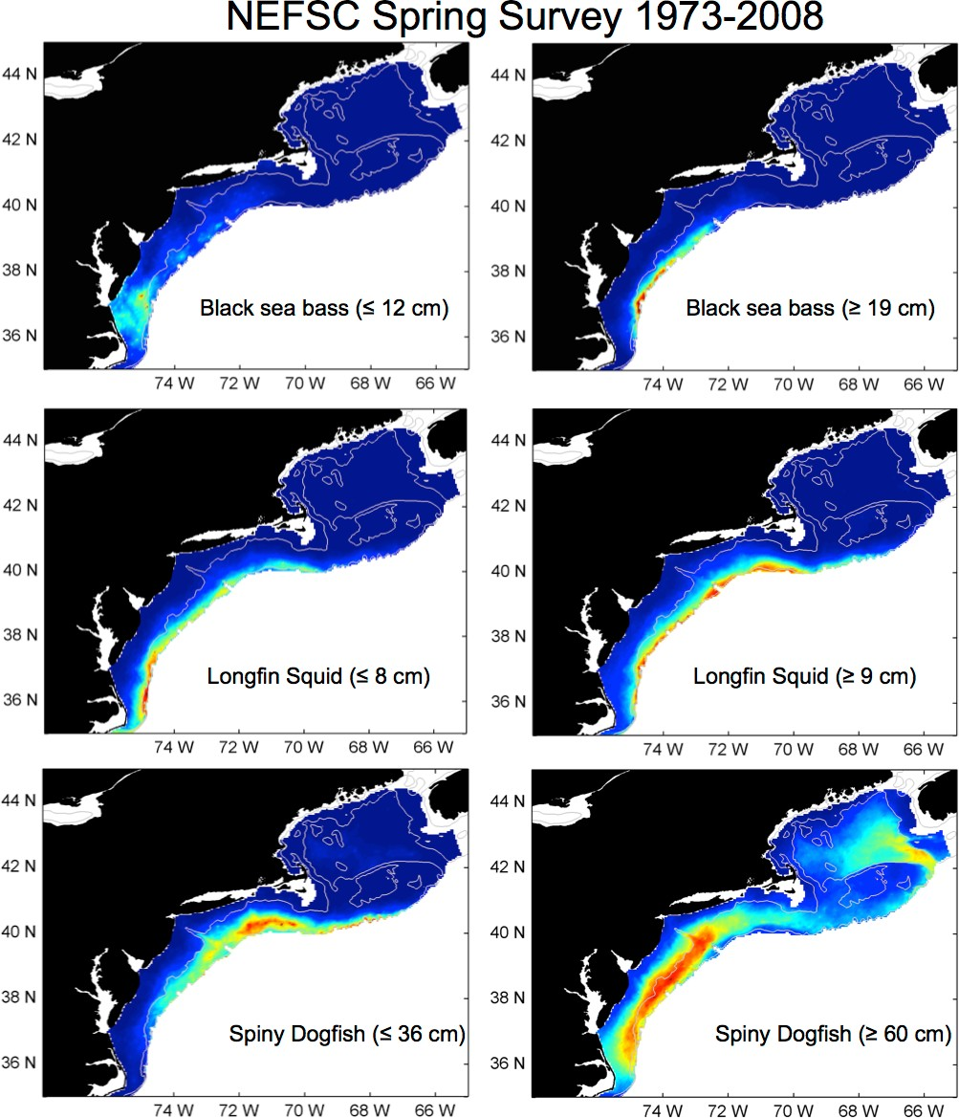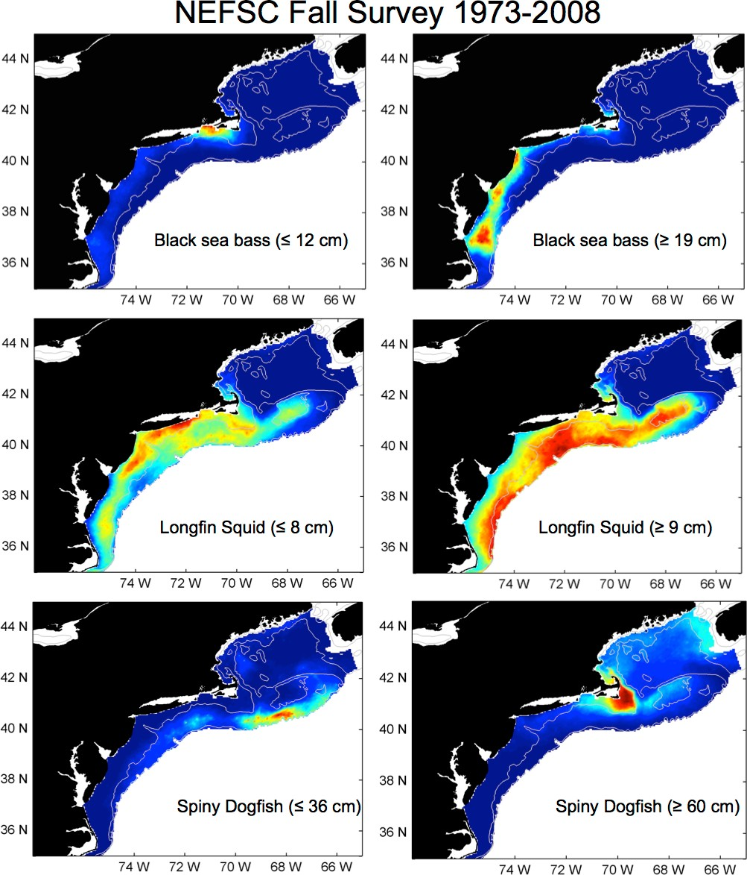

*Figure 7.* Composites of NEFSC bottom-trawl survey data for the spring and fall from 1973- 2008 for all three species at two size ranges. Warmer colors (red) indicate more animals caught per tow and cooler colors (blue) indicate fewer or no animals caught per tow.

*Objectives*

This project focuses on improving ecological hindcasts and projections using mechanistic models that link species-specific physiology to climate-based thermal scenarios. The work will have four main objectives that will be coordinated among the participating groups and engage the broader management and industry community familiar with these stocks. Our four objectives are:

1. *Laboratory studies of thermal optima* (G. Saba, B. Seibel): In collaboration with the University of Rhode Island and Rutgers University, we will use temperature-controlled swim tunnels with intermittent respirometry to determine the physiological response (i.e. critical oxygen partial pressure as well as the aerobic scope for locomotion) at a range of water temperatures of adult black sea bass, longfin squid, and spiny dogfish. Juveniles will be also be investigated if time permits and samples become available. This will allow us to identify thermal constraints on the vertical and horizontal distribution of these organisms.
2. *Simulate contemporary habitat using existing ROMS hindcast* (J. Manderson, E. Curchitser, J. Kohut, J. Hare, V. Saba, P. Moore): From the empirical data generated from the laboratory studies combined with previously published laboratory research on these three species, we will produce thermal response curves combined with fine-scale bottom topography (for black sea bass) and apply them to an existing 50-year, three-dimensional hindcast of the U.S. NES ocean conditions using ROMS.
3. *Habitat metric assessment* (J. Manderson, D. Richardson, J. Kohut, V. Saba, J. Hare, P. Moore): We will then use the hindcast simulations to develop and assess habitat metrics with respect to changes in population distribution, size, and variability. Habitat metrics will include spatial metrics of habitat location and quantity, temporal metrics of timing and duration, and metrics of patchiness. Analyses will be performed to determine metrics that account for the largest proportion of variation in population distribution, size, and variability.
4. *Habitat projections under climate change* (V. Saba, J. Manderson, J. Kohut, J. Hare): We will project habitat quality and quantity and calculate relevant habitat metrics identified in #3 for the three species within the U.S. NES over various scenarios of climate change. This will involve the use of high-resolution global climate models at NOAA GFDL that have 10-km average ocean resolution and are currently being assessed by V. Saba for their use in the U.S. NES. For comparative purposes and to have an ensemble projection, we will also project the same habitat indicators using the standard coarse climate models (100-km ocean resolution) as well as any additional downscaled model projections that become available to assess the impact of model resolution and/or downscaling method on projections of habitat metrics for these three species.

*Methods*

1**)** *Laboratory studies of thermal optima* (Years 1 and 2)

Live animals representing adult (male and female) size classes will collected from local waters near the University of Rhode Island’s Graduate School of Oceanography (URI GSO) campus located in Narragansett, Rhode Island, which is also next to the NEFSC Narragansett laboratory. Live animals will be obtained via the NEFSC cooperative research program with commercial fishermen that regularly catch black sea bass, longfin squid, and spiny dogfish. If it proves challenging to collect the appropriate size classes of live spiny dogfish from local fishermen (see letter of support from Garden State Seafood Association), we will obtain animals from the NEFSC longline survey for sharks. All three of these adult species are commonly caught at local coastal waters in the summer and fall. Because swim tunnel respirometry experiments are very time consuming requiring multiple trials, replicates, and acclimation time, we are proposing to sample adults but will attempt to sample smaller juveniles if time permits.

*Determining the effects of temperature on metabolic, locomotory, and energetic performance in squids and fishes*: Our experimental design will provide insight into the tolerance and potential acclimation of these three species to impending ocean conditions. We hypothesize that temperature affects these organisms via simultaneously increasing oxygen demand while reducing the oxygen-carrying capacity in the blood. This hypothesis is consistent with the oxygen- and capacity-limited thermal tolerance hypothesis (Pörtner, 2010). We further hypothesize that this effect will be most apparent during high oxygen demand (resulting from elevated activity levels).

Intermittent respirometry will be used for repeated measurements of critical oxygen partial pressures (Pcrit) and critical swimming speeds. This method relies on a gas equilibration column that will replenish or maintain, respectively, the oxygen content of a respirometry chamber.

Seawater will be pumped from a water-jacketed gas-mixing column held at the experimental temperature and bubbled with air at a rate sufficient to maintain the experimental oxygen partial pressure. Thus oxygen and temperature will be controlled by external adjustments without

exposing the animal to any disturbance between different treatments. Oxygen, temperature and pH probes will be held just up- and downstream in order to ensure constant conditions during oxygen consumption measurements.

*Critical Oxygen Level*: The critical oxygen partial pressure (Pcrit) is the PO2 below which the routine oxygen consumption rate (MO2) can no longer be maintained independent of ambient PO2. It will be determined by continuous measurement of the oxygen consumption rate as PO2 decreases in a closed chamber under varying activity levels. The volume of the chamber will be adjusted aiming for a 30-minute post-acclimation trial from air-saturation to Pcrit. Acclimation will take place in darkness and will be undisturbed for 6 hours. Animals will be fasted during acclimation. The Pcrit will be identified by regression analysis of MO2 vs PO2 (Fig. 8).

*Critical Swimming Speeds*: The critical oxygen level will be measured as above at stepwise increases in water velocity to achieve a final critical swimming speed indicated by the failure of the organisms to maintain position in the working section of the swim-tunnel respirometer.

Metabolism measured at resting and maximum sustainable swimming speeds will provide a measure of metabolic scope (factorial increase in metabolism between rest and maximum performance).

When each species arrives at URI GSO, the animal we be acclimated to the swim tunnel (Fig.

9) before the experiments begin. Each animal will be exposed to three different temperatures (low, moderate, high) at three different swimming speeds (resting, intermediate, maximum sustainable). Preliminary trials will first be conducted to determine the maximum sustainable swim speed.

# 20°C

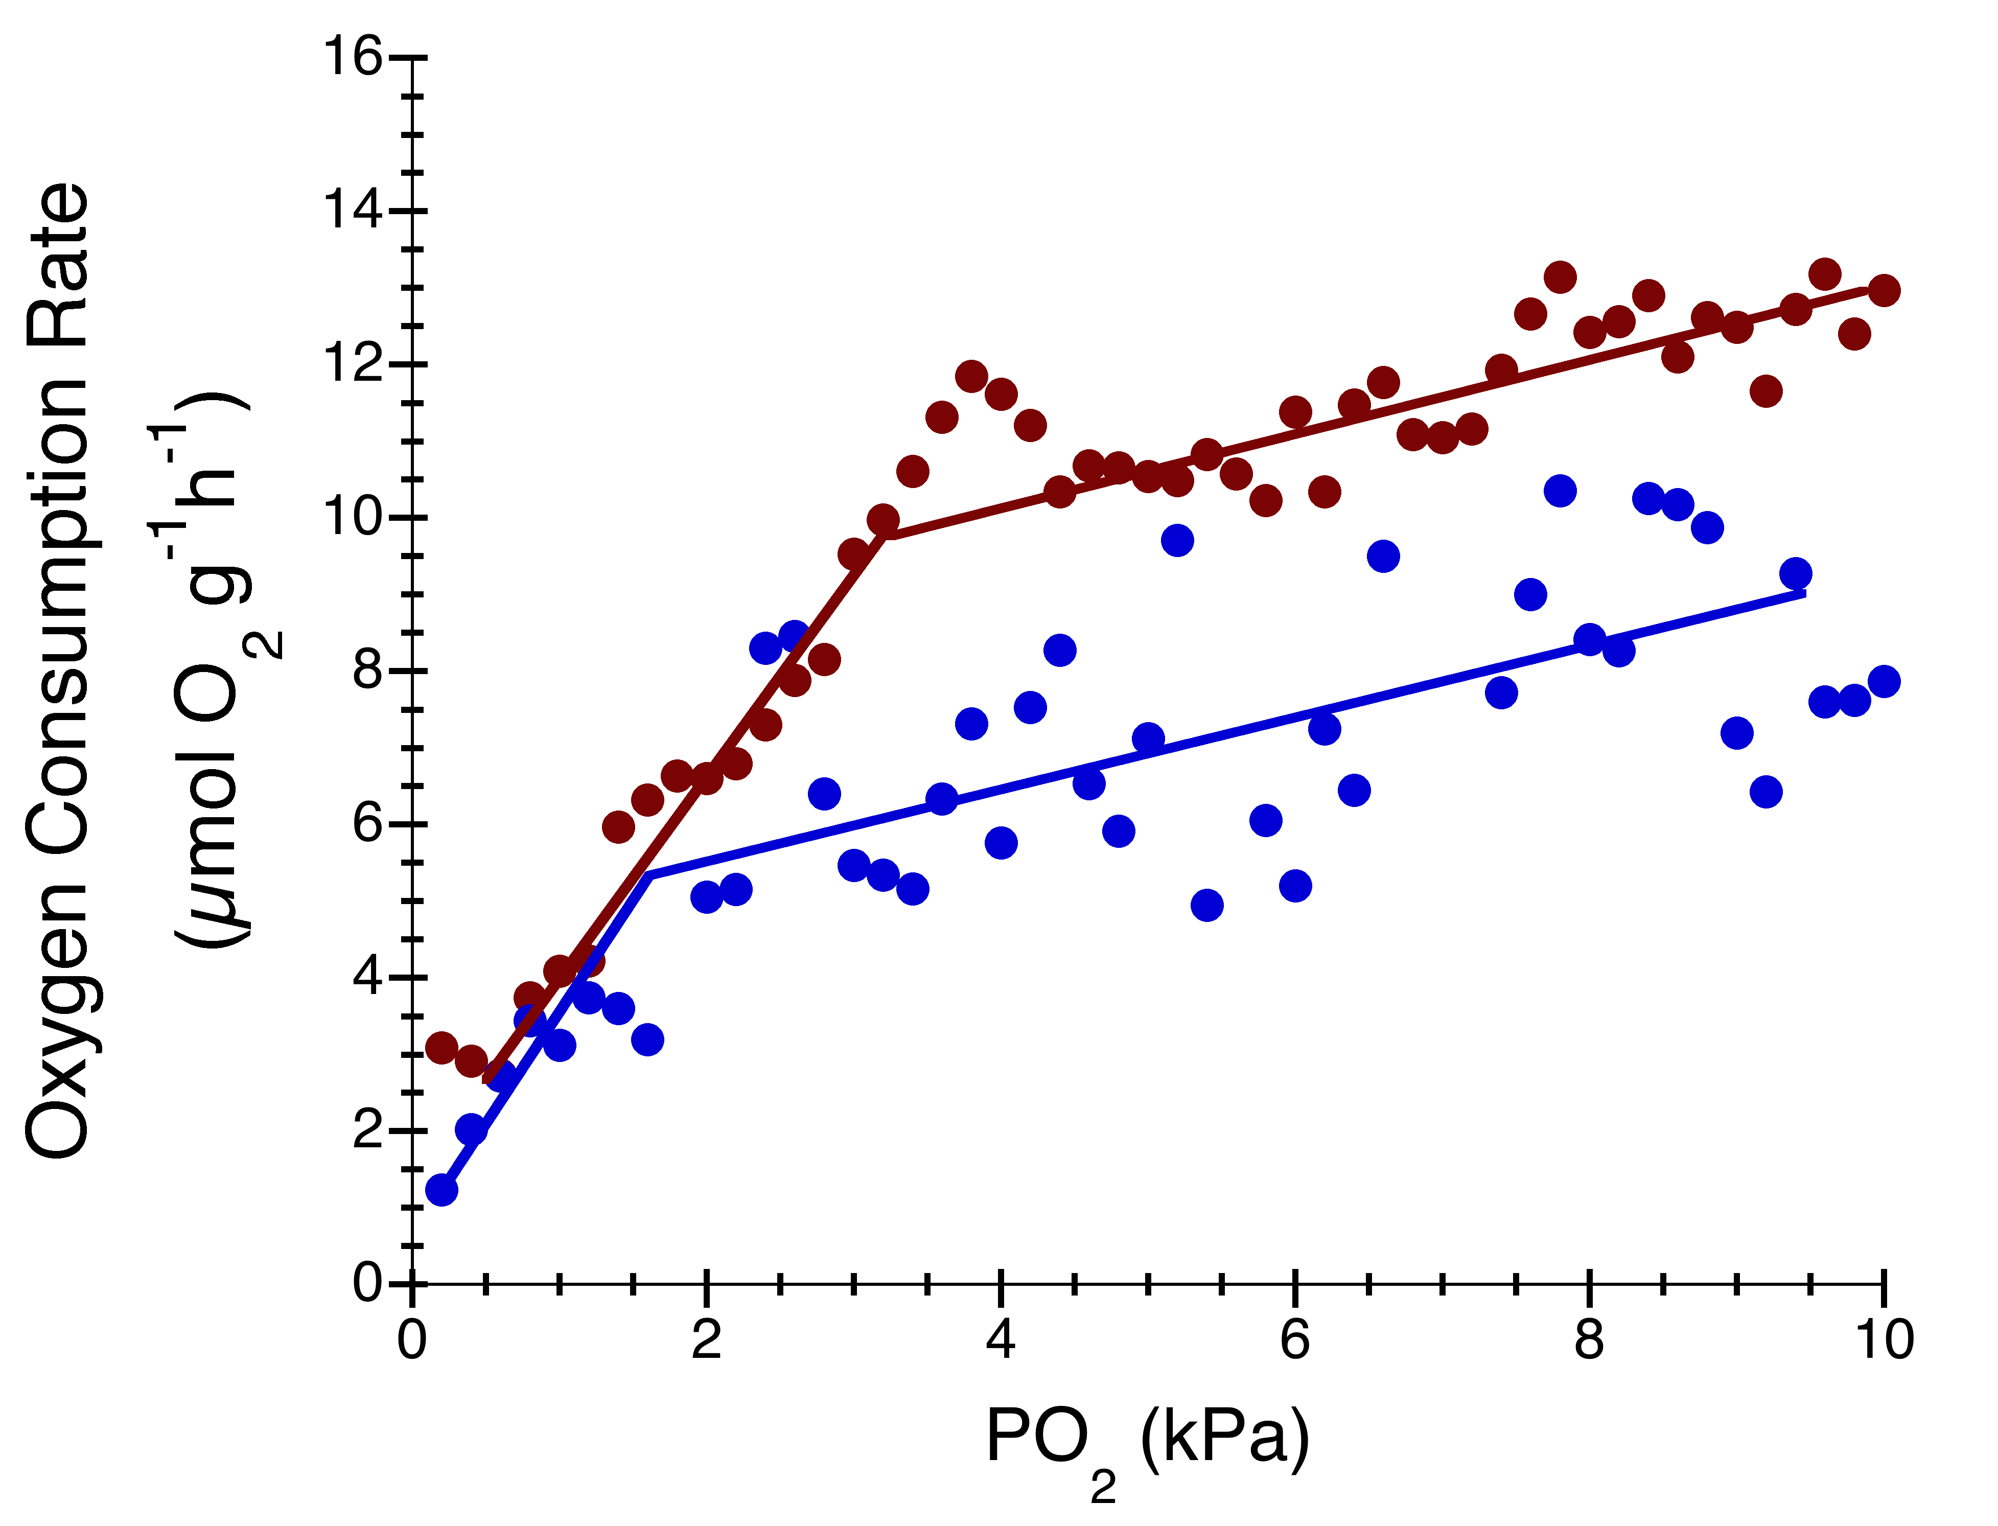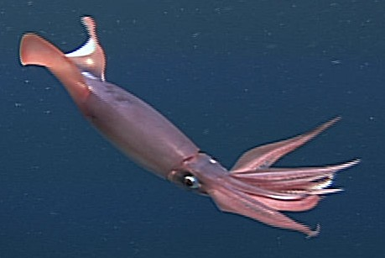

10°C

3.2 kPa

1.6 kPa

*Figure 8*. Critical oxygen partial pressures (Pcrit) at a resting rate of metabolism are 3.2 and 1.6 kPa PO2 at 20 (red) and 10°C (blue), respectively for the jumbo squid, *Dosidicus gigas*, which migrates across a large temperature and oxygen gradient in the Eastern Pacific. The Pcrit typically is dependent on the metabolic rate and is thus similarly influenced by temperature (e.g. a Q10 of 2-3, equivalent to a doubling or tripling of the Pcrit with a 10°C increase in temperature). Data from Trueblood and Seibel, 2013.

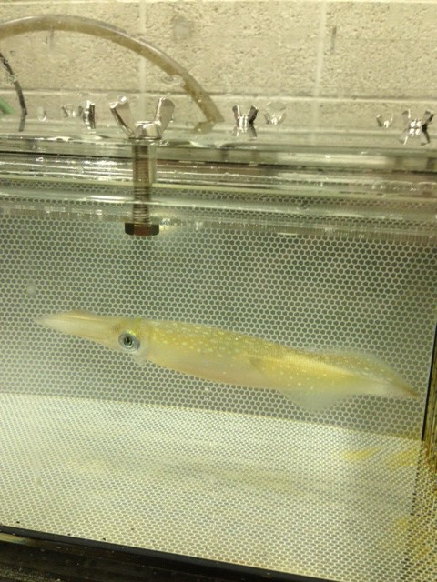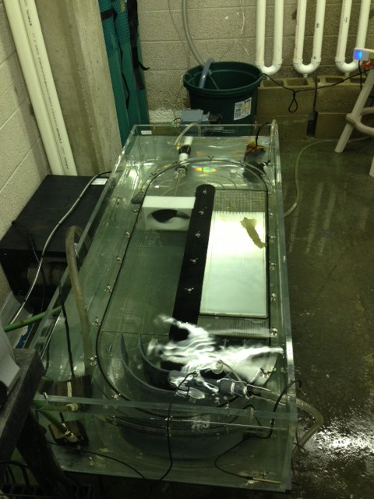

*Figure 9.* Longfin squid inside a swim tunnel at the University of Rhode Island.

1. *Simulate contemporary habitat using existing ROMS hindcast* (Years 2 and 3)

We will derive thermal optima curves from the data generated in the laboratory swim tunnel experiments described in method #1. Unlike the habitat models created form butterfish (Fig. 2; NEFSC, 2014), these new habitat models for black sea bass, longfin squid, and spiny dogfish will be based on temperature effects on both oxygen consumption and locomotion. Habitat simulations (hindcasts) for each species and each size-class (juvenile and adult) will be constructed by coupling thermal niche models to ocean temperature hindcasts using a numerical ocean circulation model and a map of seabed complexity (for black sea bass). For the thermal niche dimension, we will use the Regional Ocean Modeling System (ROMS) described in Kang & Curchitser (2013), which was originally designed to study variability in the Gulf Stream from 1958-2007. We will incorporate similar methods used in the butterfish stock assessment (NEFSC-SAW-58, 2014). Bottom bathymetry for the ROMS model will be derived from the Shuttle Radar Topography Mission (SRTM) database (Farr et al. 2007), and initial and ocean boundary conditions derived from reanalysis data of Simple Ocean Data Assimilation (SODA) (Carton & Giese 2008) version 2.1.6 (1958-2007) and the global HYCOM model (2005-2012). Surface forcing will be extracted from the Coordinated Ocean-ice Reference Experiments (CORE) datasets (Large & Yeager 2009). Ten major tidal components extracted from TPXO dataset (Egbert & Erofeeva 2002) will be included in the model. Model output will be averaged daily over a 55-year (1958-2012) hindcast. The horizontal resolution of the ROMS model is 7- km and the model has 40 vertical layers. This ROMS model was recently used with a thermal niche model to develop estimates of suitable habitat availability of the Atlantic butterfish stock and for use in computing stock availability to bottom trawl surveys that were used in a recent stock assessment (NEFSC, 2014). We will construct multiple size-class based thermal niche models for juveniles and adults of all three species, similar to the size-ranges shown in Fig. 8.

Existing field and laboratory data will also be used to parameterize the response of black sea bass to complex physical structures associated with the seabed. We will use a terrain ruggedness

index (TRI, Riley et al., 1999) calculated from a 15-arc second (350-m East–West, 430-m North–South) bathymetric grid. The TRI will be defined as the square-root of the sum of the difference of squared elevations between a grid cell and the neighboring eight cells. The spatial resolution (grain) of the TRI grid will be 1.3 km2 (see cusk example in Hare et al., 2012). We will assume that the index of bottom complexity at the resolution of the grid has been and will be stable in space and time. The laboratory analyses will be used to develop continuous response models to the niche dimensions of temperature and bottom structure. The final niche models will be scaled to produce a continuous range of values from 0 (unsuitable habitat) to 1 (highly suitable habitat) as shown in Fig. 2. The terrain ruggedness index grid will be used along with ROMS temperatures to inform the habitat niche model for black seabass whereas only ROMS ocean temperature will be used to inform the habitat niche models of longfin squid and spiny dogfish. Coupling niche models to environmental dimensions will produce daily maps of habitat suitability from 1958-2012. Time-series maps of habitat suitability will be used to develop habitat metrics that will be used in methods #3 and #4 below.

1. *Habitat metric assessment* (Years 2 and 3)

A variety of metrics will be used to index changes in habitat suitability at the scale of the U.S. NES in space and time. Suitability weighted volume calculated for each day of the time-series will be used as the basis for quantifying overall changes in habitat availability in space and time, and to develop a number of volume-based metrics. Daily habitat suitability weighted volumes will also be used to calculate changes in seasonal habitat phenology. Maps of habitat suitability (see Fig. 2) will be analyzed to calculate metrics that quantify the fragmentation or

agglomeration of suitable habitat at scales relevant to scales of movement of the species.

Statistical analyses will be performed using swept area biomass estimates, as well as indices of population body size, habitat indices, climate indices, and indices of fishing pressure as independent variables. These analyses will allow us to identify variations in population size and size structure most strongly related to variation in habitat metrics, climate variability, and fishing pressure and interactions. These analyses will also serve as the basis of determining habitat metrics with strong effects on geographic distribution, population size and population body size to be projected as function of future climate change

1. *Habitat projections under climate change* (Years 2 and 3)

The thermal habitat models designed in methods #1 and #2 will be coupled to monthly ocean temperature (three-dimensional) from the NOAA GFDL high-resolution, global climate model

2.6 (Griffies et al., in press). The average ocean resolution of this global climate model is 10-km (50 vertical levels) and is thus resolves the ocean at an even finer horizontal scale in the U.S. NES. This is a fully coupled climate model with an atmosphere resolution of 50-km (global average) with 32 vertical levels. This model is currently be assessed by Dr. Vincent Saba for its use in the U.S. NES (Fig. 6; Saba et al., in prep.). The atmospheric CO2 projections will consist of two scenarios; 1) a 1% per year increase in atmospheric CO2 concentration up until CO2 doubles; 2) a 1% per year increase in atmospheric CO2 concentration up until CO2 quadruples.

Three-dimensional ocean temperature output from CM2.6 will be bias-corrected using the CM 2.6 1990-control run, the NEFSC ocean temperature climatology (1977-2013), and the SODA ocean temperature time-series (1980 to 2010). Bias-corrected ocean temperature will be

corrected for both magnitude and variability. Projections of thermal habitat volume for each species and each size-class will be corresponded to the equivalent year ranges from the IPCC RCP 8.5 scenario (see Fig. 6; i.e. 2050-2075, 2075-2100). Not only will these projections provide long-term trends of habitat volume and location over multiple decades, but they will also provide interannual and phenological changes (i.e. changes in the onset of suitable habitat in the spring).

*Collaborative Partnerships*

MARACOOS has an active and ongoing linkage with the Mid-Atlantic commercial and recreational fishing, science, and management community. Peter Moore, MARACOOS Stakeholder Liaison, is a fishing industry veteran who also holds positions on Advisory Committees to the regional fisheries management bodies (MAFMC, NEFMC, and ASMFC). The MARACOOS Fisheries User Council is chaired by Greg DiDomenico (Garden State Seafood Association). MARACOOS supports the Open-Ocean working group, an informal collaboration of fishermen and scientists where fine-scale ecosystem information possessed by active fishermen can be shared and discussed with scientists in a neutral forum. This has led to improvements in fisheries stock assessments, notably butterfish and squid, and river herring management. Supporting ecosystem-based fisheries management has been a major focus for MARACOOS in terms of product development (thermal habitat model for butterfish, MyMARACOOS fishing tool, Mid-Atlantic Telemetry Observing System (MATOS)). It is a part of the Animal Telemetry Network (ATN), which includes sturgeon, sand tiger, and other species’ acoustic tracking and it supports the development of a water quality real time monitoring and forecasting system responsive to the needs of the shellfish industry (including a *Vibrio* spp predictive system).

*References*

*Arendt et al. 2013.* Historical versus contemporary climate forcing on the annual nesting variability of loggerhead sea turtles in the Northwest Atlantic Ocean. PLoS ONE 8(12): e81097.

*Brown. 1995.* Macroecology. University of Chicago Press, Chicago.

*Burgess*. *2002*. Spiny dogfish *Squalus acanthias* Linnaeus 1758. In: Collette, B.B., Klein- MacPhee, G., editors. Bigelow and Schroeder’s fishes of the Gulf of Maine. 3rd Edition. Washington, DC: Smithsonian Institution Press. p. 54-57.

*Carlson et al. 2014.* The Use of Satellite Tags to Redefine Movement Patterns of Spiny Dogfish (*Squalus acanthias*) along the U.S. East Coast: Implications for Fisheries Management. PLoS ONE 9(7): e103384.

*Cotton et al. 2003*. Effects of temperature and salinity on growth of juvenile black sea bass, with implications for aquaculture. North American Journal of Aquaculture 65:330–338.

*Dawe et al. 1990*. Occurrence, size, and sexual maturity of long-finned squid, *Loligo pealei*, at Nova Scotia and Newfoundland, Canada. Can. J. Fish. Aquat. Sci. 47: 1830-1835.

*Delworth et al. 2012*. Simulated climate and climate change in the GFDL CM2.5 high-resolution coupled climate model. J. Climate. doi:10.1175/JCLI-D-11-00316.1.

*Fogarty et al. 2008*. Potential climate change impacts on Atlantic cod (*Gadus morhua*) off the northeastern USA. Mitig Adapt Strateg Glob Change 13:453–466.

*Hare et al*. *2010*. Forecasting the dynamics of a coastal fishery species using a coupled climate– population model. Ecological Applications 20:452–464.

*Hare et al. 2012*. Cusk (*Brosme brosme*) and climate change: assessing the threat to a candidate marine fish species under the US Endangered Species Act. ICES Journal of Marine Science, 69, 1753–1768.

*Jacobson. 2005*. Longfin Inshore Squid, *Loligo pealeii*, Life History and Habitat Characteristics. NOAA Technical Memorandum NMFS-NE-193.

*Link & Garrison. 2002*. Changes in piscivory associated with fishing induced changes to the finfish community on Georges Bank. Fish. Res. 55: 71-86.

*Lucey and Nye. 2010.* Shifting species assemblages in the Northeast US Continental Shelf Large Marine Ecosystem. MEPS 415: 23–33

*Manderson et al. 2011.* Ocean observatory data is useful for regional habitat modeling of species with different vertical habitat preferences. Marine Ecology Progress Series 438:1-17.

*NEFSC. 2011*. 51st Northeast Regional Stock Assessment Workshop (51st SAW) Assessment Report. Part B. Loligo Stock Assessment for 2010. US Dept Commerce, Northeast Fish Sci Cent Ref Doc. 11-02.

*NEFSC. 2012*. 53rd Northeast Regional Stock Assessment Workshop (53rd SAW) Assessment Report. Part B. Black Sea Bass Assessment for 2011. US Dept Commerce, Northeast Fish Sci Cent Ref Doc. 12-03.

*NEFSC. 2014.* 58th Northeast Regional Stock Assessment Workshop (58th SAW) Assessment Report. Part A. Butterfish Assessment for 2014. US Dept Commerce, Northeast Fish Sci Cent Ref Doc. 14-04.

*Nye et al. 2009*. Changing spatial distribution of fish stocks in relation to climate and population size on the Northeast United States continental shelf. Mar. Ecol. Progr. Ser. 393, 111–129.

*Pinsky et al.* 2013. Marine taxa track local climate velocities. Science 341, 1239-1242.

*Portner. 2010.* Oxygen- and capacity-limitation of thermal tolerance: a matrix for integrating climate-related stressor effects in marine ecosystems. J. Exp. Biol. 213, 881-893.

*Rago & Sosebee. 2013.* Update on the Status of Spiny Dogfish in 2013 and Projected Harvests at the Fmsy Proxy and Pstar of 40%. Mid-Atlantic Fishery Management Council Scientific and Statistical Committee. September 12, 2013.

*Rosa and Seibel. 2008*. Synergistic effect of climate-related variables suggests future physiological impairment in a top oceanic predator. Proc. Nat. Acad. Sci*.* 52, 20776-20780.

*Saba et al. 2012.* Projected response of an endangered marine turtle population to climate change. Nature Climate Change, 2, 814-820.

*Sagarese et al. 2014.* Application of generalized additive models to examine ontogenetic and seasonal distributions of spiny dogfish (*Squalus acanthias*) in the Northeast (US) shelf large marine ecosystem. Can. J. Fish. Aquat. Sci. 71: 1–31.

*Seibel et al. 2014. Energy metabolism during hypoxic exposure in an oxygen minimum zone squid, Dosidicus gigas. J. Exp. Biol. 217, 2555-2568.*

*Seibel. 2013*. Critical depth in the jumbo squid, *Dosidicus gigas* (Ommastrephidae), living in oxygen minimum zones II. Blood-oxygen binding. Deep-sea Res. II.

*Steimle et al. 1999*. Black Sea Bass, *Centropristis striata*, Life History and Habitat Characteristics. NOAA Technical Memorandum NMFS-NE-143

*Stehlik. 2007*. Spiny Dogfish, *Squalus acanthias*, Life History and Habitat Characteristics. NOAA Technical Memorandum NMFS-NE-203.

*Sullivan & Tomasso. 2010*. Limiting and Optimal Temperatures for the Northern Atlantic Population of Black Sea Bass, North American Journal of Aquaculture, 72:3, 258-260.

*Taylor et al. 1957.* Climatic trends and the distribution of marine animals in New England. Fish. Bull. 57, 115.

*Trueblood & Seibel. 2013*. Critical depth in the jumbo squid, *Dosidicus gigas* (Ommastrephidae), living in oxygen minimum zones I. Oxygen consumption rates and critical oxygen partial pressures. Deep-sea Res. II.

*Zeidberg and Robison. 2007*. Invasive range expansion by the Humboldt squid, Dosidicus gigas, in the eastern North Pacific. *Proc. Natl. Acad. Sci. USA* 104, 12948−12950.