**Onboard Processing and Transmission of Slocum Glider Acoustic Current Profiler Velocity Profiles**

Funding Agency: Office of Naval Research

Partners: Teledyne Webb

Period of Performance: 07/01/19-06/31/22

Total Budget: $966,320

Project Summary

This proposal is submitted to the National Ocean Partnership Program’s call for Sensor Technology Development, Topic 3A, Advancing Sensors for Physical Oceanographic Measurement. The goal of this proposed project is to develop enhanced onboard processing capabilities on Slocum gliders. Increasingly complex instruments such as acoustic current profilers, multi-frequency echo sounders, optical laser diffraction sensors, wave accelerometers, passive acoustics, turbulence, and many others have been integrated into autonomous underwater gliders. These and other yet to be integrated sensors offer exciting new opportunities to sense essential ocean variables throughout the world’s oceans and in extreme environments and conditions. However, the large data volumes collected by these instruments cannot be efficiently telemetered to shore. Thus, shoreside processing is not possible until after recovery and their use for real time applications is limited. If vehicles are lost during operations in challenging conditions, or in denied areas, no useful data will be recovered. Some sensors have recently developed self-contained processing schemes on their proprietary systems. While this is a significant advance it does not allow for user software to be developed including the combination of data from multiple sensing systems independent of integrated sensors. Teledyne Webb Research (TWR) is developing an enhanced science processor that will enable onboard data processing and real time transmission of derived data products. *Our research objective is to 1) integrate this enhanced science processor onboard a Teledyne Webb Research Slocum glider, 2) implement real time onboard processing algorithms for integrated acoustic Doppler current profilers (ADCPs), and 3) transfer these derived products to shore in near real time*.

Subsurface currents were identified as a physical oceanographic essential ocean variable within the Global Ocean Observing System Ocean Observations Panel for Climate. These measurements are critical for understanding the transport of heat, salt, passive tracers, and pollutants in the global oceans. Yet due to the large data sizes and limited measurement platforms subsurface currents are greatly under sampled in real time in the global oceans. Implementation of real time subsurface current processing and transfer to shore will enable new scientific discovery, enhance operational awareness, and provide critical data for assimilation into, and validation of, regional and global ocean numerical models.

While onboard processing for glider-ADCPs has not been established, robust hardware and processing algorithms have existed for more than a decade [*Todd et al.*, 2011]. ADCPs have been integrated into glider science bays, rigorously tested, and deployed in a broad range of environments. This includes deployments on gliders in the NSF Ocean Observing Initiative (OOI) fleet, onboard Navy Littoral Battlespace Sensing-gliders (LBS-G), and in academic research fleets. Up to 20 systems are also currently recommended for future use in the upcoming National Academies Loop Current Study [*National Academies of Sciences and Medicine*, 2018]. Processing algorithms are also well established, leveraged off a significant body of research and development for ship-based Lowered ADCP (LADCP) techniques [*Fischer and Visbeck*, 1993a; *Visbeck*, 2002]. The combination of existing ADCP hardware and processing algorithms will accelerate successful implementation of onboard processing capabilities and serve as a framework for future sensors over the next decade.

1. **TECHNICAL APPROACH.** Teledyne Webb is currently developing an enhanced science bay processor capable of running background tasks while continuing to acquire data. These tasks can directly assess vehicle status, read parameters from the glider and/or science processor as well as data from log files. Additionally, tasks can modify mission characteristics, such as climb and dive

settings or waypoints, while the vehicle is underway. In this project we will install two enhanced science bay processors in TWR and Rutgers gliders and develop background tasks to process ADCP data in real time, following established inversion methods commonly used for LADCP and glider-ADCPs in post-processing. Teledyne RDI (TRDI) Explorer 600 kHz ADCPs have previously been integrated into Slocum gliders and are widely distributed across the Navy, NSF, and academic fleets. Both TWR and Rutgers have existing Explorer ADCP science bays and deep and shallow glider platforms respectively, that will be leveraged for this project.

Limited onboard processing capabilities for autonomous underwater gliders currently exist. These capabilities have generally been carried out independently on supplemental sensor processors within integrated instruments for scientific variables, or on the glider processor for glider behavior decisions. On-the-sensor processing on gliders has been used for a number of applications, including: marine mammal detection with the digital acoustic monitoring (DMON) instrument [*Baumgartner et al.*, 2013]; real-time estimates of particle concentration and size distribution with the integrated Sequoia Scientific Laser In Situ Scattering and Transmissometry (LISST) sensor [*Miles et al.*, 2018]; the Fluorescence Induction and Relaxation System (FIRE), used to assess phytoplankton physiology in situ (*Carvahlo in prep*; [*Haskins and Schofield*, 2016]); enhanced dead reckoning calculations onboard the glider science computer using an RDI Doppler Velocity Logger [*Woithe et al.*, 2011]; and even the calculation of absolute velocity from acoustic current profilers on autonomous underwater gliders, specifically Spray [*Todd et al.*, 2017]. However, these developments have typically been limited to individual sensors, their internal processing capabilities, and to proprietary software with little flexibility for user development. Limiting onboard processing capabilities to individual sensors does not allow for multiple sensor integration into derived products that can be sent to shore. Furthermore, it does not allow for flexible and streamlined code development, as each sensor and the glider behaviors themselves are programmed independently with proprietary code. Our proposed work will not replace sensor processing capabilities, but will allow user code to be developed in a sensor agnostic framework, as well as integrate multiple sensors into single derived products that can be sent to shore, minimizing data transfer and time at the surface.

* 1. *SLOCUM GLIDERS.* In order to demonstrate onboard processing capabilities the newly developed processor will be integrated into a third generation (G3) Teledyne Webb Research Slocum autonomous underwater glider. Slocum gliders are robotic systems that have demonstrated their operational maturity by collecting data over sustained periods of time over the last 10 years [*Schofield et al.*, 2016], and as such have been chosen as a key tool for the United States Navy, the National Science Foundation Ocean Observing Initiative (OOI), and many Integrated Ocean Observing System (IOOS) Regional Associations (RAs), as well as academic and private organizations globally. Slocum gliders are buoyancy driven systems thus allowing alkaline or lithium batteries to power at sea missions for months at a time. They are capable of collecting data in highly variable currents over water depths of 10 to 1000 meters allowing them to sample from the nearshore coastal ocean to the deep sea. Their broad sampling range includes extreme environments such as beneath hurricanes [*Glenn et al.*, 2016; *Miles et al.*, 2017], in coastal riverine environments[*Schofield et al.*, 2015], and in polar oceans [*Kohut et al.*, 2015]. These autonomous underwater vehicles profile the water column in a sawtooth pattern with a vertical speeds of ~15 cm s-1, resulting in high data density and full water column coverage.

Gliders have modular payload bays located in the center section of the vehicle. This provides a flexible system for integrating new sensors. These nominal 7-liter center sections use

a 6061-T6 aluminum hull to facilitate flexible machining to readily accommodate ported windows into the dry side of the vehicle, and have been modified for physical, optical, and acoustic payloads. This design allows for dedicated sensor payload bays that can be readily adapted or exchanged, as needed for each mission. In addition, the ported windows allow for individual sensor swapping or replacement. Over the past decade, throughout the transition of G1 to now G3 gliders the dedicated science-bay motherboard has contained a Persistor CF-1 processor, which is responsible only for data-logging and parsing. This additional board has provided more reliable and higher rate of sampling since it unloads the main glider CPU of these tasks. The motherboard until recently, allowed for connection of up to 7 sensors with 7+ switched power lines. Recent upgrades to the science-bay motherboard have included duplicated serial expansion circuitry, and an off-the-shelf DC-DC converter. Additional switched power lines and connectors have been added to support increased sensor capacity. Both Alkaline, Lithium primary, and Lithium rechargeable batteries are available for use on the glider as an energy source.

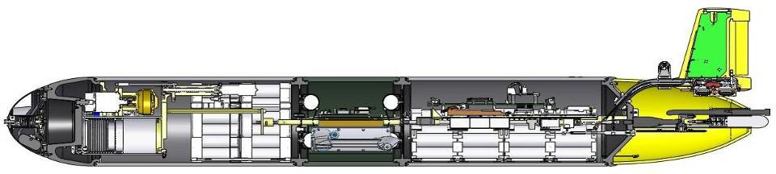

**Figure 1.** A cross section of the Teledyne-Webb Slocum glider, with modular science bay shown in the center section, pump and batteries in the fore section, and batteries and glider computer in the aft section.

* 1. *NEW PROCESSOR CAPABILITIES.* Some attempts have been made to install additional processors by individual user groups. Specifically, a research group at Rutgers developed a new programming architecture and installed two processors, an ARM-based (TS-7800) and an x86- based (TS-5500) Linux board on a G1 glider [*Woithe and Kremer*, 2009]. With this system they were able to perform thermocline tracking with seabird conductivity temperature and depth (CTD) sensors directing glider dive and climb behaviors. However, at the time these processors drew too much power to be feasible for sustained use on deployments of weeks to months. Since this project was carried out over 10 years ago, significant progress has been made in processor technology and embedded system software.

In this project the Persistor CF-1 processor, which has been used in G1, G2, and early G3 gliders will be replaced with a new G3 science CPU, the STM32L4R5 (https://[www.st.com/)](http://www.st.com/)) a processor optimized for ultra-low power. Available resources for the processor are 16 Mbytes RAM (baseline science firmware uses < 1 Mbyte), 120 Mhz single core ARM Cortex-M4 CPU, 2 Gbytes EMMC + up to 32 Gbytes external SD card. The OpenRTOS environment, which allows for embedded applications and languages and full access to hardware. The G3 science bay motherboard is pin compatible with commercially available SOM cards, up to: 2 Gbytes RAM 1.5 GHz quad core ARM Cortex A35 CPU. This processor can maintain equivalent energy use as the Persistor CF-1 processor, yet offers significantly more capability. It allows for the installation of the full Linux or Windows environment and enables development of a wide variety of applications. Furthermore this software environment will enable for code development, testing, and onboard processing that operates in the background from regular glider operations.

* 1. *GLIDERS AND ACOUSTIC CURRENT PROFILERS.* In order to test onboard processing capabilities for new advanced processing capabilities on Slocum gliders, we will focus on calculation of absolute current velocities and velocity shear from integrated ADCP systems. Subsurface currents have been identified as a physical oceanographic essential ocean variable within the GOOS Ocean Observations Panel for Climate. These measurements are critical for understanding the transport of heat, salt, passive tracers, and pollutants in the global oceans. Yet due to the large data sizes and limited measurement platforms subsurface currents are greatly under sampled in real time in the global oceans. By calculating processing subsurface current data onboard and transferring derived products to shore glider-ADCPs will enable scientific discovery, enhance operational awareness, and provide critical data for assimilation into, and validation of, regional and global ocean numerical models.

A number of current profiler systems have been deployed on underwater gliders over the past decade. Early integrated instruments on Spray gliders were the Sontek Argonaut 750 kHz system looking at poleward flows off Southern California [*Todd et al.*, 2011]; Nortek 1 and 2 MHz Aquadopp current profilers externally mounted on Slocum gliders and deployed ahead of Hurricanes [*Miles et al.*, 2017; *Zhang et al.*, 2018], integrated RDI Explorers in the Gulf of Mexico [*Ordonez and Shearman*, 2012], among others. In addition to their physical integration, software for post-processing glider integrated current profilers are well established and have benefitted from many decades of development for ship-based lowered acoustic doppler current profilers (LADCPs). The earliest measurements on profiling rosettes were carried out in 1989 off the coast of Hawaii [*Firing and Gordon*, 1990]. These systems were developed to overcome range limitations of vessel mounted current profilers and sample deep ocean currents. Early processing methods relied on simply averaging vertical shear profiles in overlapping depth bins, and then integrating throughout the water column to obtain absolute velocity. This method is detailed in *Fischer and Visbeck*, 1993 with comparisons with on vessel mounted current profiler, and further reviewed in *Visbeck*, 2002. Essentially, in order to estimate ocean velocities from measured velocities the motion of the package has to first be removed. Typically this has been done by using the ships time-integrated displacement throughout the whole LADCP cast and assuming this velocity is small in-between individual current profiler pings. From *Visbeck*, 2002 this can be represented by the equations:

𝑈"#$% = 𝑈($)"* + 𝑈$,# + 𝑈*(-.) (1)

Where 𝑈"#$% is the measured velocity at each ping, 𝑈$,# is the package velocity due to the ships motion, 𝑈($)"* is the desired absolute ocean velocity, and 𝑈*(-.) is small variations in throughout the cast. 𝑈($)"* can be further separated out into the depth average (barotropic) velocity and depth varying (baroclinic) velocity. Without some constraint, such as the ships motion, bottom track velocities or known surface velocities only the baroclinic portion can be determined, which only depends on the velocity shear. Typically shear velocities can be determined by careful quality control procedures and taking the derivative of each individual collected profile. These overlapping profiles can then be averaged in desired output bins to obtain a full water column shear profile. With a depth averaged velocity constraint from the ships motion, and an assumption of small time integrated noise, shear velocity can then be integrated and used to obtain absolute velocity estimates of the ocean. This method has been used extensively, but has some drawbacks,

including its inability to use additional constraints such as surface or bottom track velocities and limitations if successive velocity bins contain poor data.

An updated method that overcomes these limitations, and the one typically used in glider current profiler applications, is the linear inversion method. Again from *Visbeck*, 2002 the inverse method can be represented by a set of linear equations:

𝑑 = 𝐺𝑚 + 𝑛 (2)

Where 𝑑 is a vector that represents all 𝑈"#$% measured velocities, 𝑛 is noise, 𝑚 is a combined single vector of both the ocean velocity profile and then motion of the CTD, and 𝐺 is a model matrix that relates 𝑚 to 𝑑. Rather than averaging shear data within an individual desired output bin, all quality controlled 𝑈"#$% data are input into 𝑑, and if the sampling strategy is setup carefully the system of equations is formally over determined. In the absence of constraints, the motion of the CTD package can be assumed to be 0, and the solution for mocean is output as the full water column shear, or the baroclinic solution discussed above. Multiple constraints can be added and weighted within this method including ship motions, bottom track measurements, and surface velocities, which each add additional lines the matrix 𝑑.

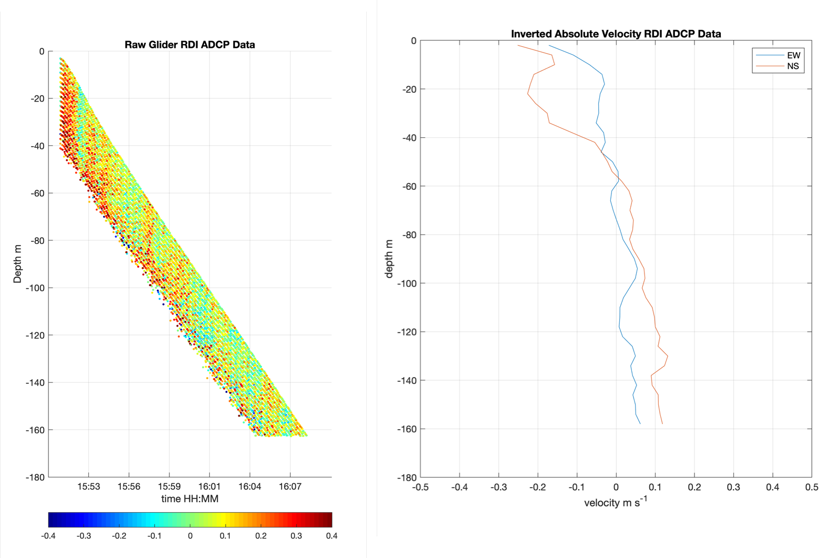

**Figure 2** An example of Slocum glider and TRDI ADCP raw data (left) collected down to 180 meters, and (right) processed data after the velocity inversion and depth averaged constraints were applied.

This method was first adapted for glider platforms in 2011 [*Todd et al.*, 2011] and has since been used in multiple deployments [*Miles et al.*, 2015, 2017; *Todd et al.*, 2017; *Zhang et al.*, 2018] in the deep ocean and on continental shelves. Some adjustments for gliders were made, primarily regarding depth averaged velocity constraints. As gliders lose GPS communications while diving their velocity moving through the ocean is not readily known until a dive is completed. In order to determine the depth averaged velocity constraint, dead reckoning techniques are used to estimate the depth averaged current [*Davis et al.*, 2012]. Glider dead reckoning requires knowledge of the gliders vertical speed through the water, its dive and climb angles, and accurate compass measurements. The gliders vertical velocity is typically determined from measured pressure as it falls through the water column. Accurate compass readings require careful calibration ahead of deployments and de-gaussing of batteries. Actual dive angles are the most difficult to determine as the glider may not be diving perfectly though the water column. Significant effort has gone into

determining angle-of-attack both theoretically based on glider design, as well as experimentally in controlled field experiments. Typically angle-of-attack is less than 3 degrees, and can induce errors of a few cm s-1 in the direction of glider flight if not accounted for.

Currently two current profiling systems are commercially available for Slocum gliders: the 1 MHz four beam broadband Nortek AD2CP, and the 600 kHz four beam phased array Teledyne RDI Explorer Doppler Velocity Log with water profiling mode **(Figure 3)**. Both systems have similar capabilities on glider platforms and planned code development will be easily adaptable between systems. For this project we have opted to use the RDI Explorer. This system has been widely used in both the NSF OOI and Navy fleets of Slocum gliders deployed globally. Advances made in this project have the potential to enhance reprocessing of archived data for both NSF OOI and the Navy and can serve to retrofit those fleets for onboard processing in the future. Additional glider ADCP systems are planned for both the National Academy of Sciences Loop Current Study, a 10 year project to improve prediction of the Loop Current, and the National Aeronautics and Space Agency (NASA) Surface Water and Ocean Topography (SWOT) program, seeking to combine altimeter and *in situ* data to increase resolution of ocean features by a factor of 10.

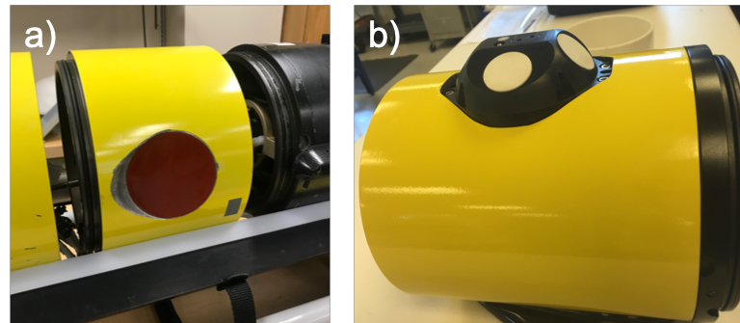

**Figure 3** Commercially available current profilers available for the Teledyne Webb Research Slocum glider a) The Teledyne RDI Explorer phased array DVL and b) the Nortek broadband AD2CP.

The Teledyne RDI Explorer phased array Doppler Velocity log is specifically designed for autonomous underwater vehicle integration. The phased array system allows for installation with no significant external profile that could interfere with vehicle deployment or recovery for standard deployment strategies. It is a 600 kHz system, with a minimum range of 1.33 meters, a maximum range of 35 meters capable of collecting velocity data in cell sizes from 10 to 800 centimeters with a velocity resolution of 0.1 cm s-1. The Explorer has a beam width of 30o for 4 beams that can measure in beam coordinates and can be transformed into east-west, north-south, and vertical velocity through standard transformation procedures. It has an operating range of -5 to 40 oC and up to 1000 meters. An external TRAX Attitude and Heading Reference system (AHRS) is used to increase pitch, heading, and roll measurements to ensure timely and accurate mapping to ADCP pings. The system has an average power while transmitting of 2W, however it has been designed to be off while not actively pinging. The system can ping at up to 12Hz and can be used in burst mode to collect ensembles intermittently. Sampling strategies vary for glider ADCP deployments including continuous sampling at 1 Hz with single pings, or burst sampling every 10 to 30 seconds at much higher sample rates. Both strategies will be explored in an effort to balance data quality, quantity, and power draw throughout the field experiments.

* 1. *DEPLOYMENT STRATEGY.* The Rutgers team will deploy gliders in all three years including one in Year 1, two in Year 2, and 1 in Year 3. These deployments will be carried out south of

Martha’s Vineyard and transit out to the NSF-OOI Pioneer Array. The Pioneer Array currently has 5 upward looking ADCP systems at various depths. This will provide numerous validation and comparison points. This region is also located within the footprint of the Mid Atlantic Regional Association Coastal Ocean Observing System (MARACOOS), which will allow for leveraging of resources for deployment and recovery and enable this project to contribute data to the established regional network of gliders.

TWR will carry out deep water tests in Monterey Bay near the M1 mooring location. The M1 mooring collects subsurface currents from the surface to 500 meters depth and is a regular test site for deep ocean glider technology. The TWR team have personnel and a glider in residence at the Monterey Bay Aquarium Research Institute (MBARI). This unique location has significant resources available for deployment and recovery, and is in very close proximity to deep water allowing for testing of the processing algorithms to depths of up to 1000 meters. Many autonomous underwater glider deployments have been carried out in this region, but most notably the recent a joint project between Rutgers and NASA JPL have performed station keeping missions at the MBARI M1 mooring (**Figure 5**) in support of the NASA SWOT mission [Clark et al., in press]. The MBARI M1 mooring includes a buoy mounted downward looking ADCP system that can be used for glider ADCP validation and algorithim testing. The NASA SWOT glider deployments in this area demonstrated the ability of gliders to hold a <500 meter watch circle, smaller than the moorings watch circle within the area, demonstrating glider capabilities to act as virtual moorings. The demonstration of glider ADCP capabilities within this region will further support NASA SWOT missions and potentially lead to broader use of the technology developed by this NOPP proposal.

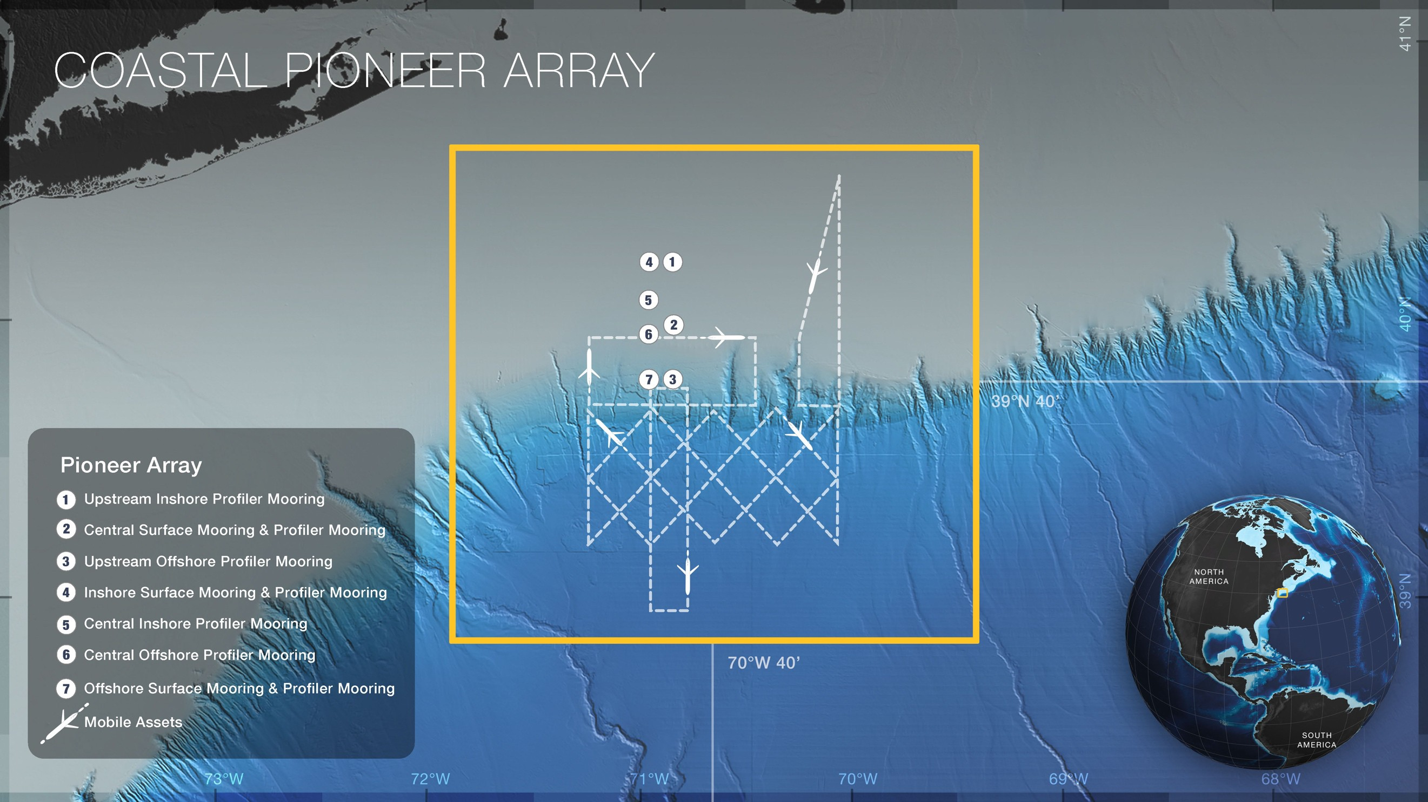

**Figure 4** A schematic of the coastal pioneer array and established associated OOI glider assets. *Credit: Ocean* O.serving

*Initiative.*

Onboard processing at both locations and across years will be carried out with a variety of ADCP setups to assess data quality, computing benchmarks, power consumption needs, and file sizes. Additionally, best practices for data storage and off-loading will be developed, including exploration of ‘in-line’ data that is exported within a standard glider data stream, or ancillary data files that can be downloaded in addition to standard formats.

All gliders will be equipped with newly developed lithium rechargeable batteries, which have an expected endurance of up to 45 days. Pioneer Array deployments will be carried out nearshore and transit out to the mooring locations. This will allow for cross-shelf data collection in shallow and deep water. Transit distances to the Pioneer Array are ~100 km, which will take 5 days at 20 km

day-1 to reach resulting in ~20 days for station keeping. MBARI is in very close proximity to the M1 mooring, so the full 45 day period will be used for station keeping at M1 for each deployment.

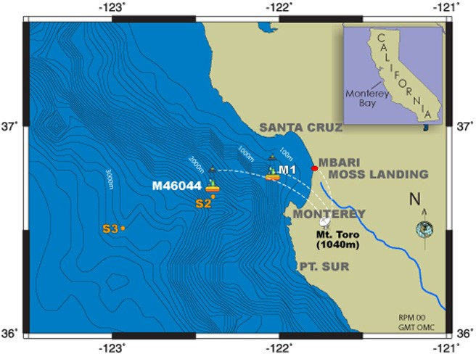

**Figure 5** Map of the Monterey Bay Aquarium Research Institute (MBARI) mooring and met station locations.

1. **ANTICIPATED OUTCOMES AND IMPACTS.** Both the newly updated processor as well as developed onboard processing capabilities for gliders and current profiles will be highly valuable to a broad array of users. Proof of concept for user developed software installed and operating on a Slocum glider will lead to broad development for an array of other sensors and future glider behavior development. If successful, this will enable a new generation of development including multi-sensor derived products, and enhanced onboard decision making. Additionally, the specific development of ADCP onboard processing can directly impact Navy glider operations. The Navy currently owns a large fleet of Slocum gliders, some of which already include Explorer ADCP systems. These developments can immediately improve their ability to achieve their missions. Other large fleets such as those operated by NSF-OOI and future projects with the National Academies Loop Current and the NASA SWOT program will benefit from these developments. Lastly this will have the potential to open up a new dataset for ocean model data assimilation and validation. Real-time subsurface current observations are highly limited globally. Developing real-time processing will allow for operational modeling teams to further constrain and validate their systems leading to enhanced forecast quality and guidance for Navy warfighters and civilians alike.

# MANAGEMENT APPROACH AND TIMELINE.

* 1. **MANAGEMENT APPROACH** Rutgers and TWR have partnered to develop and integrate numerous sensors and processing software over the past two decades. Sponsors include the Navy, EPA, NOAA, NSF, academic partners and many others. They will continue to build off these successes for this project. Two new Pathfinder 600 kHz ADCPs will be provided by TRDI and integrated into Rutgers Slocum gliders along with necessary hardware upgrades. The Rutgers PI, postdoc, graduate student, and staff will perform glider field deployments, post-deployment data analysis, and glider-LADCP code development. TWR will perform the software transition into the Slocum glider for real time shear profile and absolute velocity calculations and perform software benchmark tests prior to the second field deployment. Both Rutgers and TWR will work to develop best practices documentation and workshop training materials.

# Abstract

**Onboard Processing and Transmission of Slocum Glider Acoustic Current Profiler Velocity Profiles**

The goal of this proposed project is to develop enhanced onboard processing capabilities on Slocum gliders. Increasingly complex instruments such as acoustic current profilers, multi- frequency echo sounders, optical laser diffraction sensors, wave accelerometers, passive acoustics, turbulence, and many others have been integrated into autonomous underwater gliders. These and other yet to be integrated sensors offer exciting new opportunities to sense essential ocean variables throughout the world’s oceans and in extreme environments and conditions. However, the large data volumes collected by these instruments cannot be efficiently telemetered to shore. Thus, shoreside processing is not possible until after recovery and their use for real time applications is limited. If vehicles are lost during operations in challenging conditions, or in denied areas, no useful data will be recovered. Some sensors have recently developed self-contained processing schemes on their proprietary systems. While this is a significant advance it does not allow for user software to be developed including the combination of data from multiple sensing systems independent of integrated sensors. Teledyne Webb Research (TWR) is developing an enhanced science processor that will enable onboard data processing and real time transmission of derived data products. *Our research objective is to 1) integrate this enhanced science processor onboard a Teledyne Webb Research Slocum glider, 2) implement real time onboard processing algorithms for integrated acoustic Doppler current profilers (ADCPs), and 3) transfer these derived products to shore in near real time*.