Coupled Atmosphere-Ocean Modeling Framework: WRF and ROMS

Funding Agency: NOAA

Partners: RPS Group

Period of Performance: 10/15/18-10/14/20

Total Budget: $351,218

# Project Summary

Atmospheric and coastal ocean models have improved dramatically in the past decade in the sophistication of environmental processes they simulate, and in their use in conjunction with observing networks. These advances have been facilitated by embracing community open-source modeling frameworks and by introducing advanced data assimilation algorithms, multiple nesting capabilities, new physics parameterizations, and increased horizontal and vertical resolutions. Combining these advances in individual earth system components (i.e. standalone models of the atmosphere, ocean, or wave climate, etc.) by introducing full coupling of fluxes at the air-sea boundary layer is a critical next step to improving forecast skill in both the atmosphere and ocean, and maximizing the value of ocean observing assets – ultimately though simultaneous data assimilation in the fully coupled modeling systems.

The goal of the proposed research is to couple the Weather Research and Forecasting (WRF) model with the Regional Ocean Modeling System (ROMS), including data assimilation, using Earth System Modeling Framework (ESMF) tools on a National Unified Operational Prediction Capability (NUOPC) layer for a regional, coastal application. Specific objectives are:

**(i)** To transition coupling capabilities between WRF and ROMS with ESMF/NUOPC libraries to join other operational NOAA modeling systems. **(ii)** To use the existing Rutgers University Center for Ocean Observing Leadership (RUCOOL) and Mid-Atlantic Regional Association Coastal Ocean Observing System (MARACOOS) atmosphere and ocean grids.

This project benefits operations by Integrated Ocean Observing System (IOOS) Regional Associations (RAs), NOAA labs, state and local agencies, academic research institutions, private industry, and other units that engage in community regional atmospheric and ocean modeling. WRF and ROMS are among the most ubiquitous community atmosphere and ocean models worldwide. Output from these systems is used by numerous organizations to develop information products that inform applications related to storm surge, coastal inundation, flooding, ecosystem modeling, renewable energy development, weather prediction, search-and-rescue, and more.

Project partners are the RUCOOL WRF team, led by co-investigator Joseph Brodie, the MARACOOS ROMS modeling team, led by co-investigator John Wilkin, and the MARACOOS Technical Director Michael Crowley, who is also the Transition Principal Investigator. These team members are co-located at Rutgers University and will work in close collaboration throughout the project. MARACOOS stakeholders, and end users of the data generated by the regional model application, are commercial and recreational fisheries, US Coast Guard (USCG) search and rescue operations, local weather forecast offices, coastal community resilience planners, the offshore wind industry, and local and regional utilities.

# Project Description

## Significance, Goals, and Objectives

Along the U.S. East Coast, and globally, populations are increasingly concentrated along highly developed and urbanized coastlines. These communities are reliant on the coastal ocean in a variety of ways, including food, commerce, energy production, navigation, recreation, and others. This reliance results in their being increasingly vulnerable to coastal hazards such as hurricanes, extratropical cyclones, and associated damages from wind, surge, flooding, inundation, and floatable pollutants. Tropical storms have resulted in higher than 3,400 deaths and $850 billion in economic losses in the US alone since 1980 (<https://www.ncdc.noaa.gov/billions/>). To minimize

the impact of these events, increase maritime safety, and develop resilient renewable power sources for coastal communities, accurate hindcasts, nowcasts, and forecasts of the ocean and atmospheric conditions are necessary.

Atmospheric and coastal ocean modeling system components have improved dramatically in the past decade, mainly when used in conjunction with observing networks. These advances have accelerated under community modeling frameworks (Shchepetkin and McWilliams, 2005; Chen *et al.*, 2007; Warner *et al.*, 2010, Moore *et al.*, 2011a, b) and include advanced data assimilation techniques, multiple nesting capabilities, continually evolving physics parameterizations, and increased horizontal and vertical resolutions leveraging advances in high- performance computing. Combining these advances in coupled atmospheric-ocean modeling systems is a critical next step to improving both atmosphere and ocean forecasts as well as enhancing other integrated model output from waves to sediment and biogeochemistry. Significant progress has been made over the past decade in the standardization of coupling tools without reducing model diversity through the Earth System Modeling Framework (ESMF; Collins *et al.*,

2005) and the National Unified Operational Prediction Capability (NUOPC) consortia. The NUOPC layer on top of ESMF is an agreement between the Department of Commerce (NOAA) and the Department of Defense (Navy, Air Force) to standardize the coupling between Earth System Models (ESM) components under a common framework.

The primary goal of the proposed research is to couple the Weather Research and Forecasting (WRF) model with the Regional Ocean Modeling System (ROMS) using the ESMF/NUOPC library on a regional, coastal application that includes the Mid-Atlantic Bight and the Gulf of Maine. This project is of considerable significance as it benefits operations by the Integrated Ocean Observing System (IOOS) Regional Associations (RAs), NOAA labs, academic research institutions, and private industry.

The specific objectives of this Coastal Ocean Modeling Testbed (COMT) project are:

* 1. To transition coupling capabilities between WRF and ROMS with the ESMF/NUOPC libraries to join other operational NOAA modeling systems.
  2. To use the Rutgers University Center for Ocean Observing Leadership (RUCOOL) and Mid- Atlantic Regional Association Coastal Ocean Observing System (MARACOOS) atmosphere and ocean grids, respectively, to test and evaluate the coupling between WRF and ROMS including ocean data assimilation.
  3. RPS researches will develop cloud computing capabilities for both the Chesapeake Bay Operational Forecasting System (CBOFS) and the ESMF coupler to enable future compilation and execution of this newly developed coupled ROMS-WRF system.

This project exploits the existing and proven capabilities of WRF and ROMS. Both models have been used extensively by the scientific and operational communities. Previously, coupling applications between WRF and ROMS used the Model Coupling Toolkit (MCT; Larson *et al.*,

2005) library (*e.g.* Warner *et al.*, 2010; Nelson and He, 2012; Olabarrieta *et al.*, 2012; Zambon *et al.*, 2014) and the Ocean-Atmosphere-Sea-Ice-Soil (OASIS) library (Renault *et al.*, 2016). Thus, we expect the coupling of WRF/ROMS with the ESMF/NUOPC library will transition from a NOAA Readiness Level (RL) of 4 to 6. The coupling tools have been tested and used for each component model representing an RL of 4, and we expect to perform initial testing of coupled simulations within the MARACOOS operational environment resulting in a final RL of 6. Further, these developed coupling modeling capabilities will be incorporated into the official version of ROMS ([www.myroms.org](http://www.myroms.org/)) and be available for distribution to all its user groups globally, but

especially within IOOS RA coastal modeling groups where ROMS and WRF are already in widespread but *uncoupled* usage.

## Background

The coupling of atmosphere and ocean plays an essential role in the Earth climate and the long- and short-term predictability of both systems. Typical uncoupled ocean modeling systems utilize atmospheric model data snapshots from files at coarser temporal and spatial resolutions and interpolate the forcing fields at each time-step to drive circulation forward. Similarly, some atmospheric modeling systems have simplistic representations of oceanic and air-sea transfer processes. They may use a static sea surface temperature field derived from satellite imagery composited over days to weeks, or one-dimensional ocean mixing models that do not represent three-dimensional baroclinic circulation on continental shelves. This method performs well in regions where the ocean evolves slowly relative to the atmosphere and where the sea state has limited impact on the atmospheric state. However, in coastal areas, the ocean can respond to the atmosphere rapidly and is highly variable over short spatial scales. In these cases, significant feedbacks between the ocean and atmosphere occur regularly (Olabarrieta *et al.*, 2012; Glenn *et*

*al.*, 2016; Seroka *et al*., 2016, 2017; Chambers *et al.*, 2014). The air-sea coupling capabilities have been highlighted as a priority for the next decade by the IOOS Modeling Task Team (Wilkin *et al.*, 2017). Furthermore, WRF and ROMS are cited by the NOAA Unified Modeling Overview (<ftp://ftp.library.noaa.gov/noaa_documents.lib/NOAA_UMTF/UMTF_overview_2017.pdf)> as

leading examples of models that have evolved into a community modeling framework.

### Regional Ocean Modeling System (ROMS)

ROMS is a modern, open-source, terrain-following, primitive equation model used by both the scientific and operational communities over a wide range of spatial (coastal to basin) and temporal (days to seasons, years to decades) scales. It solves the Reynolds-averaged Navier-Stokes equations using the hydrostatic vertical momentum balance and Boussinesq approximation (Haidvogel *et al.*, 2000; Shchepetkin and McWilliams, 2005). ROMS is unique in that it is the only community framework including the adjoint-based analysis and prediction tools that are available in Numerical Weather Prediction (NWP), such as 4-dimensional variational data assimilation (4D-Var), ensemble prediction, observational sensitivity and impact, adaptive sampling, and circulation stability and sensitivity analysis. The major strengths of ROMS are its progressive evolution and improvement, its extensive algorithms and options to explore diverse ocean modeling applications, and its vibrant and active user community. The success of ROMS can be measured by the thousands of users worldwide, the hundreds of peer-reviewed articles in scientific journals and books, and the research work of numerous Ph.D. students and post-doctoral fellows. It is freely distributed using Subversion (*svn*) revision control software to users worldwide under conditions similar to the MIT/X License ([www.myroms.org/license).](http://www.myroms.org/license))

The coupling between multi-models in ROMS is either direct or indirect. In direct coupling, the coupled models exchange data at specified time intervals. The ESM components are

executed sequentially or concurrently by the coupler communication software. The coupling library is either the Model Coupling Toolkit (MCT; Larson *et al.*, 2005) or the ESMF library (Collins *et al.*, 2005) with the NUOPC layer (version 7 or higher). Contrarily, in indirect coupling, the exchange of data between model is via input NetCDF files. The coupling fields are spatially and temporally interpolated between available snapshots.

### Weather Research and Forecasting (WRF)

The WRF model is a state-of-the-art, community numerical weather prediction model maintained by the National Center for Atmospheric Research (NCAR). It is fully adaptable to study phenomenon over local to global scales (Skamarock *et al.*, 2008). The dynamical core consists of a suite of fully compressible non-hydrostatic equations, with a hydrostatic option, along with a wide array of updating physics options. The model allows for several nested grids, with both one- way and two-way nesting options. The flexibility and reliability of WRF have resulted in it being widely used in both research and operational settings throughout the world, by academic institutions, government laboratories, and in the private sector.

### Model Coupling Interface

Several coupling interfaces exist to exchange data between ESM components including the ESMF (Collins et al., 2005), MCT (Larson et al., 2005), and OASIS (Vlacke, 2013) libraries. All three coupling libraries have been used for coupling ROMS with an atmosphere model (e.g., Turuncoglu and Sannino, 2017, Warner *et al.*, 2010, Renault *et al.*, 2016, respectively). In this project, we propose to couple WRF and ROMS with the ESMF library with the NUOPC layer.

The NUOPC Layer is a simplified infrastructure on top of the ESMF library (version 7 or higher) that provides conventions and templates to facilitate the smooth coupling between ESM components. The ROMS coupling interface with the ESMF/NUOPC library allows both *driver*

and *component* methods of operation. In the *driver* method, it provides all the interfaces needed to couple to other ESM components including the executable driver, NUOPC-based generic ESM component services, model gridded components or NUOPC Model *cap* files, connectors between components for re-gridding source and destination fields, input scripts, and coupling metadata management. A NUOPC Model *cap* is a Fortran code layer that sits on top of the ESM component, making calls to the numerical kernel via the *initialize, run*, and *finalize* phases. Alternatively, in the *component* method, the NUOPC ROMS *cap* module is provided, and it can be adapted and incorporated into other NUOPC-based coupling systems, like the NOAA Environmental Modeling System (NEMS).

A prototype of the ROMS coupling framework based on the ESMF/NUOPC library is illustrated in Figure 1 showing the Driver, Models, and Connectors. The Driver controls all the aspects of the coupling between the ESM components and their connections: configuration, initialization, time-stepping sequence, data exchanges, and termination. The Models are the gridded data and gridded geophysical numerical kernels wrapped into a NUOPC cap file interface. The Connectors between ESM components execute the remapping and regridding between the source and destination fields. The interpolation is usually linear with extrapolation support in the vicinity of masked grid cells. In this project, the coupling framework will include the Atmosphere Model (WRF), the Ocean Model (ROMS), and the Data Model since the grids are incongruent. The Data Model is needed because WRF requires sea surface temperature (SST) on those grid points not covered by ROMS (see Figure 3).

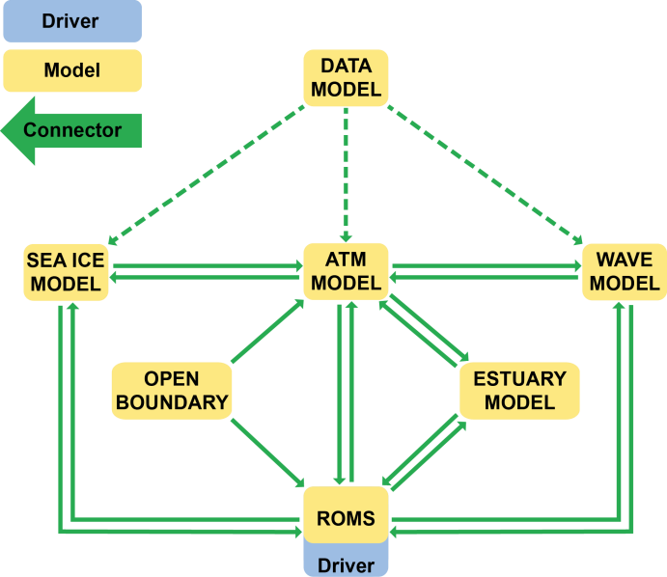

**Figure 1:** ROMS native ESMF/NUOPC coupling framework showing the Driver, the Model components, and the Connectors. The system includes seven gridded components: Ocean Model (ROMS), Atmosphere Model, Sea Ice Model, Wave Model, Data Model, Open Boundary Model, and Estuary Model. The Connectors show the direction of interaction between components.

### ROMS Data Assimilation: Split 4D-Var

The ROMS 4D-Var data assimilation (Moore *et al.*, 2011a, b) is now widely used both nationally and internationally. Several IOOS RAs currently use ROMS 4D-Var for their near real-time and analysis systems. Recently, NOAA adopted ROMS 4D-Var for the West Coast Ocean Forecasting System (WCOFS). Simultaneous assimilation of ocean and atmosphere observations in a fully coupled Atmosphere-Ocean model is an area of active research that does not yet meet readiness levels appropriate to this proposal. In the meantime, we propose to evaluate Split 4D-Var (S4D- Var) data assimilation in the WRF/ROMS coupled system. The 4D-Var driver is divided into two executables to separate the computation of the nonlinear trajectory from the iterative minimization algorithm running the inner loops (Figure 2). The strategy is to have two different executables (**A** and **B**) that run in a shell script. Executable **A** computes the nonlinear (NLROMS) trajectory used to minimize the tangent linear (TLROMS) and the adjoint model (ADROMS) used in executable **B,** the inner loops minimization algorithm. This allows the ROMS nonlinear model trajectory to

be part of a coupling system (like WRF/ROMS) and or include nested grids. It will also enable running the inner iterations at a different resolution. It is common in NWP operational applications of 4D-Var to use a different model resolution between inner and outer loops for efficiency. Typically, the full resolution forecast model is employed during outer-loops, while a lower resolution version of the model (often with simplified physics) is used during the inner-loops. A similar approach (see ECMWF, 2017) is run operationally at European Centre for Medium-Range Weather Forecast's Integrated Forecasting System (ECMWF's IFS).

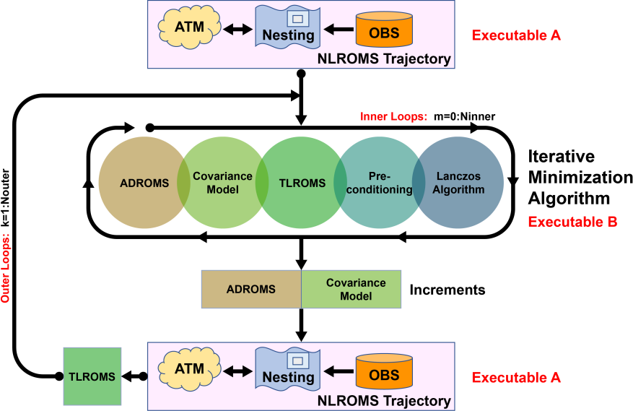

**Figure 2:** ROMS W4D-PSAS data assimilation algorithm split into two different executables to allow the nonlinear (NLROMS) trajectory to be part of a coupling system and have nested grids.

### WRF-ROMS Application: RUCOOL and MARACOOS Grids

The WRF-ROMS coupling will undergo initial testing evaluated over the Mid Atlantic Bight (MAB) using the RUCOOL and MARACOOS atmosphere and ocean grids, respectively, shown in Figure 3. The operational WRF RUCOOL domain (grid-**a**) runs daily for the MAB meteorological 5-day forecasts. It has a resolution of about 9 km, and an additional two smaller nested grids at 3 km and 1 km (not shown). WRF uses model data from NOAA’s operational Global Forecast System (GFS) to provide initial and lateral boundary conditions. The surface

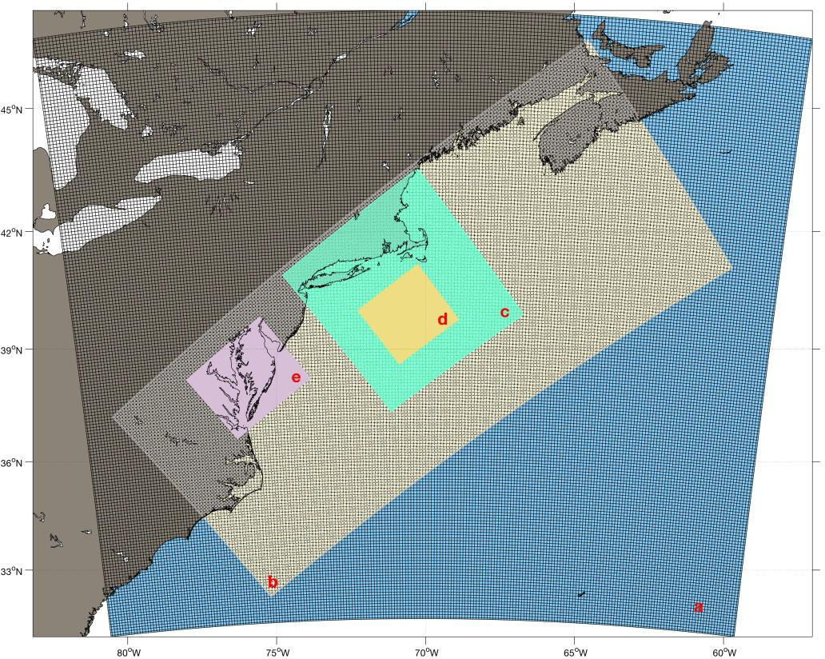boundary condition over the ocean is from composite SST. The MARACOOS grid (Figure 2, **b**) at ~7 km resolution, is being used to study circulation and cross-frontal exchange processes between the MAB continental shelf and the deep ocean. It is used for daily forecasting and ocean 4D-Var analysis and reanalysis. Also, it is our primary tool for evaluating grid nesting and nested 4D-Var. The telescoping refinement grids (**c** and **d**) inside MARACOOS further resolve the shelfbreak front in the vicinity of the Ocean Observatory Initiative (OOI) Pioneer Coastal Array. The finer resolution solutions are used to evaluate the 4D-Var observations impacts and sensitivities of the Pioneer array observing system. Currently, the regular lateral open boundary conditions are extracted from Mercator ocean analysis and forecast (www.mercator-ocean.fr).

**Figure 3:** Coupled Mid-Atlantic Bight application grids: **a**) WRF RUCOOL ~9km grid, **b**) ROMS MARACOOS ~7 km coarser grid, **c**) PIONEER ~2.3 km refined grid, **d**) ARRAY ~800 m refined grid and **e**) Chesapeake-Delaware Bay Estuaries ~1.4 km refined grid.

## Audience

Many IOOS RAs have regional stakeholders that focus on maritime safety, environmental decision support, water quality, coastal inundation, and offshore wind. Coupled ocean-atmosphere model solutions will enhance the quality of products across these and other groups. However, few IOOS RAs currently operate a coupled ocean-atmosphere forecast system. User groups that we will work with on this project are the broad ROMS user community through distribution of coupling modeling tools, and the RUCOOL WRF and MARACOOS ROMS operators for initial implementation of the coupled framework. Both RUCOOL and MARACOOS teams have stakeholders that include the hurricane research and forecasting community, US Coast Guard, the companies and state agencies developing and creating the policy for offshore wind and wave energy in the Mid-Atlantic, among many others.

Both WRF and ROMS are used by research and operational and groups globally. NOAA National Ocean Service (NOS) operates ROMS domains, and 8 out of the 11 IOOS RAs currently run at least one ROMS grid in their application. Internationally, ROMS modeling systems are used operationally across a range of ocean and atmospheric forecasting agencies and organizations. Many of these user groups employ the data assimilation capabilities included with ROMS. The ROMS trunk *svn* source code will be updated to include the necessary modifications for the ESMF/NUOPC coupling framework and will be distributed to the ocean community. Co- Investigator Arango, who will be tasked with developing the ESMF/NUOPC coupling algorithms, also manages the community ROMS version and the myroms.org User Portal hosted at Rutgers University. These tools will be released to the ocean modeling community after testing is completed. Training will be carried out at the annual ROMS Workshop and via ongoing annual visits to NOAA NOS by co-investigators Arango and Wilkin.

## Approach

This project will be carried out over two years, with specific tasks designated in each year of the project.

### Work Plan

**Task 1 (Year 1): Develop ESMF/NUOPC coupling capabilities for WRF/ROMS with 4D-Var ocean data assimilation.** Co-Investigator Arango will develop ESMF/NUOPC cap files that enable coupling between WRF and ROMS. These cap files will include coupling of the Data Model for regions where model grids are incongruent. They will also preserve ROMS multi- nesting capabilities and include capabilities for split 4D-Var ocean data assimilation. This task will address both project objectives (i) and (ii). This task will move WRF/ROMS coupling capabilities from NOAA RL 4 to 5.

**Task 2 (Year 1): Use ESMF/NUOPC coupling capabilities to couple WRF and ROMS over the Mid-Atlantic Bight and the Gulf of Maine.** COMT project co-investigators Levin and Brodie will combine the existing, un-coupled, operational MARACOOS ROMS and RUCOOL WRF model grids (Figure 3) into a single coupled modeling system. The MARACOOS ROMS model already includes 4D-Var ocean data assimilation capabilities, and the RUCOOL WRF grid was designed to cover the ROMS spatial footprint and forecast duration. Additionally, RUCOOL WRF model output has been used as forcing for MARACOOS ROMS in research simulations of Hurricane Irene (Glenn et al., 2016, Seroka et al., 2017) and Sandy (Miles et al., 2017). Validation and assimilation datasets are housed locally at Rutgers and will be easily accessible for coupled ocean data assimilation and evaluation.

**Task 3 (Year 2): Test and evaluate a coupled WRF/ROMS model simulation for Hurricane Irene (2011).** Scientific PI Miles and co-investigator Brodie will perform a coupled

model simulation of the ocean and atmosphere during Hurricane Irene. This application represents a model use case where ocean and atmosphere feedbacks rapidly de-intensified a storm just before landfall (Glenn et al., 2016). This test case has been studied thoroughly by COMT project team members with both MARACOOS ROMS and RUCOOL WRF un-coupled simulations. Additionally, a Slocum ocean glider and additional MARACOOS observing assets were deployed throughout the storm that can be used for evaluation of model performance. Simulations will be compared with previous un-coupled WRF/ROMS model simulations. Completion of this task will move WRF/ROMS coupling capabilities from NOAA RL 5 to 6.

**Task 4 (Year 1 and 2)**: RPS researches will develop cloud computing capabilities for both the Chesapeake Bay Operational Forecasting System (CBOFS) and the ESMF coupler to enable future compilation and execution of this newly developed coupled ROMS-WRF system. This work will include:

1. Deploy CBOFS in the cloud for regional modelers to experiment with Currently posted NOS/NCEP supported CBOFS model (ROMS) source code ([http://www.nco.ncep.noaa.gov/pmb/codes/nwprod](https://na01.safelinks.protection.outlook.com/?url=http%3A%2F%2Fwww.nco.ncep.noaa.gov%2Fpmb%2Fcodes%2Fnwprod&data=02%7C01%7Ctnmiles%40marine.rutgers.edu%7C987c3ffd74e748a8533708d5fe282f94%7Cb92d2b234d35447093ff69aca6632ffe%7C1%7C0%7C636694370916554261&sdata=kF7W3UzPiDyBHD02ThQRBjBka%2BHpqrera2rHpGzjSUc%3D&reserved=0)) will be used to create a cloud-based, on-

demand execution environment for researchers to collaborate with NOS and NCEP operations. The NOS/NCEP build, deploy and execution patterns will be used to mimic as closely as possible, the NOS/NCEP process with updated ROMS code provided by researchers. Deliverables will be the cloud-oriented build scripts matching the existing NOS/NCEP process alongside above source code and a list of alternatives that were needed (for example, noting the WCOSS compiler is not available in cloud and gcc/gfortran has been used). Table of cost estimates for each CBOFS execution will be built providing resource planning capacity.

1. Deploy NUOPC/ESMF for ROMS in the cloud to help Rutgers team transition to cloud-based infrastructure solution. The current coupled WRF-ROMS-SWAN stack in use by existing cloud collaborators (NCSU) uses the Model Coupling Toolkit (MCT) vs. the ESMF framework that is the basis for the NEMS/NUOPC implementation at NCEP. The capability to compile ROMS against ESMF instead of MCT will be built. The core ESMF library will be integrated into the cloud execution environment, giving Rutgers ROMS developers the ability to test ESMF couplers with WRF atmospheric model. Following implementation, an extended environment implementing the NUOPC conventions and templates will be created. Successful tests against the ESMF only environment can then be executed with the NUOPC constraints, giving researchers and NOS/NCEP teams the ability to explore the deficiencies/challenges of transition to NUOPC standards.

### End User Engagement

The end users of the coupled modeling system comprise the full ROMS user community, the RUCOOL WRF model operators, and the MARACOOS ROMS model operators, and their stakeholders. Both RUCOOL WRF and MARACOOS ROMS team operators are included as co- investigators and PIs on this proposal and share computing resources and environments on a regular basis. Monthly model coupling meetings throughout the project and, as needed, communication will be facilitated by the Transition PI to ensure the progress by each group is as seamless as possible. Engagement with the full ROMS user community will be carried out at the annual ROMS workshops including demonstration of coupling capabilities and presentation of model simulation results.

### Data Management Plan

Transition Principal Investigator Michael Crowley will serve as the Data Point of Contact on this project. Both model coupling tools and environmental data and information from coupled ocean- atmosphere numerical model simulations will be made available following NOAA’s data sharing policies and in close collaboration with the IOOS DMAC Group and COMT Cyberinfrastructure (CI) team. We will leverage our extensive experience providing data through MARACOOS to ensure datasets meet COMT CI requirements.

WRF-ROMS ESMF/NUOPC coupling capabilities will be distributed through the official version of ROMS from [http://www.myroms.org](http://www.myroms.org/). The algorithms developed during this project are

open-source and available, when tested and validated, to the scientific and operational ocean modeling communities. The codes are managed via a website, based on *Trac* software, which keeps a record of each change made to the ROMS algorithms including bug tracking, updates, and new developments. We will add web-based documentation and tutorials in wikiROMS ([www.myroms.org/wiki](https://www.myroms.org/wiki/Documentation_Portal)) to facilitate a better understanding of ROMS coupling capabilities with

the ESMF/NUOPC library. Output from the coupled WRF-ROMS solutions will be available on our OPeNDAP servers for easy, open access and uploaded following COMT CI and IOOS DMAC procedures. This will include model initialization (data to be available at the end of Year 1) and output files for the simulation of Hurricane Irene in 2011 (data to be available at the end of Year 2). WRF and ROMS data adhere to the metadata standards for Climate & Forecast (CF) compliance and Unidata’s Attribute Convention for Data Discovery (ACDD). Further details can be found in the Data Sharing Plan Addendum or in **Appendix 9.3**.

## Benefits

Enabling atmosphere and ocean model coupling with ocean data assimilation will benefit a large and diverse group of model users, and local, regional, and global stakeholders who create valuable information products based on openly and readily accessible outputs from comprehensive, high resolution models. At the federal level, these include IOOS RAs, NOS, NMFS, NWS, NASA, DOD, DOE, and other units that engage in community regional atmospheric and ocean modeling and model analysis. These groups are committed to the use and on-going integration of modeling systems employing the ESMF/NUOPC layer. Applications include storm surge, coastal inundation, flooding, ecosystem forecasting, renewable energies, weather prediction, search-and- rescue, among many others. Additionally, WRF and ROMS are among the most ubiquitous community atmosphere and ocean models used by academic institutions and maritime industries worldwide. Many user groups have augmented their ROMS systems with locally applicable biogeochemical and ecosystem prediction models. A significant benefit to these groups is that the NUOPC coupling design will not disrupt these added capabilities, and it is likely that coupled ocean-atmosphere models will improve simulation of biogeochemically relevant processes at the air-sea interface.

Specifically, for the MARACOOS regional atmosphere and ocean modeling operators, local stakeholders include commercial and recreational fisheries, US Coast Guard (USCG) search and rescue operations, coastal community resilience, the offshore wind industry, and local and regional utility operators. In 2017, the MARACOOS ROMS model was the third most ordered datasets from the Environmental Data Server (EDS), with the first and second being two global modeling systems operated by NWS and NCEP. Improvements to ocean prediction capabilities within MARACOOS through atmosphere-ocean coupling will positively impact this large user

base, and the project will conclude with the release of community tools and tutorials for data assimilative coupled modeling ready for adoption by IOOS RAs and their partners. Experience shows that more skillful coastal weather and marine forecasts will benefit energy ratepayers throughout the Mid-Atlantic and Northeast regions. For example, the RUCOOL WRF model has been used to simulate the offshore wind resource for the New Jersey Board of Public Utilities (NJ BPU) since 2011, with these data being used for economic and health impact analyses for the roughly 3500 MW Ocean Wind lease areas off the coast of New Jersey. Additionally, a new DOE consortium is currently being developed that includes offshore wind prediction as a significant priority. The development of coupled atmosphere and ocean modeling capabilities with data assimilation over these wind energy sites will enable the RUCOOL WRF team to resolve the local renewable energy resource better and engage with state agencies to benefit ratepayers for years to come.

Both MARACOOS ROMS and RUCOOL WRF model operators are included as co- investigators on this project. Furthermore, the Transition Principal Investigator Michael Crowley is also the MARACOOS Technical Director. Including these operators as team members throughout the project will ensure that information on the use of new model coupling tools and sharing of validation and evaluation activities will be coordinated throughout the entirety of the project. Monthly coupled modeling meetings coordinated by the Transition PI will ensure close collaboration within the group. Bi-weekly MARACOOS operations calls will also serve to share internal progress across many regional partners. Additionally, the RUCOOL WRF team holds monthly meetings with the NJ BPU, where development progress and operational testing results can be shared alongside uncoupled modeling results. This relationship with NJ BPU will also serve as a forum to work toward transitioning the new MARACOOS coupled modeling system to

operational near-real-time use. The ROMS group has an established process for liaison with NOS that migrates new ROMS capabilities into NCEP operational Coastal Ocean Forecast systems.

## Milestone Schedule

The project objectives, tasks, and timelines are organized in priority order and with increasing complexity. In addition to the Milestone Schedule below (Table 1), our COMT project team is committed to attending and collaborating at annual IOOS COMT meetings, training users in model coupling tools at annual ROMS Workshops and establish NOS meetings, and sharing results at scientific conferences.

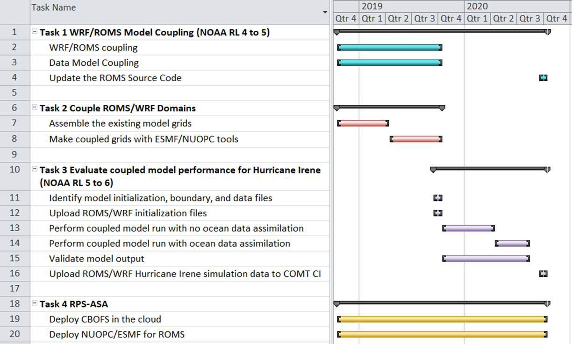

**Table 1:** The project Milestone Schedule is organized in order of Task Priority and with increasing complexity.

## Project Budget

Our total project budget is $351,218. Year 1 includes Task 1,2 and a portion of Task 4 at $184,544. Year 2 includes Task 3 and the remainder of Task 4 at $166,674. Additional detailed budget information is contained in **Appendix 9.4**.