# Optimizing Ocean Acidification Observations for Model Parameterization in a Coupled Slope Water System of the US Northeast Large Marine Ecosystem

Funding Agency: NOAA OAR

Partners: Stony Brook University, University of New Hampshire, University of Maine, MARACOOS, MERACOOS

Period of Performance:

Total Budget: $1,499,896 (+10% IOOS Supplemental)

Project Summary:

Ocean acidification (OA) has significant societal ramifications that range from economic losses due to the decreased survival of commercially important organisms to the ecological consequences associated with altered ecosystems (Cooley et al., 2009; Doney, 2010; Hare et al. 2016). Temperate marine ecosystems such as the U.S. Northeast Shelf (NES) that are influenced by extreme seasonality and high riverine and/or eutrophication are particularly susceptible to negative impacts of ocean and coastal acidification (Salisbury et al., 2008; Cai et al., 2011).

These systems are also highly productive and support our most valuable fisheries. Yet few time series of sufficient spatial and temporal resolution exist to observe or model the existence, persistence and movement of low pH and carbonate saturation state (Ω) water – information that is necessary to assess the impacts of OA on marine populations and ecosystems. The goal of this project is to strengthen the regional OA observation system from the Gulf of Maine (GoM) to the Mid-Atlantic Bight (MAB) using a combination of new technologies, existing data, and modeling to optimize an efficient and effective network and ultimately develop a mechanistic understanding of the physical and biological drivers of carbonate chemistry dynamics in the productive, strongly seasonal temperate U.S. NES.

All carbonate chemistry efforts have tradeoffs in spatial and temporal coverage. Surface buoys or bottom-mounted instruments can measure pH or *p*CO2 continuously, but in a fixed location while shipboard flow through systems cover a wide area, but only sample surface waters. Water column measurements are limited to large field campaigns that occur infrequently. Only a fraction of these efforts include the U.S. continental shelves (e.g., Gulf of Mexico Ecosystems and Carbon Cycle Cruises [GOMECC], East Coast OA [ECOA] cruises) (Jiang et al., 2008; Wang et al., 2013; Wanninkhof et al., 2015; Wang et al., 2017), where commercially important finfish, lobster, and wild stocks of shellfish are present (Hales et al., 2005; Feely et al., 2008; Vandemark et al., 2011; Xue et al., 2016; Salisbury and Jönsson, 2018; Goldsmith et al., *in revision*). Furthermore, few monitoring efforts presently combine frequent monitoring with multiple parameters needed for full characterization of the carbonate system. Thus, the three critical needs in optimizing a regional OA observation network are: 1) to deploy new, cost- effective technologies that can routinely provide high resolution full water column OA data on regional scales in our coastal ocean, 2) leverage existing target assets for expanded OA sampling, and 3) make data easily accessible by both the user community and modelers. These enhancements are necessary for improving biogeochemical (BGC) model parameterizations, evaluating modeling output and predictions on regional scales, and informing future observing system strategies.

The U.S. NES Large Marine Ecosystem (LME) is one of the nation’s most economically valuable coastal fishing regions (NMFS, 2017). As for most shelf-sea systems, the existing NES observational network does not sample at the time, space, and depth scales needed to capture the physical, biological, and chemical processes occurring in this dynamic region. Specific to inorganic carbon and OA, these data have yet to be fully applied to better understand and model seasonal-scale, spatial-scale, and subsurface carbonate chemistry dynamics, variability, and drivers in the NES. In this collaborative project, we propose to add novel high-resolution glider- based OA observations, enhance existing regional OA sampling in several key locations, improve compilation and integration of regional OA-relevant data, and apply these data to an existing NES ocean ecosystem/BGC model that resolves carbonate chemistry and its variability.

# Background

*Ocean and Coastal Acidification*: Due to human activities, atmospheric carbon dioxide (CO2) has increased from preindustrial levels of 280 ppmv (parts per million volume) to current levels over 400 ppmv. Nearly one third of emitted anthropogenic CO2 is absorbed by the oceans (Sabine et al., 2004; Sabine and Feely, 2007), resulting in complex alterations of carbonate chemistry collectively termed OA. Current CO2 concentrations are projected to double by the end of the 21st century (Houghton et al., 1996; Solomon et al., 2007), a rate unprecedented in at least the last 300 million years (Hönisch et al., 2012). In addition, coastal regions such as the NES are prone to coastal acidification: high variability and extremes in high CO2/low pH due to a combination of local natural and anthropogenic biogeochemical and physical processes including land use, stormwater runoff, and eutrophication (Chen et al., 2012; Wallace et al., 2014; Baumann and Smith, 2018). Projected decreases in pH associated with acidification are expected to depress aragonite saturation state, ΩArag, a measure and proxy for calcifying conditions, and challenge the ability of calcifying organisms to deposit shell (e.g., Barton et al. 2015). OA has also been observed to affect hatching success, larval development, metabolic processes, organ development, acid-base regulation, and olfaction in numerous calcifying and non-calcifying organisms (reviewed for Mid-Atlantic species in Saba et al., *in revision*; Fabry et al., 2008; Doney et al., 2009; Kroeker et al., 2010, 2013; Waldbusser et al., 2014). As such, there is a critical need to monitor and study carbonate chemistry dynamics in our coastal oceans.

While OA monitoring efforts are expanding nationally, there is still a clear need to determine the temporal and spatial sampling scales that are most relevant within each U.S. large marine ecosystem, the NES being no exception (Goldsmith et al., *in revision*).

*Project Location:* This project is focused on the U.S. NES extending from the GoM south to Cape Hatteras, North Carolina. The NES is one of the most productive LMEs in the world (O’ Reilly and Zetlin, 1998; Sherman et al., 2002; NMFS, 2017; Stock et al., 2017) and supports diverse and abundant finfish, lobster, and shellfisheries (Gates, 2009; Sherman et al. 1996), with ex-vessel landings of nearly $US 2 Billion y-1 that represent nearly 40% all US landings (NMFS, 2017). Bottom waters of the NES are influenced from the south by warm slope water emanating from the Gulf Stream and Slope Sea, and colder, fresher inflows from Canadian coastal waters to the north. The relative strength of these influences control temperature and salinity entering the GoM, and crossing the shelf-break front to impact the MAB shelf and slope (Nye et al., 2010). In the GoM, the Northeast Channel is a significant control point where the partitioning of influences from the Scotian Shelf and adjacent deeper waters affect physics and the regional ecosystem (Townsend et al., 2006; Green and Pershing, 2003; Mountain, 2012; Green et al., 2013). The MAB has a broad shelf (~100 km in width). While this somewhat insulates the coastal MAB from immediate deep-sea drivers of circulation, it increases the relative influence of inflows from it estuaries. The MAB and GoM are separated by the highly productive Georges Bank, which is supplied by nutrients brought onto the Bank by tidal pumping on the northern flank (Franks and Chen, 1996; Townsend et al., 2014). MAB waters undergo considerable seasonal and interannual variability in temperature and salinity (Mountain and Taylor, 1998; Zhang et al., 2013). In late spring/early summer, waters ventilated by strong winter-time air-sea exchange on Georges Bank and the Nantucket Shoals become isolated from the surface by the onset of a strong thermocline across the entire shelf. This establishes a subsurface mid-shelf “Cold Pool” of water extending southward from the Nantucket Shoals much of the way to Cape Hatteras (Houghton et al., 1982). The seasonal persistence of Cold Pool bottom temperatures as low as 8o C have been linked to the distribution and recruitment of commercially important fin

and shellfish species (Goldberg and Walker, 1990; Steves et al., 2000; Sullivan et al., 2000; Sullivan et al., 2005; Weinberg, 2005). Further inshore, upwelling during spring-summer is associated with high primary productivity and fishing activity (Church et al., 1994; Wood et al., 1996), but also low dissolved oxygen (DO) in bottom waters (Schofield et al., 2012).

*State of Acidification in U.S. NES*: Existing OA surveys reveal large natural seasonal and spatial variability and possible decadal changes of surface carbonate chemistry (Boehme et al., 1998; Wang et al., 2013, 2017; Wanninkhof et al., 2015; Xu et al., 2017). The underlying mechanisms causing this variability likely include a combination of biological processes, episodic upwelling, water mass intrusion, physical mixing, and air-sea gas exchange. On the MAB shelf, regional *p*CO2 algorithms based on modeled and satellite data (Signorini et al., 2013) and measured *p*CO2 (Boehme et al., 1998) show lowest surface values during the winter- spring transition and highest values during the summer-fall transition. Furthermore, high short- term (~10 days) and interannual variability in surface ΩArag occurred in the central MAB, and the drivers of this variability differ spatially (Xu et al., 2017) from biological activity (respiration and photosynthesis) in shelf waters and physical advection and mixing in slope waters (Xu et al., 2017). Local ΩArag is highly dependent on source waters, with higher ΩArag in well buffered Gulf Stream water and lower in the north in the less buffered Labrador Sea slope water (Wanninkhof et al., 2015; Fig. 1) and the GoM (Wang et al., 2013; Salisbury and Jönsson, 2018). Thus, processes impacting the relative proportions or

rate of supply of these different source waters to the coast likely drives large-scale variability in carbonate chemistry in bottom waters of the NES. *The weakly buffered source waters and northern region of the NES are expected to have greater susceptibility to ongoing OA* (Wang et al., 2013; Wanninkhof et al., 2015; Fig. 1), *and deserve focus in any monitoring program*. NES surface water *p*CO2 is currently increasing at rates of 1.93 ± 1.59 µatm yr-1 (Wang et al., 2017), similar to the rate in the open ocean (Bates et al., 2014; Kitidis et al., 2016).

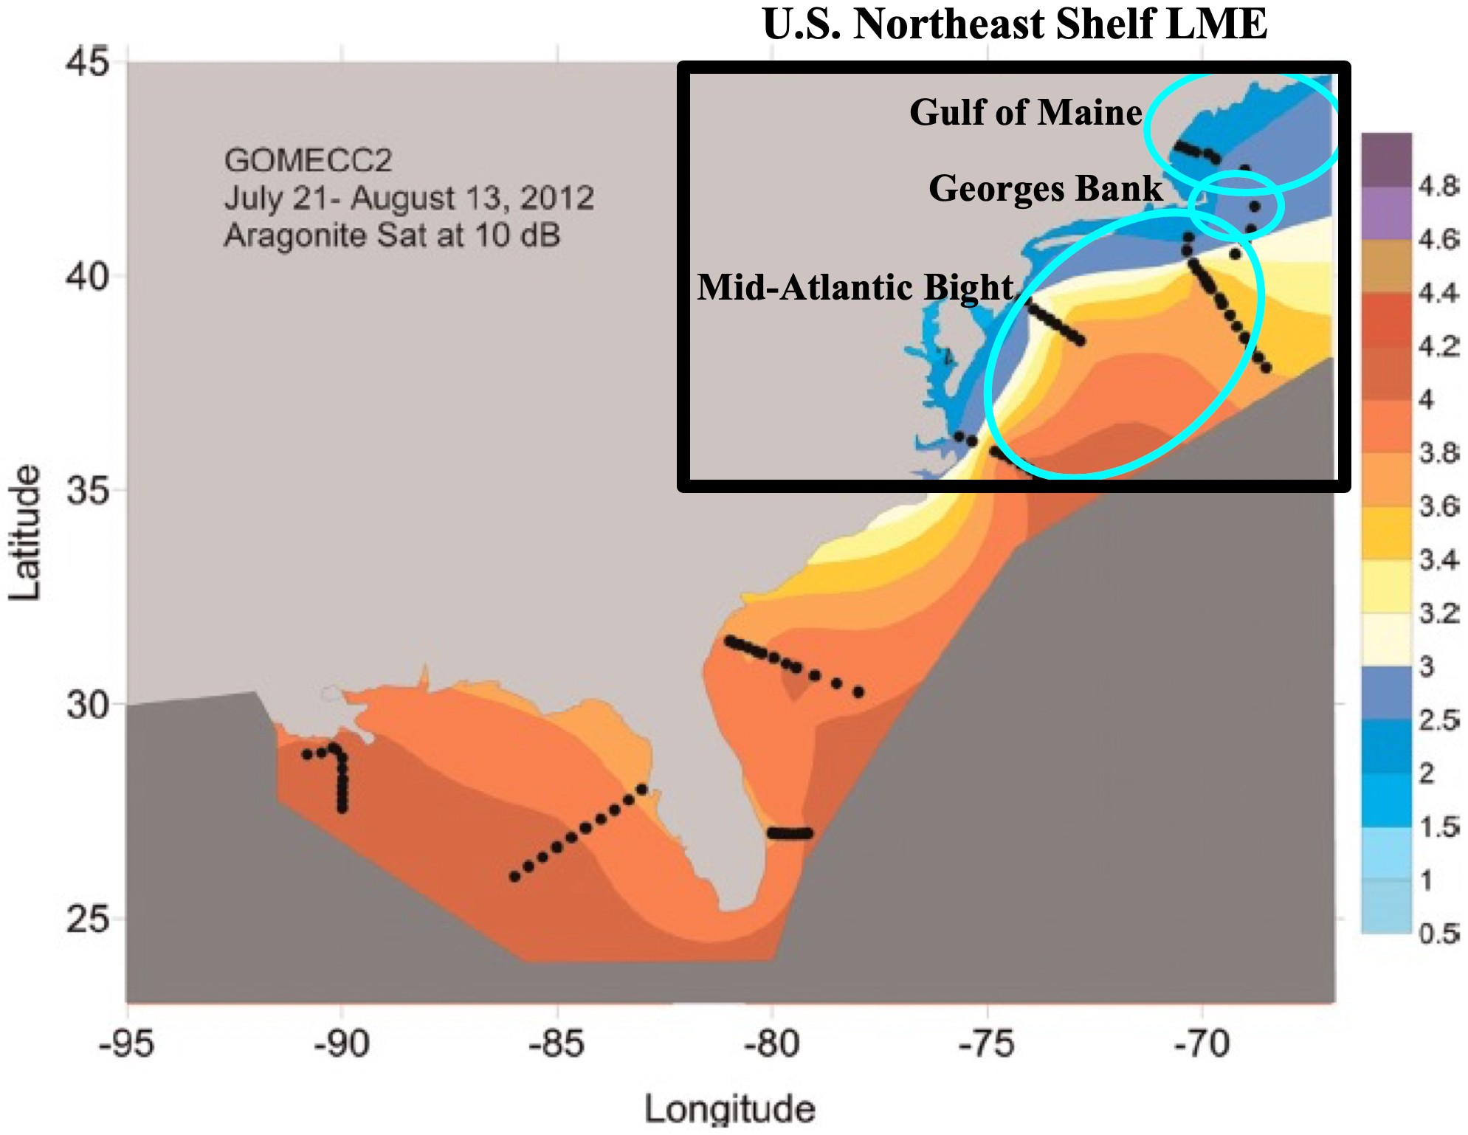

However, this trend in the NES is neither fully explained by the rapid warming in this region (0.1 – 0.3°C decade-1, Wu et al., 2012), nor interestingly, to estimated CO2 invasion, or OA (Salisbury and Jönsson, 2018; Wang et al. 2017).

**Figure 1**. Near-surface Arag sampled (black circles) and interpolated during the summer GOMECC2 cruise encompassing the U.S. NES LME.

(Modified from Wanninkhof et al., 2015)

Although very little information on subsurface carbonate chemistry in the NES exists, there is evidence that dissolved inorganic carbon (DIC) is significantly higher and opposingly, pH/ΩArag are significantly lower, in most bottom water compared to surface water on the shelf (Wang et al., 2013). The ECOA 2015 and 2018 cruises (see Salisbury, 2017) and recent deployments with a glider fitted with a newly developed deep ISFET-based pH sensor (Saba et al., *in review*) also revealed the existence of a large spatial area of low pH/ΩArag water in bottom waters of the MAB Cold Pool. We hypothesize this is likely due to a combination of enhanced seasonal stratification, biological activity, and the inflow of Labrador Sea slope water into the Cold Pool. This likely impacts pelagic and benthic organisms (finfish, groundfish, lobster, shellfish) on the shelf. Furthermore, episodic low pH events throughout the water column

associated with Spring-Summer upwelling in the coastal NES. We hypothesize that upwelling is a mechanism contributing to low pH/ΩArag in the surface waters of the NES as has been described in other upwelling regions (Feely et al., 2008; Feely et al., 2010a; reviewed in Hofmann et al., 2011; Yu et al., 2011). Other intermittent coastal processes such as hurricanes and coastal storms that generate excess rainfall, increase sedimentation, and nutrient runoff can locally impact water quality and exacerbate coastal acidification conditions (Johnson et al. 2013; Saba et al., *in review*). But the relative importance of these processes in driving unfavorable conditions on seasonal or annual scales locally and regionally are currently unknown.

*Current Data and Observation Gaps*: In the MAB and GoM the low density of observations limit our ability to fully understand carbonate chemistry dynamics, or to parameterize certain biogeochemical process transformations in ecosystem models. This general paucity of OA data is summarized for the GoM by Gledhill et al. (2015), and for the MAB by Goldsmith et al. (*in revision*). As a synopsis of those summary studies we note: First, although there are some fixed autonomous stations, much of the region is sampled at too low of a frequency to detect episodic events such as upwelling or water mass intrusion that could significantly impact susceptible species. The majority of past and ongoing acidification sampling in the NES is primarily conducted via cruises with underway *p*CO2 systems and/or discrete samples, primarily sponsored principally by NOAA (i.e., GOMECC, ECOA, Northeast Fisheries Science Center Ecosystem Monitoring [EcoMon]; Table 1). These only occur either once every six months (EcoMon) or once every 3-4 years (GOMECC, ECOA), limiting temporal resolution needed to understand daily, seasonal, and interannual variability. For any long-term trend to be detectable requires a fine enough resolution to cover short-term variability, such as seasonal or shorter time scale (Keller et al. 2014). Second, few sampling locations include more than one of the four measurable carbonate chemistry parameters (pH, DIC, total alkalinity [AT], and *p*CO2) (Goldsmith et al., *in revision*). Often only one parameter, such as pH or *p*CO2, is measured. At least two out of the four are necessary to fully characterize the marine carbonate system, including determinations of aragonite saturation state (ΩArag), an index of whether calcium carbonate (in the form of aragonite) is available for shell formation in calcifying organisms (Lee et al., 2006; Cai et al, 2010; Johnson, 2010; Wang et al., 2013). Third, most regional data collected are in surface water, with far less available data in the subsurface. However, subsurface waters are typically more acidic due to biological respiration resulting from bacterial remineralization of sinking particulate organic surface material. The benthic environment and its carbonate system status is critical for many commercially important bivalves and crustaceans.

The OOI’s Pioneer array (Table 1) is the only continuous monitoring system capturing measurements near the bottom in the NES. The ability to monitor carbonate chemistry throughout the water column and especially at depth is critical in order to track the movement of acidified water, understand the variability of acidification, and predict how mixing events and circulation will impact acidification across the shelf. Ships can provide detailed water column profile data, but their cost of operation limits temporal and spatial coverage. Moorings return high-resolution temporal data but poorly resolve spatial structures. The design of a regional OA observing system should exploit the respective strengths of differing existing platforms and implement new observing platforms to balance the requirements of sampling scope (surface versus depth), density, frequency, and cost. Following sampling theory (Cochran, 1977), effort should be higher where variability is higher. Thus, when designing and implementing a regional monitoring system these complex physical, biological, and chemical processes require sampling at high spatial and temporal resolution.

*Gliders - Novel Tools for High Resolution Sampling:* Autonomous underwater gliders have proven to be a transformative technology that achieves the spatial, temporal, and depth resolution that far exceeds that of traditional sampling from ships and moorings (Rudnick et al., 2004; Schofield et al., 2007). These 1.5-m long gliders dive and climb in repeat sawtooth sampling patterns, profiling vertically at 10-15 cm s-1, sampling every 20-30 cm, and resulting in high vertical data density and full water column coverage. Gliders collect data in highly variable currents from 4 to 1000 m allowing them to sample from the nearshore to the deep sea for weeks to months at a time, traveling horizontally at speeds of ~20 km day-1. Due to their robustness and high data quality, they are chosen as a key tool for the United States Navy, NOAA Integrated Ocean Observing System (IOOS), NSF Ocean Observatories Initiative (OOI), and numerous academic institutions and international partners (Schofield et al., 2013). Gliders operate at 4% and 66% of the daily cost of research class vessels and smaller coastal vessels, respectively (Schofield et al., 2010). Operations are coordinated through Iridium communication, allowing for adaptive sampling during missions based on real-time data and simultaneous glider deployments to provide a sampling network. Regional glider networks already exist and have proven valuable in providing baseline ocean observations to address such issues as climate variability and water quality (Schofield et al. 2010, Zaba and Rudnick 2016). Recent calls for a national (Baltes et al., 2014) and international observational network for OA identified gliders as “excellent” monitoring platforms for monitoring OA due to their ability to “resolve shorter space-time scale variability” (Martz et al., 2010; Feely et al., 2010b; Baltes et al., 2014).

Until very recently, carbonate chemistry sampling from a glider was not possible.

However, new pH sensors that can rapidly respond to pH change and also withstand higher pressure (depth) have been developed (Seidel et al., 2008; Martz et al., 2010) and will transform how we monitor coastal systems. A Deep-Sea ISFET (Ion Sensitive Field Effect Transistor) profiling pH sensor, recently developed by Monterey Bay Aquarium Research Institute (MBARI) and Honeywell, has successfully collected high quality

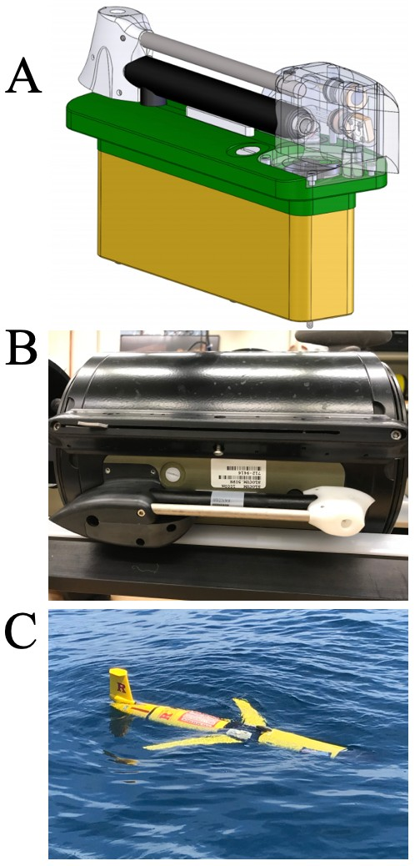

data on a depth-profiling mooring (Martz et al., 2010; Johnson et al., 2009, 2016). PI Saba recently further modified and integrated this deep ISFET-based pH sensor, coupled with a CTD, into a Slocum glider and evaluated its performance during deployments in the NES (Fig. 2), demonstrating the ability for gliders to routinely provide high resolution water column data that can be applied to OA monitoring efforts on regional and national scales through glider networks (Saba et al., *in review*). These glider measurements have shown that pH, and estimated AT/ΩArag, vary greatly in time and horizontal and vertical space, reflecting complex circulation patterns that are likely driven by the influence of stormwater runoff, source water from Labrador Sea slope/GoM, and on-shelf intrusions from Gulf Stream water (Saba et al., *in review*). These fluctuations may lead to large ecological and economic impacts, reinforcing the need for reliable high-resolution observations of the full water column. Significant improvements

could be achieved with the implementation of a real-time OA observation network that quantifies the spatial location, duration, and transport of low pH/ ΩArag water in coastal regions (Martz et al., 2010; Feely et al., 2010b).

**Figure 2**. Deep ISFET-based

pH sensor integrated with pumped CTD (A), integrated into a glider science bay (B), and deployed in the MAB (C).

*Needs for a Coordinated Regional OA Observation System*: As of now, the paucity of carbonate chemistry data in the NES severely hampers the ability to fully evaluate the veracity of the existing biogeochemical (BGC) models and the robustness of model parameterizations; hence, comprehensive regional-scale analysis is unfeasible. One of the great benefits of the work proposed here is that it brings together experts in the region to establish a regional network that will integrate new and existing OA coastal observation data on continuous or seasonal scales, and some in near-real-time for easier accessibility to benefit end users and modelers that would allow them to: 1) Address hypotheses related to identifying the drivers, and relative importance of the drivers, of acidification on various time scales in both the MAB and GoM; 2) Identify high-risk areas that are more prone to periods of reduced pH/ ΩArag and/or high pH/ ΩArag variability to enable better management of essential habitats in future, more acidic oceans; 3) Determine natural variability that will provide a framework to better study organism response and design more realistic experiments; and 4) Represent a step change in the independent data available for constraining BGC model rate constants and other parameterizations.

The proposed effort represents a unique collaboration of partnerships under two Regional Associations (RAs) of IOOS (MARACOOS, NERACOOS) and their respective Coastal Acidification Networks (MACAN, NECAN). We propose a multi-pronged approach to develop an OA observation network encompassing the MAB and GoM regions in the NES LME. Our approach adds seasonal deployments of underwater gliders equipped with transformative, newly developed and tested deep ISFET-based pH sensors and additional sensors measuring temperature, salinity (for AT and ΩArag estimation), DO, and chlorophyll, optimizes existing cruises to include OA sampling, and integrates existing OA assets. These data will be used in ecosystem/BGC model validation and parameterization.

# RESEARCH OBJECTIVES AND HYPOTHESES

O1) Employ seasonal deployments with gliders integrated with deep ISFET-based pH sensors (Yrs 2 & 3)

*New observations will be incorporated via seasonal glider deployments (~30-45 days each) in three locations including the* GoM*, the New York (NY) Bight/North MAB, and the South MAB. These gliders provide high-resolution vertical profiles of temperature, salinity, pH, DO, chlorophyll fluorescence, and salinity-based estimations of AT and ΩArag.*

O2) Add carbonate chemistry measurements to existing cruises for optimization (Yrs 1, 2, & 3) *We propose to: a) Add a flow-through ControsTM AT system to the monthly Portland, ME to Iceland line (Eimskip Shipping) and maintain the ControsTM AT presently on the NOAA Bigelow; b) Expand water column discrete seawater sampling and analysis of pH, AT and DIC to supplement the underway surface pCO2 and pH samples already collected during seasonal cruises located in the NY Bight; and c) Expand sampling and analyses of carbonate parameters during the Spring/Fall NOAA EcoMon cruises.*

O3) Integrate existing OA data from U.S.NES into appropriate databases for access (Yr 1) *Available existing OA data) and new data produced from this project will be integrated into appropriate RA databases (MARACOOS, NERACOOS) available to the user community and for the proposed modeling efforts. These data include those collected from moorings, ships, and recent and ongoing (through 2019) PI Saba’s deep ISFET-based pH glider deployments.*

O4) Optimize an ecosystem/biogeochemical (BGC) model (Yrs 1, 2, & 3)

*We will optimize an established companion ecosystem/BGC model that simulates nitrogen and carbon including DIC and AT from which pCO2, pH, and ΩArag can be calculated. Data collected during this project (and previously) will enable us to evaluate, constrain parameterizations, and improve this BGC module to give it utility for regional OA analysis and forecasting. Modeling will enable an analysis of the persistence of observable OA signals and their transport pathways, which will be key indicators of how representative glider-based and other in situ observations are of the wider OA state of NES waters.*

O5) Hypothesis Testing (Yrs 2 & 3)

*The following hypotheses will be tested using both observations and modeling:*

***H1****: Biological activity drives pH/ΩArag variability in shelf waters, while physical advection and mixing processes are the most dominant driver of pH/ΩArag variability in slope waters.*

***H2****: Cold Pool pH/ΩArag is lowest in summer and fall prior to winter/storm mixing, and pH/ΩArag minima are associated with high stratification index and surface chlorophyll.*

***H3****: Processes impacting the relative proportions or rate of supply of these different source waters likely drives large-scale variability in carbonate chemistry in bottom waters of the NES*.

# PLAN OF WORK

**Observations**

We will employ seasonal deployments with gliders integrated with deep ISFET-based pH sensors, leverage existing cruises to add OA measurements for optimization, and integrate existing OA assets (Fig. 3).

*Seasonal glider deployments for high resolution pH measurements and AT/*ΩArag *estimations (O1)*: The new glider deep ISFET-based pH sensor platform developed in a recent collaborative project (Led by PI Saba) has been validated during field deployments in the NES (Fig. 2). Comparisons between glider pH and pH measured spectrophotometrically from discrete seawater samples indicate that the glider pH sensor is capable of accuracy of 0.011 pH units for several weeks throughout the water column in the coastal ocean, with

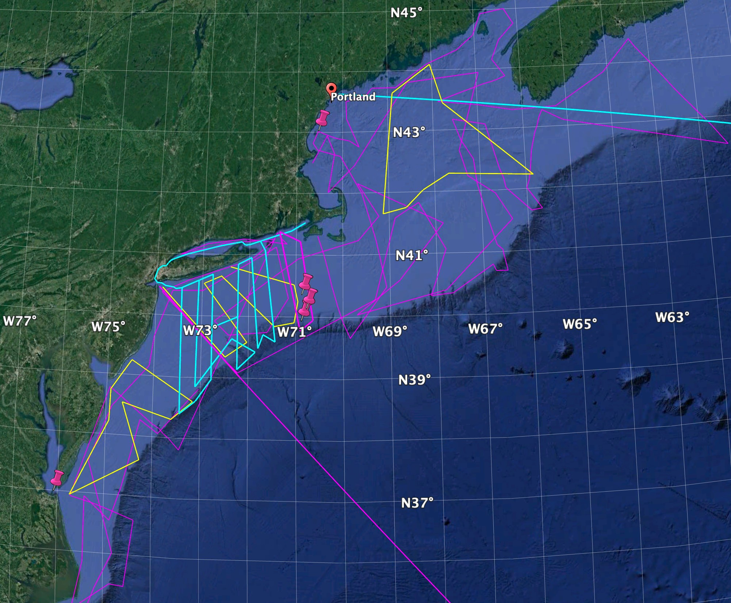

**Figure 3**. Map depicting locations of existing periodic (seasonal to triennial) OA sampling (magenta), existing platforms that will be optimized for OA sampling (cyan), and new glider-based OA observations (yellow).

a precision of 0.005 pH units (Saba et al., *in review*). Furthermore, simultaneous measurements from multiple sensors on the same glider enabled salinity-based estimates of AT using a linear regression equation, determined from the near-conservative salinity-AT relationship at three ECOA-1 cross-shelf transects along the NES (Cai et al., 2010; Wang et al., 2013; Saba et al., *in review*). ΩArag was then calculated using CO2SYS (van Heuven et al., 2011). High-resolution glider pH and derived AT/ ΩArag data collected along the cross-shelf transect in May 2018 revealed higher pH/ΩArag associated with the depth of chlorophyll and DO maxima and a warm,

salty water mass and lowest pH/ΩArag in bottom waters of the mid-shelf and slope, and nearshore following a period of heavy precipitation (Fig. 4; Saba et al., *in review*).

Proposed deployments (30-45 days each) will be simultaneously conducted seasonally (4x per Yr) in three locations in the NES (Fig. 3), ensuring the capture of both seasonal dynamics and short-term episodic events (i.e., upwelling, storm mixing) that can dramatically alter carbonate chemistry in the NES. Rutgers, the State University of New Jersey (hereafter RU), will operate the glider deployment located in the southern MAB. They own two sensor units as well as rechargeable lithium batteries that will be leveraged for the proposed

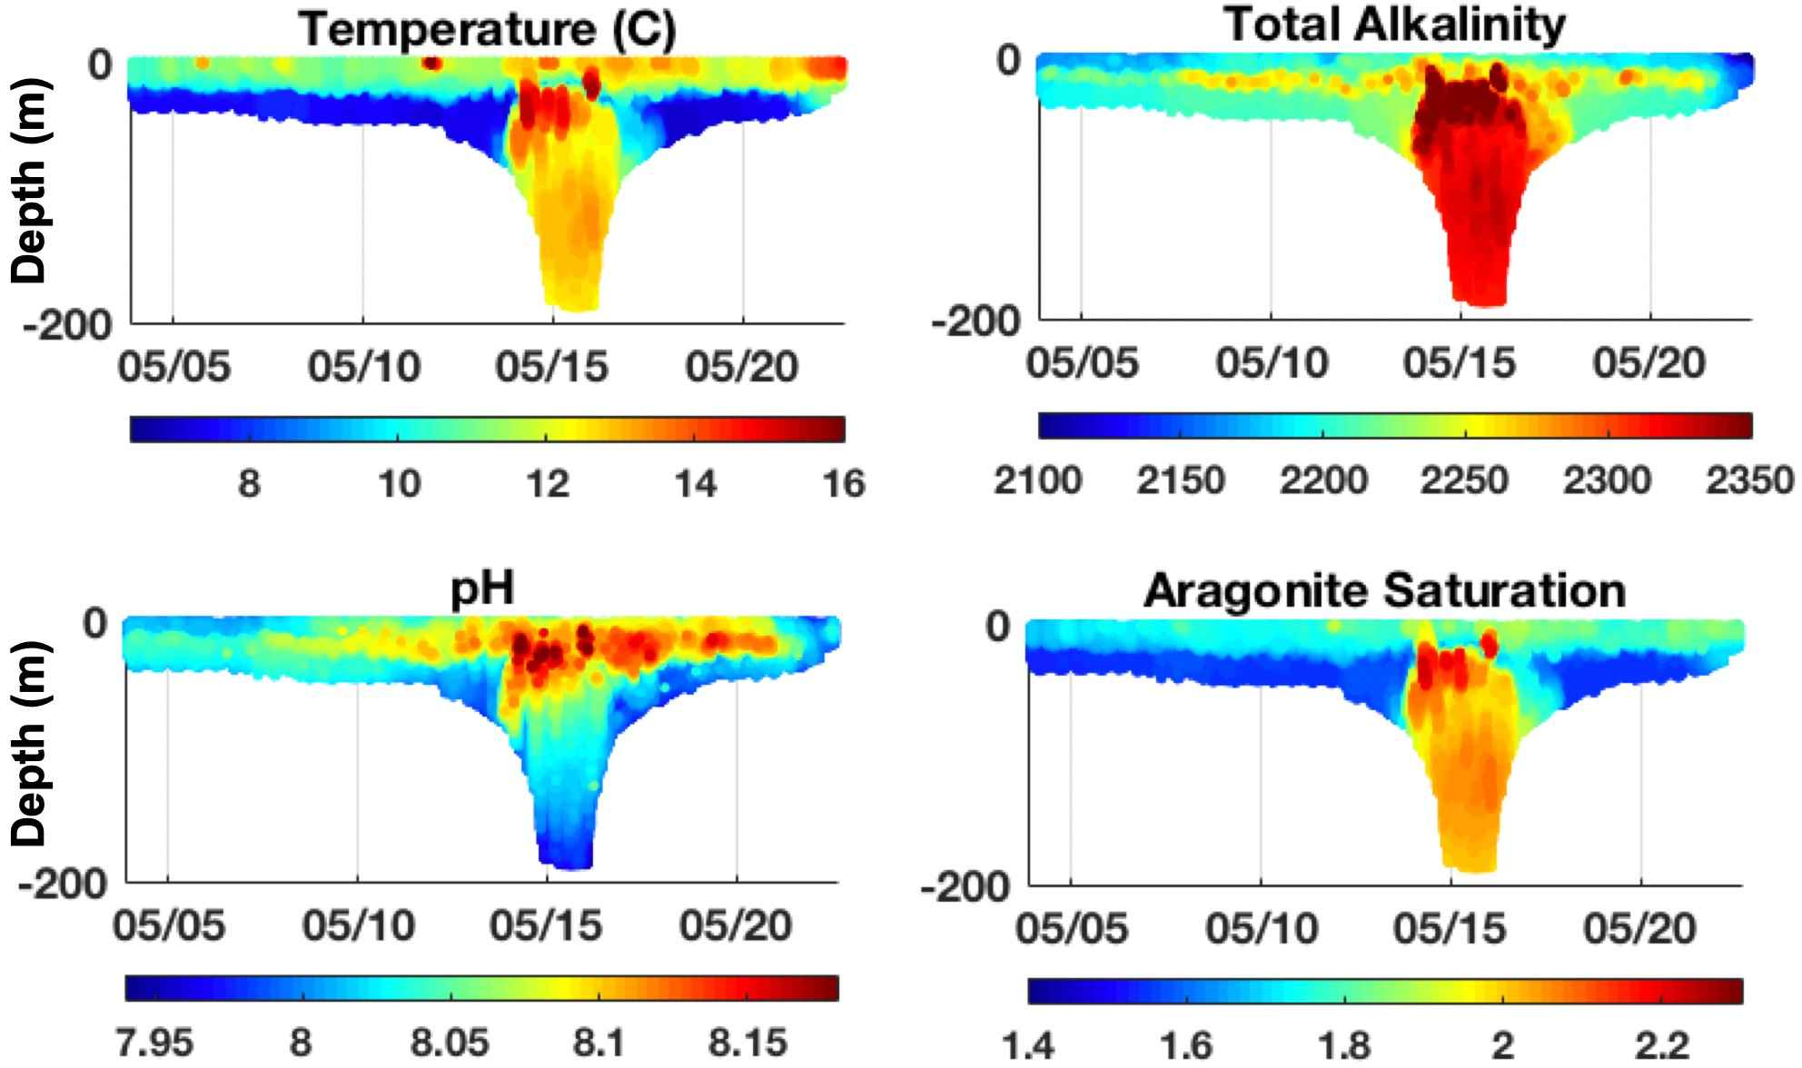

**Figure 4**. Cross-sections of measured temperature and pH and estimated AT and ΩArag during the May 2018 glider deployment. The glider was deployed off the coast of Atlantic City, NJ, traveled to the shelf break and back to

Atlantic City where it was recovered. The glider also measured conductivity (salinity), DO, and chlorophyll.

project. One sensor unit is integrated into a Slocum Webb G2 glider (200 m capacity), and the other in a spare glider bay. This insures a “back-up” system in the event we undergo damage or need unforeseen maintenance on any of our gliders/sensors during the course of this project.

New coupled pH/CTD sensor units will be integrated into both the NY Bight/North MAB glider (Stony Brook University; G3, 200 m) and the GoM (University of Maine; G2, 350 m) glider.

Glider depth capacities are sufficient to reach bottom depths on the shelf in their respective locations. In addition to the coupled pH/CTD sensor, each glider will be outfitted with a Sea- Bird Scientific ECO puck (BB2FL) configured for simultaneous fluorescence, CDOM, and optical backscatter measurements, and an Aanderaa optode integrated into the aft of the glider for measuring DO. Each glider will be powered by a rechargeable lithium battery pack which supports a typical deployment of 4-6 weeks. While these will provide new observations, some of these proposed deployments are already partially or fully funded, specifically those in the NY Bight/North MAB. These will be leveraged for this project, but will be optimized here with deep ISFET-based pH/CTD integration.

*Optimization of existing platforms (O2)*: Several existing platforms will be optimized for this project that will not only enhance spatial and temporal sampling, but will increase the number of carbonate parameters measured. First, we will add a flow-through AT system to the monthly Portland, ME to Iceland line (Eimskip Shipping) and maintain the present AT system aboard the NOAA RV *Bigelow* (both already have underway *p*CO2 systems. Additionally, we will expand full water column discrete sampling and analysis of AT and DIC to supplement the pH profiles already collected during the seasonal cruises located in the NY Bight (roughly from Montauk to Hudson Canyon). co-PI Nye is currently funded by NY State Department of Environmental Conservation (DEC) to conduct four ecosystem monitoring cruises per year, one objective of which is to monitor surface pCO2 and pH continuously. Surface samples will be supplemented by periodically taking discrete samples that will be analyzed for AT and DIC in the lab. In addition, we will increase the number of CTD casts at which AT, DIC, and pH measurements are taken along transects in the NY Bight. And finally, we propose to expand sampling and analyses of carbonate parameters in the GoM during the Spring/Fall NOAA EcoMon cruises (that currently collect vertical profiles of pH, AT, DIC) to better constrain water

masses that impact the region. These additional samples will be analyzed at UNH. These efforts will also include continued maintenance of the underway AT analysis system on the EcoMon vessel, the NOAA *Bigelow*, for the duration of this project.

*Integration of existing OA assets (O4)*: Existing OA assets include both previous and ongoing collections of observational data in the study region (summarized in Table 1; Fig. 3). These data include those collected from moorings (surface pH/pCO2 and/or bottom pCO2), cruises (surface underway pCO2, pH, and/or AT and/or vertical profiles of pH, AT, DIC from discrete water samples), and recent and ongoing (through 2019) PI Saba’s deep ISFET-based pH glider deployments (measured pH, estimated AT/ΩArag). These data (and new data produced from this project described above) will be integrated into the appropriate RA databases (MARACOOS, NERACOOS; see Cyberinfrastructure below). This serves two purposes. First, it allows the ability for the respective regional user communities to easily access OA-specific data along with other concurrent observational data managed by the RA operators. Second, it facilitates modeling efforts which will use this data to validate and parameterize the nature runs.

**Table 1**. Description of existing OA assets in the proposed study region that will be integrated into appropriate databases and used for the proposed modeling efforts.

|  |  |  |  |
| --- | --- | --- | --- |
| **Existing OA Asset** | **Location** | **Description** | **Sampling interval** |
| **Moorings** | | | |
| NSF OOI Pioneer – Inshore | South of New England | Surface pH, *p*CO2, DO, temperature, conductivity: hourly; near- bottom *p*CO2 (*p*CO2W): every 2 hours | Continuous (with some gaps) since May 2015 |
| NSF OOI Pioneer – Central | South of New England | Surface pH, *p*CO2, DO, temperature, conductivity: hourly; near- bottom *p*CO2 (*p*CO2W): every 2 hours | Continuous (with some gaps) since May 2015 |
| NSF OOI Pioneer – Offshore | South of New England | Surface pH, *p*CO2, DO, temperature, conductivity: hourly; near- bottom *p*CO2 (*p*CO2W): every 2 hours | Continuous (with some gaps) since December 2014 |
| NOAA OA at First Landing Buoy | Chesapeake Bay mouth | Surface pH, *p*CO2, atmospheric CO2 | Continuous (with some gaps) since April 2018 |
| UNH Gulf of Maine CO2 buoy | Western Gulf of Maine | Surface pH, *p*CO2, atmospheric CO2, temperature, conductivity, DO; every 3 hours | Continuous (with some gaps) since May 2006 |
| **Cruises** | | | |
| NOAA GOMECC | Gulf of Maine  – Florida shelf | Vertical profiles of pH, AT, DIC; Continuous surface pH and *p*CO2. | Summer 2007, 2012 |
| Oleander | New York – Bermuda | Continuous surface *p*CO2, temperature, salinity, and currents | Weekly transects (Coming in 2019) |
| NOAA ECOA | Gulf of Maine  – Florida shelf | Vertical profiles of pH, AT, DIC; Continuous surface pH and *p*CO2  (2015) and TA (2018) | Summer 2015, 2018 |
| NOAA Wilkinson Basin | Gulf of Maine | Vertical profiles of pH, AT, DIC; Continuous surface O2 and *p*CO2. (NCEI accession identifiers: 0184288; 0154836; 042327) | Monthly 2005-2009; quarterly+ 2010-present |
| NOAA EcoMon | Gulf of Maine  – Virginia | Bottle samples for DIC, AT, and pH at surface, mid, and at most 10m off the bottom; CTD and nutrients. Continuous surface *p*CO2, AT, and DO | Fall, Spring since 2009; AT since 2016 |
| NSF NES LTER | South of New England | Bottle samples for DIC, AT, and pH at surface, mid, and at most 10m off the bottom; CTD and nutrients. | Seasonal cruises (2018-  2023) |
| NY DEC | New York Bight | CTD and bottle samples for vertical profiles of temperature, salinity, DO, nitrogen, and pH; Underway *p*CO2 system measuring surface temperature, salinity, DO, turbidity, CDOM, fluorescence and *p*CO2 | Seasonal cruises starting July 2018; funded through 2028 |
| **Glider Deployments** | | | |
| RU deep ISFET- based pH glider | New Jersey shelf waters | High-resolution vertical profiles of temperature, salinity, pH, DO, chlorophyll fluorescence, salinity-based estimations of AT and ΩArag. | May 2018; seasonal deployments started Feb 2019-through Nov 2019 |

*Quality Assurance and Quality Control (QA/QC)*: **pH/CTD***.* We will follow Best Practices for autonomous pH measurements with the DuraFET, including the recommended rigorous calibration and ground truthing procedure (Bresnahan et al., 2014; Martz et al., 2015; Johnson et al., 2016). Once per year, the coupled deep ISFET-based pH/CTD sensor will be factory calibrated by Sea-Bird Scientific (Johnson et al., 2016; Saba et al., *in review*). Adjacent

to the glider upon glider deployment and recovery, and during cruises that are deployed near the gliders, the glider pH measurements/AT estimations will be validated with discrete seawater samples (250 mL borosilicate glass bottles, preserved with 50 µL of saturated mercuric chloride). The glider CTD will be verified *in situ* using a manufacturer calibrated SeaBird-19 CTD following the EPA Quality Assurance Project Plan (QAPP; Kohut et al., 2014). **Aanderaa optode**. Like the CTD, the optode measuring DO will be factory calibrated at least once per year. We also will complete in-house verifications by comparing optode observations to concurrent Winkler titrations of a sample at both 0% and 100% saturation (Kohut et al., 2014). **BB2FL ECO puck**. The pucks we deploy will be standard factory calibration from WET Labs (recommended every 1-2 years for pucks in gliders). **Discrete sample analysis**. From the discrete samples collected during both the proposed glider deployments/recoveries and previously described research cruises, the pH will be measured spectrophotometrically at 25 degrees Celsius on the total pH scale using purified M-Cresol Purple purchased from R. Byrne at the University of South Florida [Clayton and Byrne, 1993; Liu et al., 2011). The accuracy of pH data will be calibrated against *Tris* buffers (Millero, 1986; DelValls and Dickson, 1998) purchased from Andrew Dickson at UCSD Scripps Institute of Oceanography. AT titrations will be performed using open cell Gran titration and Apollo Scitech AT titrator AS-ALK2 following previously described methods [Cai et al., 2010; Huang et al., 2012; Chen et al., 2015). DIC will be measured using an Apollo Scitech DIC analyzer AS-C3 (Huang et al., 2012; Chen et al., 2015). Precision of AT and DIC are better than ±0.1%. Measurements of AT and DIC will be quality controlled using CRMs obtained from Andrew Dickson. Temperature correction will be conducted for the measured pH values to the *in situ* conditions using the same Excel version of CO2SYS the guidelines for input (analysis) and output (*in situ*) temperature, a total pH scale (mol/kg-SW), K1 and K2 constants (Mehrbach et al., 1973) with refits (Dickson and Millero, 1987), and the acidity constant of KHSO4 in seawater (Dickson, 1990). These discrete samples will be compared to the glider deep ISFET-based pH measurements. Final carbonate system parameters on the discrete water samples will be calculated using CO2SYS (Pierrot et al., 2006).  **Underway systems**. The underway *p*CO2 system used during the Eimskip, NOAA *Bigelow*, and NY DEC transects is a General Oceanics LICOR-based *p*CO2 sensor, maintained by NOAA AOLM personnel. The Contros Hydro-FIA underway AT analysis systems are calibrated each cruise using Dickson certified reference materials. Additionally, both systems are equipped with an automated CRM check that can be programmed to sample at any time interval necessary for validation, and can be changed at any time using web based commands. These data are used to correct for any drift that may occur during the cruises.

# Cyberinfrastructure

The OA data will be made available to the user community and the modelers via web services. In the case of gliders, all data will be managed using the IOOS National Glider Data Assembly Center (GliderDAC) and made available via ERDDAP. The GliderDAC provides a centralized location for managing glider data facilitating coordination of glider efforts across the nation. It provides a standard process for submitting. Inclusion in the DAC allows the data to be visualized, analyzed, and distributed via web services. Traditionally the DAC has only supported CTD data. The next release (Spring 2019) will include the ability to add any variable with a standard name (i.e., pH) making it a good solution for this effort. The glider project team will work with the GliderDAC team to register as data providers, register each new deployment, and submit compliance NetCDF files in near real-time for each deployment. The mooring data will

be converted to and stored as NetCDF format and made available via THREDDS from OPeNDAP and SOS services (MARACOOS) and ERDDAP (NERACOOS). Cruise data formats are typically in matlab, excel, or text formats. Whether the cruise data will be stored in a database as is or converted to a series of netCDF files will be dependent on initial review of the datasets. All new data produced during the course of this project will be archived and accessible on National Centers for Environmental Information (NCEI). MARACOOS and NERACOOS will manage the integration of all data in the MAB and the GoM, respectively. This approach addresses both the Program requirements and the needs of the diverse community (academic and Federal scientists, natural resource managers, industry stakeholders, and policy makers) who require OA information (see also Data Management Plan).

# Modeling (O4)

The RU Ocean Modeling Group has developed, and extensively evaluated, a ROMS (www.myroms.org) hydrodynamic circulation model for a domain extending from Cape Hatteras to Halifax and from the coast to beyond the Gulf Stream (encompassing the NES region; Fig. 1). The horizontal grid resolution is ~5 km, which captures shelf-wide mesoscale dynamics, and the vertical grid has 40 levels in terrain following coordinates stretched to resolve surface and bottom boundary layers. (A detailed description of model inputs for surface meteorological forcing, river inflows, and open boundary data is given in Wilkin et al., 2018). Using the ROMS 4D-Var (four-dimensional variational) data assimilation system, the model is run daily to derive a best-estimate of the ocean state that blends ocean physics constraints and data to subsequently initialize a 3-day real-time ocean physics forecast. The real-time system assimilates a comprehensive suite of observations including sea level from all satellite altimeters on orbit (Jason, AltiKa, Cryosat, Sentinel), surface currents from CODAR HF-radar, satellite sea surface temperature (METOP & GOES infrared; AMSR-2 microwave), and in situ temperature and salinity from Argo profiling floats, surface drifters, NDBC and NERACOOS buoys, ship-of- opportunity XBT, IOOS gliders, NOAA EcoMon surveys and the NSF OOI Pioneer Coastal Array. An earlier version of the real-time system compared to 7 other forecast models in the MAB (Wilkin and Hunter, 2013) found that no other model was more skillful than MARACOOS ROMS/4D-Var. The model is also run in conventional forward-only mode, i.e. without data assimilation, for regional studies related to ecosystems (Hu et al., 2012; Xu et al., 2013), biogeochemical cycles (Mannino et al., 2016), sediment transport (Dalyander et al., 2013; Miles et al., 2015), storm-driven circulation (Miles et al., 2017; Seroka et al., 2017) and underwater acoustics (Lin et al., 2017).

A companion nitrogen and carbon cycle biogeochemical (BGC) model (Druon et al 2010; Hofmann et al. 2010) for the region is well-established, having been applied to studies of productivity on the shelf (Fennel et al. 2006; Fennel et al. 2008; Fennel and Wilkin, 2009; Friedrichs et al. 2019) and in estuaries (Feng et al. 2015), atmospheric nitrogen deposition (St- Laurent et al. 2019) and drivers associated with major climate modes (Previdi et al. 2009; Cahill et al. 2016). The BGC model traces the fate of inorganic nitrogen, phytoplankton, zooplankton, size differentiated detritus, semi-labile and refractory organic nitrogen and carbon, DO, DIC, and AT. The model allows for water column and benthic denitrification, and carbon and nitrogen burial. From modeled temperature, salinity, DIC, and AT we can compute all other key parameters of the ocean carbonate state such as pH and ΩArag. The qualitative capabilities of the BGC model along a cross-shelf New Jersey transect are demonstrated in Fig. 5. At mid-shelf, low ΩArag is associated with low temperatures in the Cold Pool as hypothesized, but the lowest

ΩArag occurs further inshore beneath a pronounced subsurface phytoplankton maximum at the coast. These patterns have striking similarities (qualitatively and quantitatively) to ECOA-1 observations made at this same transect at the same time of year. This gives us confidence that the fundamentals of the BGC model are sufficiently sound to allow us to explore physical-BGC interactions in greater detail, and can be improved by the verifying data that will be provided by the proposed comprehensive in situ observing program utilizing gliders, moorings and vessels.

Equipped with a coupled physical-BGC model with demonstrated skill at reproducing the principal processes controlling carbonate chemistry in regional shelf and shallow coastal waters, we propose a set of numerical experiments to inform the design and

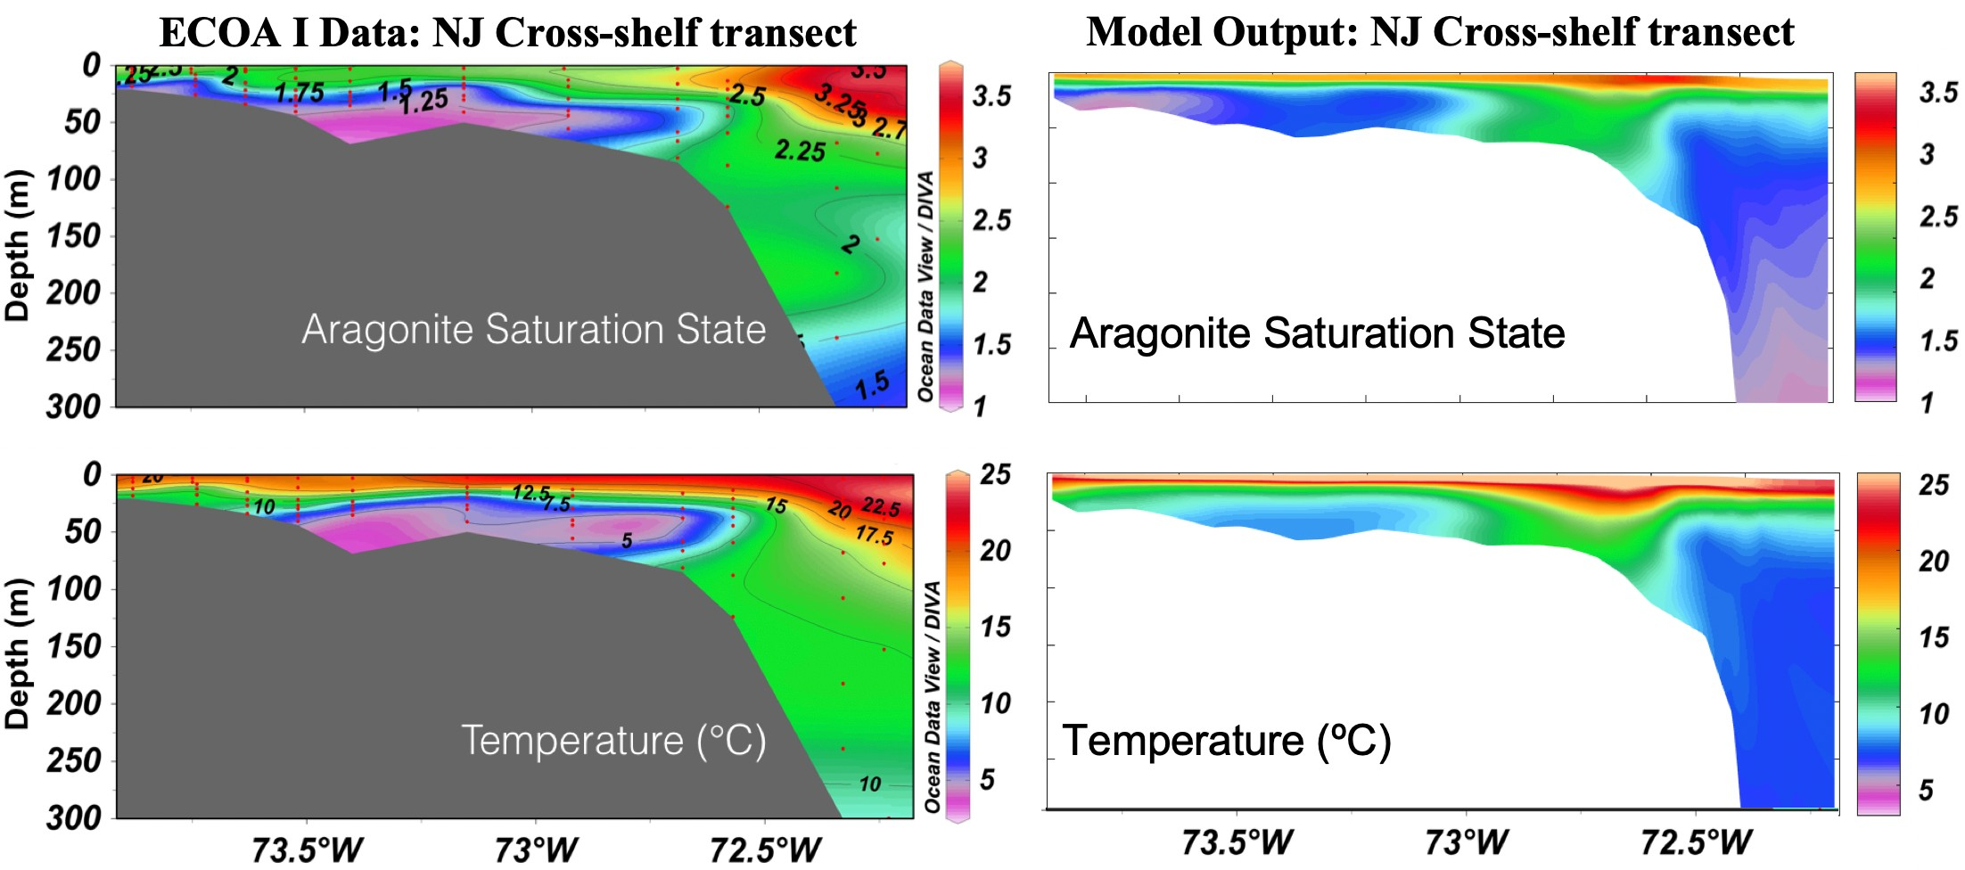

operation of a future OA observational network for the MAB/GoM using two distinct analysis approaches. First, we will run decade-long

**Figure 5**. Results for aragonite saturation state and seawater temperature in the MARACOOS biogeochemical model (right) along the same ECOA-1 transect (left) during the same approximate time-of-year (the BGC model has not yet been run for 2015 to attempt a more direct comparison).

simulations of the coupled physical-BGC model to characterize transport pathways and time and space correlation scales for DIC and AT that control pH and ΩArag. The results will inform simple Observing System Simulation Experiment (OSSE) by indicating where observations are most representative of regional conditions and are therefore most useful for mapping spatial variability by traditional statistical analysis approaches. These OSSEs will be especially useful for evaluating the value of sustained, repeated observing locations (e.g. commercial vessel repeat transects) for long-term monitoring of OA conditions. Secondly, exploiting tools that underpin the ROMS 4D-Var assimilation system, we will use modeled flow-dependent *representers* (Bennett 2002) to compute the representativeness of any single observation. This is a sophisticated approach to OSSE that formally computes the covariance of each observation with neighboring locations and times. We have previously used this approach to explore how temperature and salinity information from gliders propagates through time and space in response to the prevailing flow to inform conditions dynamically upstream or downstream of the observation location, previously or later in time, respectively (Zhang et al. 2010). This approach will be especially useful for identifying whether observations are indeed informative of a given event (e.g. upwelling or eddy-shelf interaction). Used in conjunction with the MARACOOS real- time ocean forecast, the *representer* method can be used to propose, *operationally*, where observations should be made “now” to inform conditions several days hence. These space-time correlation and 4D-Var *representer* analysis approaches will be used initially in a set of OSSEs to evaluate the information content of the projected glider and vessel sampling strategies. They will also be applied in a broader suite of OSSEs to address hypothetical sampling strategies targeted at capturing other important information needs, such as how best to observe the OA state of the inflow end-member water masses.

An observing system that is designed and operated using this combination of retrospective analyses, real-time ocean forecasts, and a broad exploration via OSSEs of

alternative sampling plans will be responsive to requirements for both sustained monitoring and adaptive event-based sampling of the drivers of coastal OA.

# Hypothesis Testing (O5)

In the work proposed here, the real-time ocean physics model forecast system will be used to inform adaptive sampling by glider operations with respect to anticipated extreme weather, the onset of coastal upwelling events, anomalous river discharges, and mesoscale eddy intrusions. Equally importantly, observations and a BGC model of the carbon cycle coupled to the circulation model will be used to infer the relative roles of externally driven physical transport pathways, mixing, and air-sea gas exchange compared to internal transformations due to ecological and biogeochemical processes.

Our experience modeling carbon cycle dynamics in shelf and estuarine environments in the MAB and GoM has revealed the importance of knowing the nutrient and carbonate state of end-member waters that enter the domain; namely, the Gulf Stream inflow, mesoscale eddies in the Slope Sea, cool and fresh northern source waters entering from the Scotian Shelf, and river inflows. We propose a synthesis of historical carbon cycle observations in the region, complemented by new targeted observations, to characterize water mass properties across the MAB shelf into the Slope Sea, along transects within the GoM, on Georges Bank, and where Slope Sea mesoscale variability impinges upon the shelf. We will use methods from cluster analysis and principal component analysis to frame a robust method for specifying the BGC inflows to the regional model, informed by these data, and to address the stated hypotheses.

# Engaging User Community

With guidance from our Advisory Committee, we will build upon and leverage established networks and partnerships of the two RAs, MACAN, and NECAN to facilitate engagement using the following tools: 1) Conduct two joint webinars presenting progress and outcomes from this project coordinated through MACAN/NECAN efforts; 2) Enhancing OA visualization products (i.e., conceptual models) for efforts that are currently underway through the existing Sea Grant/North Atlantic Regional Team/MACAN/NECAN project that involved PIs Saba and Morrison; and 3) Leverage stakeholder or CAN workshops to present results from this project. We will benefit from on-going involvement with the RAs and collaborations with NOAA and industry to establish dialog with their collaborative commercial fisheries contacts.

Our goal here is not only to inform them of the project and involve them in using the data output, but also to begin fruitful discussions regarding the identification of potential vulnerable populations, and potential mitigation options to low pH/omega water.

# PI Roles

Grace Saba (RU), Assistant Professor in the Department of Marine and Coastal Sciences, will serve as the Lead Investigator on the project. She will be responsible for planning and implementation of the proposed collaborative research, all proposed RU glider flights, and will supervise the glider and software technicians involved in the project. Saba will organize PI meetings and facilitate communications with both the project’s Advisory Committee and the OAP Program Manager(s), analyze data, present results at selected symposia, write manuscripts for submission to peer-reviewed journals, and in Year 3, through her position as co-coordinator of MACAN, will lead the proposed engagement efforts. The following collaborators will serve as project co-PIs and will all participate in scheduled PI/Advisory Committee meetings:

John Wilkin (RU), Professor in the Department of Marine and Coastal Sciences: He will lead the proposed modeling efforts, supervise the modeling technician involved in the project, organize data and coordinate model validation and parameterization discussions with other co- PIs on the project.

Charles Flagg (Stony Brook University), Research Professor in the School of Marine and Atmospheric Sciences: He will manage the NY Bight/North MAB seasonal glider surveys of this project and supervise the glider technicians, data processors, and data analyzers.

Janet Nye (Stony Brook University), Associate Professor in the School of Marine and Atmospheric Sciences: Nye will be the primary liaison between RU, Stony Brook and other collaborators. She also will supervise one student who will help with deployment of the glider, collecting water samples on all cruises and at glider deployments and recoveries as well as analysis of the data as part of their thesis.

Joseph Salisbury (University of New Hampshire), Associate Research Professor at the UNH Ocean Processes Analysis Laboratory: He will be responsible for equipment deployment, sample analysis and advising model parameterization.

Doug Vandemark (University of New Hampshire), Research Professor in the Ocean Process Analysis Laboratory: He will be responsible for application of the regional model data to dedicated model/data comparisons and analyses at the long-term OA time series sites in collaboration with J. Wilkin. He will also contribute to the overall development of the regional biochemical datasets and assimilation of these data into the ROMS regional model.

Neal Pettigrew (University of Maine), Professor in the School of Marine Sciences and director of the Physical Oceanography Group: He will manage the GoM seasonal glider surveys of this project and supervise the glider technicians, data processors, and data analyzers. He will supply synoptic time series metocean data from the GoM OOS buoy array to project scientists.

Gerhard Kuska (MARACOOS), Executive Director: He will utilize the Data Management and Communications (DMAC) contractor (RPS ASA) for co-leading data management related to this project (with NERACOOS).

Ru Morrison (NERACOOS), Executive Director: He will utilize the Data Management and Communications (DMAC) contractor (GMRI) for co-leading data management related to this project (with MARACOOS) and will coordinate the NECAN engagement efforts.

# Advisory Committee Membership and Roles

Communications between the PIs and the project’s Advisory Committee will occur remotely through web teleconference three to four times per year during the course of the proposed work. These communications will focus on diverse community needs for observations, modeling output, and observation strategies to improve model parameterization. We have organized an Advisory Committee consisting of members from diverse associations and with a broad range of expertise that this project’s proposed work plan and engagement strategies will benefit from. They include:

1. Sarah Cooley (Program Director for Ocean Acidification, Ocean Conservancy): Her expertise in carbon cycling, science communication, and science-based policy development will provide a unique perspective on the policy and socioeconomic relationships with OA with respect to the research proposed here and will also help guide our engagement efforts.
2. Marjorie Friedrichs (Research Associate Professor, Virginia Institute of Marine Science): Her expertise in modeling, specifically from the carbonate chemistry perspective, and estuarine/coastal dynamics will assist in the model validation and parameterization component of the project.
3. Peter Hughes (Director of Sustainability, Atlantic Capes Fisheries): He is currently serving as a stakeholder mentor for PI Saba’s existing glider OA project, and will provide an industry perspective, specifically on sustainability, for this proposed project.
4. Chris Melrose (Research Oceanographer, NOAA NEFSC): As principal investigator for the Oceanography Branch’s Ship of Opportunity program, his involvement in OA observations from the NOAA NEFSC EcoMon surveys (and potentially others) will assist in the data integration component of or work plan.
5. Beth Phelan, NOAA (NOAA NEFSC OA Program Manager): Her position, as well as her involvement in developing OA Research Implementation Plans, will assist in ensuring that our proposed work plan is representative of NOAA Oobservational and research needs.
6. Aleck Wang (Associate Scientist, Woods Hole Oceanographic Institution): As an expert in OA sensor systems and carbonate chemistry dynamics and trends in the U.S NES, he will help guide our proposed observational work plan and will assist in the existing OA assets integration component by providing OA data collected during the seasonal NES LTER cruises (he has agreed to share the data).

# RELEVANCE OF PROPOSED PROJECT

Our proposed development of a coordinated OA observation system for model parameterization in the U.S NES addresses specific priorities identified in this call for proposals, but also both community and overall Program needs. First, we focus here on a Large Marine Ecosystem, the Northeast (NOAA LME 7), which has no coordinated observation network nor published model for carbon variability at present. Also, we plan to evaluate the capability of existing OA assets within the LME of interest to adequately characterize the magnitude and extent of acidification at the scale of this LME, which is the second priority identified in the call for proposals. Second, we address several monitoring gaps recently described for both the GoM and MAB (Gledhill et al., 2015; Goldsmith et al., *in revision*). Gledhill et al. (2015) states: “A more comprehensive observing system is needed to provide enhanced spatial and temporal coverage as well as subsurface monitoring capability. This system will require leveraging existing capacity as well as creating opportunity for expansion of the system.” Our cost-effective proposed approach not only integrates existing OA assets and optimizes existing cruises to include OA sampling, but also the addition of seasonal deployments with underwater profiling gliders newly equipped to measure pH and estimate AT and Ωarag addresses specific gaps defined in both Gledhill et al. (2015) and Goldsmith et al. (*in revision*) including the need for high sampling frequency, the need for measurements of multiple carbonate chemistry parameters, and the need for high resolution depth-profiling measurements. Additionally, our configuration will inform much needed regional models that will, in turn, further optimize site selection and guide sampling strategies that will inform Observing System Simulation Experiments (OSSEs) and lead to larger investments in continuous monitoring. Finally, our optimized regional OA observing network will inform the development of a U.S. National Ocean Acidification Observing Network, a national glider network (Baltes et al. 2014, Schofield et al. 2015, Rudnick 2016), and the international Global Ocean Acidification Observing Network.