# Physiological ecology and habitat suitability: combining experiments and surveys to inform stock assessments.

Funding agency: NOAA CINAR

Partners: NMFS-NEFSC

Period of Performance:

Total budget: $88,011

**Background** - Incorporating "habitat effects" into stock assessment models has proven difficult. There are multiple reasons. First, the scale of most habitat studies is not matched to the scale of most assessments. Generally, the habitat studies must be "scaled-up" to be appropriate. Second, most assessment models are structurally unable to include "habitat effects". At the NEFSC, more than 15 models are used for stock assessments, but only two have the ability to directly include habitat information (Age-Structure Assessment Program [ASAP] and Stock Synthesis 3).

Despite these limitations, "habitat effects" impact stock dynamics and observations of stock dynamics. Previous work with winter flounder shows that long-term warming has reduced the amount of available habitat, which has resulted in a decrease in stock productivity (Manderson 2008, Bell et al. in prep). This information was not included in the recent assessment model because the model was structurally unable to include the effect. We are currently working to include these "habitat effects" in ASAP.

"Habitat effects" also impact observations of stock abundance. Recently, we presented an analysis at the butterfish assessment that calculated the proportion of habitat sampled by a fishery-independent survey. This proportion was calculated annually based on a habitat suitability model that was coupled with a circulation model hindcast (Figure 1). The time varying proportion of habitat sampled was then included in the assessment model as contributing to changes in catchability (Manderson et al. in prep). The habitat suitability model used in this assessment was parameterized using catch densities and temperatures from multiple field surveys. However, extracting niche dimensions from field survey collections can problematic.

Another approach is to develop niche dimensions experimentally. Physiological ecology proposes that distribution and productivity are largely governed by metabolic responses (Kingslover 2008). By extension, field-based habitat suitability models should compare well with experimentally-based metabolic functions (Bozinovic et al., 2011, Sanchez-Fernandez, 2012). Here we will test this premise and compare habitat suitability models based on field and experimental data. We will then evaluate the effect of parameterization on catchability estimates for butterfish along the U.S. east coast in the context of the stock assessment model.

**Approach** - We propose to parameterize mechanistic thermal niche models by measuring temperature and size-dependent metabolic rates for butterfish. We propose two experimental approaches: in situ respirometry and biochemical assays. The experimental nature of this work clearly separates our proposed effort from the FATE Program. We have three specific objectives:

1. measure respiration as a function of temperature and body size using in situ experiments
2. estimate respiration as a function of temperature and body size using a biochemical assay
3. compare habitat suitability models derived from survey-based species distribution models, experimental-based respirometry experiments and biochemical assay of metabolic potential

Objective 1 - We will conduct respirometry measurements of butterfish in the field during the August and November EcoMon cruises in 2014 and 2015. We will use a Loligo® respirometry system that recirculates seawater through swim tunnels (described in Dupont-Prinet et al. 2012). The fish will be acclimated to the vessel until respiration rate stabilizes (1-6 hours) to eliminate any stress caused from the transfer process. Then, rates of oxygen consumption will be measured for 1 hour. The EcoMon cruise cover the entire the shelf and respiration experiments will be conducted over a range of natural temperatures.

Objective 2 - Individuals tested in the respirometer and other individuals collected on the cruise will be analyzed for Electron Transport System (ETS) enzyme activity, which is a measure of metabolic capacity (Ikeada et al. 2006). Temperature of collection and live-mass will be measured and then individuals will be frozen at -80°C. The ETS assay will be run at the Narragansett Laboratory, where these assays have been successfully completed in the past.

Objective 3 - The respiration and ETS activity by temperature will be compared to the survey based habitat suitability model. Based on physiological ecology principles, the three measures should agree, but they are few if any tests involving marine fish (Kingsolver, 2009). The habitat suitability models will be compared in a unified modeling framework using General Additive Models and a factor term for the source of parameterization. The analyses of Manderson et al. (in prep) then will be re-run with the respiration and ETS based functions to determine the difference in the proportion of habitat sampled compared to the survey-based approach.

Schedule of Work - Year 1: purchase respirometry system; run trials; use on Aug and Nov 2014 cruise; analyze fish for ETS; conduct preliminary data analysis; develop lessons learned for changes in year 2. Year 2: make changes to system; use on Aug and Nov 2015 cruise; analyze fish for ETS; complete data analysis; compare respirometer, ETS, and survey based models

**Benefits** - This proposal addresses all of the program priorities: incorporating information into the butterfish stock assessment, estimating catch efficiency based on a habitat suitability model, measurement of respiration, and identification of priority habitat areas for butterfish. In addition, it will provide a direct comparison between habitat suitability models developed with three very different kinds of data. If there is agreement, this will bolster the use of survey-based models. If there is disagreement, the magnitude of the effect will be demonstrated and hypotheses will be developed for future research.

# Deliverables

1. Modified availability estimates based on respirometry, ETS, and field derived habitat­ suitability model evaluated in the context of the butterfish stock assessment model
2. Peer-reviewed manuscript describing comparison of three methods
3. Generalized approach for moving forward with incorporating "habitat effects" on survey availability in stock assessment applications

**Figure 1** - (Left) Field based habitat suitability model based on coupled measurements of temperature and butterfish abundance. (Right) Predicted butterfish habitat based on habitat suitability model and numerical circulation model hindcast of temperature. The overlap between the NEFSC trawl survey and the predicted habitat ofbutterfish was used in the recent butterfish assessment to inform the model catchability.

Atlantic Butterflsh:lhermal niche model **(NL_BA** ML fit}



Atlantic Butterlish: 2013·09·29 12:00:00

ROMS temperature based forecast

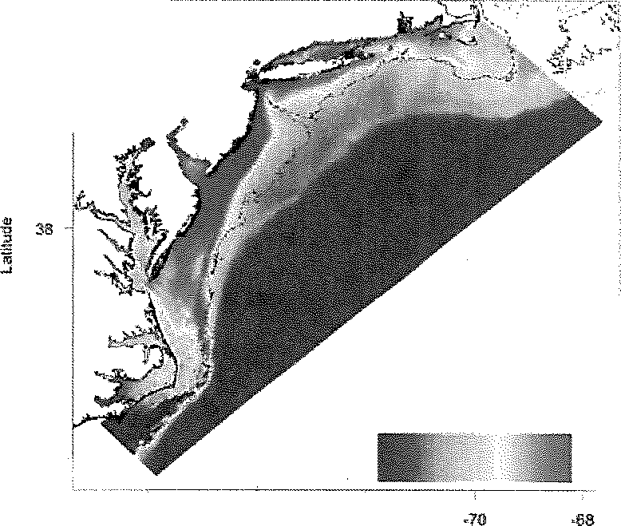

42

---- 50m

, zoom

40

36

Thennru HSI

0 0,5

34

*·16*

,74

.72

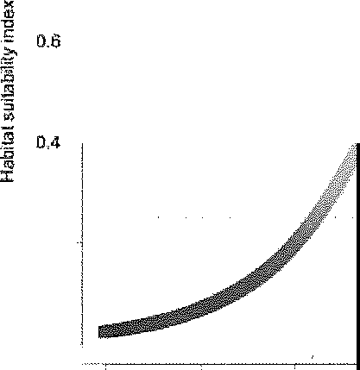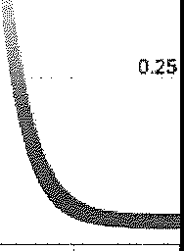

LO

o.a

0,75

14.5

. 21.4 0.5

0.2

0.0

0 10

15 20

25 30

Bot1om Temperature F

:Pararr.etars{Er=1.402,9, IEd.,,8.4759, Topt=19.163)

lon-g'1tude:

2013#21iij;-16:18 NL-BA model:Ba e (Er- 1.,U)2 Ed= B,4'/'59 'top-I= -r . t$3)

# References

Bell, R. Hare, JA, Manderson JP, and Richardson DE. In prep. Externally driven changes in the abundance of summer and winter flounder. ICES Journal of Marine Science

Bozinovic, F., P. Calosi, and J. I. Spicer. 2011. Physiological correlates of geographic range in animals. Annual Review of Ecology, Evolution, and Systematics 42:155-179.

Dupont-Prinet, A., M. Vagner, D. Chabot, and C. Audet. 2012. Impact of hypoxia on the metabolism of Greenland halibut *(Reinhardtius hippoglossoides).* Canadian Journal of Fisheries and Aquatic Sciences. doi: 10.1139/cjfas-2012-0327.

Ikeda, T., Sano F, Yamaguchi A, Matsuishi T. 2006. Metabolism of mesopelagic and bathypelagic copepods in the western North Pacific Ocean. Marine Ecology Progress Series 322:199-211

Kingsolver, J. G.. 2009. The well-temperatured biologist. The American Naturalist 174: 755-768 Manderson JP. 2008. The spatial scale of phase synchrony in winter flounder

*(Pseudopleuronectes americanus)* production increased among southern New England nurseries in the 1990s. Can. J. Fish. Aquat. Sci. 65:340-351.

Manderson J.P., D. E. Richardson, J. A. Hare, H. Townsend, L. Palamara, J. Kohut, J. Quinlan, C. Roebuck, G. Monsen, G. Didomenico, J. Hoey, A. Schmidt, and N. Georgas. 2013. A thermal habitat model based estimate of the availability (p) of Atlantic Butterfish to surveys for use in stock assessment catch equations. Butterfish Stock Assessment Working Paper

Sanchez-Fernandez, D., P. Arago, D. T. Bilton, and J.M. Lobo. 2012. Assessing the congruence of thermal niche estimations derived from distribution and physiological data. A test using diving beetles. PLoS ONE 7:e48163.

Wuensche! M.J., A.R. Jugovich, and *I.A.* Hare. 2005. Metabolic response of juvenile gray snapper *(Lutjanus griseus)* to temperature and salinity: Physiological cost of different environments. Journal of Experimental Marine Biology and Ecology 321: 145-154