Assessing the susceptibility of Atlantic sea scallops and surf clams to ocean acidification using glider-based coastal modeling and larval transport models

Funding agency: NJ Sea Grant

Partners: NOAA NEFSC, Atlantic Capes Fisheries, Inc.

Period of Performance: 08/01/18-07/31/20

Total Budget: $94,001

# Project summary

Acidification has significant societal ramifications ranging from economic losses due to decreased survival of commercially important organisms to ecological consequences associated with altered food webs and ecosystems (Cooley et al., 2009; Doney, 2010). Ocean Acidification (OA), linked to increases in atmospheric CO2 and subsequent increases in dissolved CO2 concentrations in the ocean (*p*CO2), is occurring at a rapid rate and causing complex changes in ocean chemistry, including declines in pH and aragonite saturation state, Arag (National Climate Assessment, 2014). It is projected that within this century, global ocean pH will drop by 0.2-0.3 pH units and some regions will become under-saturated with respect to aragonite (National Climate Assessment, 2014).

Upwelling zones, estuaries, and bays are particularly prone to natural and anthropogenic acidification (coastal acidification). These coastal areas are under the influence of freshwater inflow and natural and human-induced influences on biological activity (e.g. eutrophication) that strongly influence *p*CO2, pH, and buffering capacity of water (Feely et al., 2008, Salisbury et al., 2008; Thomsen et al., 2010; Wang et al., 2013; Cai et al., 2011, 2017).

While acidification monitoring efforts are beginning to expand nationally, they are still severely limited in temporal and spatial resolution and lacking in several economically and ecologically important regions, including the Mid-Atlantic Bight (MAB), housed within the U.S. Northeast Shelf (NES). Therefore, we cannot identify locations or time periods susceptible to acidification to inform what species may be potentially impacted. Sampling for water chemistry parameters in the surface waters of the NES has been conducted primarily through large field campaigns every four to six years. These surveys depict large spatial and temporal variability and possible decadal changes of surface carbonate chemistry on the NES (Wang et al., 2013). The recent NOAA-funded East Coast Ocean Acidification survey revealed the existence of large scale low pH and Arag water in the MAB, and this acidification was associated with the “Cold Pool” (Wei-Jun Cai, pers. comm.). This distinctive mass of cold (<8C) bottom water has been linked to the distribution and recruitment of several commercially important fin and shellfish species (Goldberg and Walsker, 1990; Steves et al., 2000; Sullivan et al., 2000; Sullivan et al., 2005; Weinberg, 2005). It is a prominent feature co-located with wild stocks of commercially important shellfish including the Atlantic sea scallop (*Placopecten magellanicus*) and the Atlantic surf clam (*Spisula solidissima*).

Organisms that build structures with calcium carbonate, such as shellfish, are especially susceptible to ocean acidification due to decreased Arag (Gezeau et al., 2007; Doney et al., 2008), resulting in reduced calcification rates or depression of metabolic processes (Cooley et al., 2015). In laboratory studies, adult shellfish exposed to elevated levels of *p*CO2 exhibit thin or malformed shells with severely impaired hinge development (Gazeau et al., 2007; Talmage and Gobler, 2010), making them more vulnerable to predators or environmental stressors (Doney et al., 2008; Talmage and Gobler, 2010). Sea scallop genus *Placopecten* has exhibited decreased fertilization success under acidified conditions in the lab, while larval stages exhibit impaired development, lessening the ability of larvae to disperse to suitable settlement zones (Desrosiers, Desilets, and Dube, 1996). Less acidification work has been done on surf clam genus *Spisula,* but other marine clam taxa such as *Mercenaria* and *Tivela* exhibit a decrease in larval survival and delays in larval metamorphosis when exposed to increased CO2 (Talmage and Gobler, 2009). Due to limited mobility in adult life stages and a long-lasting planktonic larval stage, larval dispersal plays a key role in determining success of sea scallops and surf clams (Daphne Munroe, pers. comm.). Understanding larval dispersal is necessary in order to effectively manage shellfish fisheries and predict the impacts of climate change on shellfish success (Kritzer and Sale, 2004; Bernhardt and Leslie, 2013). However, there are no documented field studies that have examined the state of acidification in locations with high

abundance of wild shellfish stock and through which larvae disperse, thus making predictions of acidification impacts on these stocks difficult.

Therefore, a critical need exists to deploy new, cost-effective technologies that can routinely provide high resolution data on regional scales in our coastal ocean to inform how populations of important species respond to acidification. This project will utilize a new technology that will provide real-time autonomous underwater glider pH measurements and salinity-based total alkalinity and Arag estimates. In conjunction with surf clam and sea scallop stock assessments (adults) and larval dispersal models, I will use this data to identify times and locations where these species may be at high risk of acidification impacts. Data resulting from this project will assist Atlantic Capes Fisheries, Inc. in developing and implementing strategies for maintaining sustainable shellfish fisheries in the Mid-Atlantic. Additionally, data from this study will be used to aid NOAA NEFSC in integrating glider-based environmental data into their surf clam and sea scallop stock assessments for the first time, aiding a shift toward ecosystem-based management.

# Research Plan

Glider Deployments: The ability to monitor pH throughout the water column is critical in order to track the movement of low pH water, understand the variability of pH, and predict how mixing events and circulation will impact pH across the shelf. Autonomous underwater gliders have proven to be a robust technology that fulfills this role as they are capable to collecting data in highly variable currents over water depths up to 1000 meters (Schofield et al., 2007; Rudnick et al., 2016). As part of a recently-funded NSF project (OCE1634520) led by Dr. Grace Saba, we have integrated, for the first time, a deep sea ISFET pH sensor into a Teledyne-Webb Slocum G2 glider. In addition to pH,

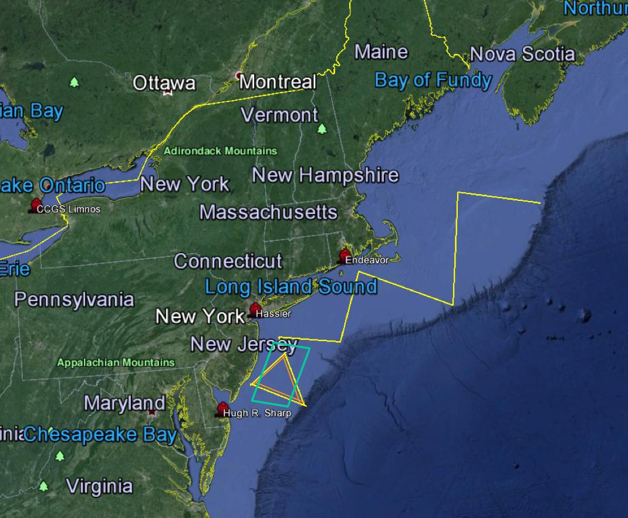the glider is equipped with sensors that will provide profiles of conductivity, temperature, depth, spectral backscatter, chlorophyll fluorescence, and dissolved oxygen. This will allow us to map ocean pH against the other variables and conduct salinity-based estimates of total alkalinity in order to derive Arag. This proposed project will leverage three glider deployments (May 2018,

July/August 2018, October 2018) funded by NSF and a fourth glider deployment (February 2019) funded by NOAA’s Integrated Ocean Observing

**Figure 1**. Map of the U.S. Northeast shelf depicting the transect for the 60-day glider deployment from Georges Bank in the north to Tuckerton, NJ (yellow line; July/Aug 2018) and the New Jersey shelf transects that will occur May 2018, July/Aug 2018, October 2018, and February 2019 (orange triangle). Glider deployment area will focus on Strata 21 (blue rectangle), where surf clam and sea scallop fisheries operate.

System (IOOS) through the Mid- Atlantic Regional Association Coastal Ocean Observing System (MARACOOS, NA11NOS0120038). All

deployments will conduct a triangle-shaped transect in and

out of Atlantic City, NJ (Fig 1) which encompasses areas of interest throughout the location of Atlantic surf clam and sea scallop fisheries (Stratum 21, NEFSC, 2014; NEFSC, 2017), and the paths of larval dispersal (Zhang et al., 2015; Daphne Munroe, pers. comm.). Additionally, the July/August 2018 deployment is a 60-day deployment from Georges Bank to Atlantic City, NJ, and will allow for the assessment of acidification dynamics on the entire NES. These deployments will allow for the monitoring of pH (and derived Arag) throughout the water column in order to track the movement of low pH water, understand diel and seasonal pH variability, and predict how mixing events and circulation impact pH across the shelf.

Identification of Points of Interest: Overlaying larval transport paths, settlement areas, and maps of ocean pH along with other physical ocean characteristics over the Mid-Atlantic Bight will allow us to identify any major fishery zones susceptible to ocean acidification. Adult sea scallops and surf clams spawn between May and November, with the most successful larvae along the MAB being released from early August to late September (Zhang et al., 2016; Daphne Munroe, pers. comm.). In order to successfully settle, surf clam and sea scallop larvae must reach settlement size within 35 days but will drift an average of 120-150 km south alongshore during this time (Zhang et al., 2016, Daphne Munroe, pers. comm.). During this dispersal period, larvae will likely encounter environmental conditions that degrade their ability to survive (Zhang et al., 2016). Larval dispersal models published for Atlantic surf clams (Zhang et al., 2015) and in review for Atlantic sea scallops (Daphne Munroe, pers. comm.) incorporate physical circulation, atmospheric forcing, larval growth lab studies, temperature, food concentration and quality, and behavioral factors, but not changes in pH or Arag predicted in the dispersal zone. We will use our cross-shelf measurements of pH and calculated Arag, focusing specifically on Stratum 21 off the southeast coast of New Jersey, an important fishery zone, to better inform larval dispersal models. We will identify key fisheries areas that are at risk for increasing acidification, and strategize with Atlantic Capes Fisheries, Inc. and NOAA NEFSC about how best to mitigate the effects of pH and Arag variability across the MAB.

# Outcomes and Broader Impacts

The results of this project will combine state-of-the-art ocean observation techniques with informed predictions of shellfish ecological bounds. Glider pH deployments, supported by existing from NSF and NOAA projects, will provide high resolution pH measurements and derived Arag spatially (Georges Bank to Southern New Jersey) and temporally (diel and seasonal off of the New Jersey coast). Incorporating this data into shellfish larval dispersal models, we will be better able to understand the effects of ocean acidification on commercially important local shellfish fisheries.

The Atlantic sea scallop (*Placopecten magellanicus*) is one of the most economically important shellfish in the United States. Its fishery was valued at $465 million in 2013 (NEFSC, 2014). The MAB serves as the primary harvest area for sea scallops in the U.S. The Atlantic surf clam (*Spisula solidissima*) is a commercially significant shellfish, with a fishery valued at $28 million in 2015 (NEFSC, 2017). Surf clams are highly abundant along the New Jersey shelf and Delmarva peninsula, but commercial catch rates have declined in recent years in New Jersey for unknown reasons (NEFSC, 2017). We will use our data to aid Atlantic Capes Fisheries, Inc. in their sustainability initiatives. Atlantic Capes is a leading sea scallop and surf clam producer in the country, marketing approximately 20% of domestic scallop landings and running the largest hand shucking surf clam plant in the northeast. They operate along the coast from New Bedford, MA to Ocean City, MD. We will use our glider pH data and larval dispersal models to identify areas susceptible to ocean acidification along the Mid-Atlantic Bight. This will allow Atlantic Capes to prepare for predicted effects of ocean acidification in the habitats in which they fish, ensuring that they are well-prepared to maintain a sustainable shellfish fishery into the future.

Local fisheries like Atlantic Capes are subject to regulations set in place by decision-makers in the government. While working with Atlantic Capes directly will be beneficial to their specific fishery, we also want to incorporate our data into higher-level management organizations. Atlantic Capes and I will be working with NOAA’s Northeast Fisheries Science Center (NEFSC) to gain a better understanding of surf clam and sea scallop stock assessments, and aid in their goal of implementing ecosystem management practices in the Northeast to benefit regional fisheries. Our data will provide the NEFSC with an up-to-date look at the effects of ocean acidification in the MAB that will help move toward environmentally-based management

# Timeline and Milestone Chart

|  |  |
| --- | --- |
| **Milestone** | **Date of Completion** |
| pH glider deployments 1, 2, 3, and 4 | *May 2018, *July/August 2018, October 2018,  February 2019 |
| Create maps of pH/Arag along the NJ coast | August 2018 - September 2019 |
| Identify areas of interest using pH/Arag data, larval dispersal models, and fisheries stock  assessment | May 2019 - October 2019 |
| Predict future success of Atlantic surf clams and sea scallops based on pH, larval dispersal, and settlement | November 2019 - January 2020 |
| Create an informed sustainability management plan with Atlantic Capes Fisheries, Inc. | February 2020 - July 2020 |

*Pre-fellowship period

# Research Team and Coordination

Elizabeth Wright-Fairbanks, Ph.D. student at Rutgers University, is the applicant for this fellowship and will lead the proposed project. Elizabeth will be responsible for glider data collection, analysis of glider data to inform larval dispersal models, identification of areas of interest in terms of shellfish habitat pH, and generating deliverables to aid Atlantic Capes Fisheries, Inc. and NOAA Northeast Fisheries Science Center (NEFSC) in sustainability practices and environmentally-based fishery management efforts.

Grace Saba, Assistant Professor of Marine Science at Rutgers, will act as Elizabeth’s academic advisor throughout the duration of this project. Grace is a PI on NSF grant #OCE1634520 which is supporting three pH glider deployments. She is also Ocean Acidification Innovation Lead and co-PI for MARACOOS, which will support a fourth pH glider deployment during the fellowship period. Grace also serves as co-coordinator of the Mid-Atlantic Coastal Acidification Network (MACAN). She will aid Elizabeth in data collection and research initiatives.

Peter Hughes, sustainability Director of Atlantic Capes Fisheries, Inc., will serve as Elizabeth’s primary professional mentor throughout this project. He will work with Elizabeth to enhance Atlantic Capes’ sustainability mission using the data collected throughout the proposed project.

Daniel Hennen, Assessment Scientist at NOAA NEFSC, will work with Elizabeth to integrate environmental data into stock assessments for surf clams and sea scallops in the Mid-Atlantic Bight. This will help guide ecosystem-based management goals and sustainability practices for NOAA NEFSC and Atlantic Capes.

Daphne Munroe, Associate Professor at Rutgers’ Haskin Shellfish Research Laboratory, will serve as a consultant on shellfish larval dispersal, settlement, and population ecology. She will provide the larval dispersal models which are a major component of the proposed work.