# REU Site: Research Internships in Ocean Sciences (RIOS)

Funding Agency: NSF

Period of Performance: 05/01/18-04/30/20

Total budget: $241,993

**Project Summary:**

The objective of this proposal is to renew our Rutgers University based REU site, Research Internships in Ocean Sciences (RIOS). During the previous fifteen years, 183 students have participated in RIOS (most supported by the NSF grant, with additional interns supported by Department of Marine and Coastal Sciences [DMCS], NOAA, and individual faculty research grants). Feedback from the students and mentors indicates their participation in the program is an enriching and rewarding experience. In a recent survey, the majority of past RIOS participants (94%) indicated that the program influenced their career choices or paths. We are confident that we have been successful in providing REU experiences that motivate and prepare students towards careers in ocean science, a goal that is central to the mission of DMCS.

We also acknowledge areas of the program that could be improved and over the last two years, have implemented significant changes to make these improvements. First, over the first thirteen years of the RIOS program, recruitment of underrepresented minority students was weak (an average of 10% of all applicants). Two years ago in our prior renewal, we proposed specific actions to improve recruitment of underrepresented minority students. These included direct collaboration with community colleges and the New Jersey chapter of the Louis Stokes Alliances for Minority Participation (LSAMP) program, and changes to the selection process which increased minority participation by a factor of 3 in 2019. A second area of focus in recent years is the mentor/mentee relationship (see section 5.0 below). Like most REU sites, we used pre- and post-surveys to document the strengths and weaknesses of our program. Through these evaluations and our own direct observations, it was clear that some mentors consistently have high- performing students who demonstrate real growth as scientists during the course of the internship. Previous renewals of the RIOS program have added trainings for the students. Recognizing the diversity of undergraduate mentoring experiences among our faculty, we added mentor training two years ago so that best practices demonstrated by our most effective mentors could be shared with all participating faculty. In this proposed renewal, we will expand this training by entraining Rutgers University faculty and staff from other departments who research, train, and support mentor-mentee best practices.

The goal of RIOS is to enable students interested in ocean sciences to participate in meaningful, interactive research directed by an enthusiastic, experienced group of mentors. Group activities and independent research are embedded within ongoing programs, many of which are focused on the New Jersey continental shelf and adjacent estuaries. Our approach focuses on 3C’s: *conceiving* a project, *conducting* the research, and *communicating* the results. Students write research proposals, participate in research cruises, conduct laboratory and field research, analyze either existing or their own generated data, and communicate their work in various formats throughout the 10 week program. Finally, a poster designed for display at a national scientific meeting communicates their work with a summary of the hypotheses tested, approach taken, and new knowledge gained. These experiences are enhanced through discussions of traditional and non-traditional careers in marine science at two career panels hosted by graduate students in the department, and workshops on scientific ethics, teamwork, leadership, and graduate and career training. The 10-week program generally begins the first week in June and concludes the first week in August.

The Department of Marine and Coastal Sciences (DMCS) is committed to undergraduate success. All DMCS faculty routinely work with undergraduates in their laboratories and mentor students throughout the academic year. During the previous fifteen years, the 183 RIOS students were mentored by over 60 faculty, postdocs, senior graduate students, and senior technicians. Over the past two years, 21 mentors advised 24 students. The program uses facilities maintained by DMCS, including coastal research vessels, small boats, and a diverse range of laboratories. Our main campus in New Brunswick, NJ offers seawater facilities, a molecular biology laboratory, a biogeochemistry laboratory, a remote sensing and coastal ocean

observation laboratory, and an advanced data assimilation and modeling laboratory. On the coast, the Rutgers University Marine Field Station (RUMFS) in Tuckerton, NJ gives direct access to the salt marsh and coastal ocean ecosystem with additional laboratory, seawater, small vessel, and aquaria facilities. Along the Delaware Bay, a series of laboratories – all part of the Haskin Shellfish Research Laboratory (HSRL) – offer seawater labs, aquaculture hatchery, nursery, and farm facilities, shellfish disease, advanced genetics, selective breeding, and fisheries ecology laboratories. Many programs at HSRL are conducted in collaborations with state agency partners elevating interns’ exposure to non-academic jobs in marine biology.

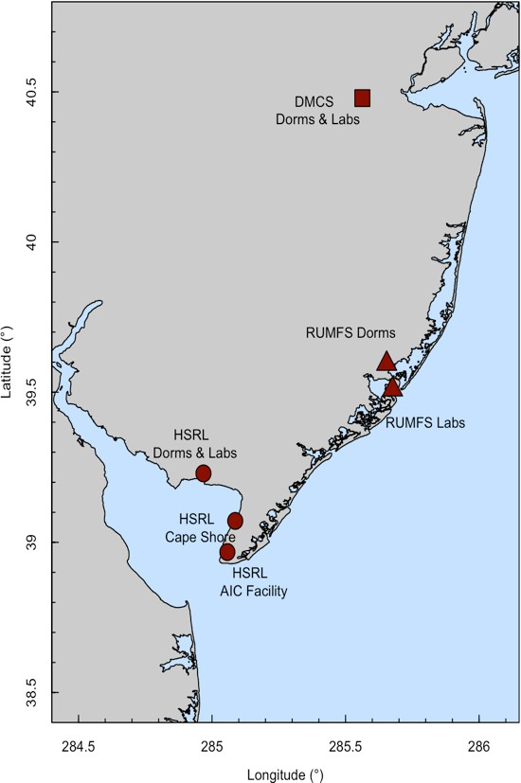

Figure 1. Map of Rutgers main campus in New Brunswick (DMCS; red square) and coastal facilities along the ocean (RUMFS; red triangles) and Delaware Bay (Haskin Shellfish Laboratory; red circles) coasts.

The contributions of the RIOS program to science go beyond the research that students and mentors advance year after year and the dissemination of projects results through presentations and publications. For many students, participation in the RIOS program represents a crossroads in their careers – a mechanism to help them answer a life-changing question: *After completing my undergraduate degree, do I want to pursue a career in research?*

In summer 2017 and updated in 2019, we conducted a survey to learn about the career paths of students who had participated in the RIOS program from 2010 through 2018. We sent links to a short survey (Survey Monkey) to all former RIOS participants (n=96). Current email addresses were obtained though social media (all cohorts have established Facebook groups). In total, 66 completed the survey, which included between 6-9 respondents for every RIOS cohort.

The overwhelming majority of respondents (94%) indicated that their participation in the RIOS program influenced their career choices. Not surprisingly, among our most recent participants, the perception of how much the RIOS program influenced their career path is very high.

To gain insight into whether this goal was accomplished and into the students’ experiences in general, RIOS participants completed pre- and post- evaluations, which included demographic questions as well as questions on the students’ relationships with their mentors, confidence and knowledge of science practices before and after the internship, and overall feelings about the program.

Evaluations from RIOS participants in 2018 (n=11) indicate significant increases in the participants’ knowledge of all six scientific skills (Table 1) when comparing matched pre- and post- survey responses. The two areas that showed the largest average change between pre and post survey responses were knowledge of the research poster design (2.1±0.3) and presenting research to colleagues (1.7±0.3).

|  |  |  |  |
| --- | --- | --- | --- |
| **Scientific Skill** | **Average Before** | **Average After** | **Average Change** |
| The research process | 3.6 | 4.6 | 1.0 |
| Writing a research proposal | 3.2 | 4.4 | 1.2 |
| Research poster design | 3.3 | 4.5 | 1.2 |
| Presenting research to colleagues | 3.1 | 4.6 | 1.5 |
| Publishing research/ paper preparation | 2.4 | 3.7 | 1.3 |
| Career opportunities in oceanography | 2.6 | 4.2 | 1.6 |

Table 1. Knowledge of six scientific skills rated by RIOS participants before and after completing the program. Survey ratings were: 1 = nothing, 2 = little, 3 =some, 4 = fair amount, 5 = substantial amount.

Participation in RIOS positively impacted the students’ confidence in their ability to perform certain tasks (Table 2). Results indicated that there was a significant positive change in students’ confidence in six of the 12 scientific tasks that they were asked about. The largest changes were seen in their ability to contribute to science, discuss scientific concepts with others, prepare a scientific poster, defend an argument, and analyze data.

|  |  |  |  |
| --- | --- | --- | --- |
| **Scientific Tasks** | **Average**  **Before** | **Average**  **After** | **Average**  **Change** |
| Contribute to science | 3.7 | 4.5 | 0.8 |
| Discuss science concepts with others | 3.2 | 4.4 | 1.2 |
| Work collaboratively with others | 4.4 | 4.7 | 0.3 |
| Do well in future science courses | 4.4 | 4.6 | 0.2 |
| Write scientific reports or papers | 3.6 | 4.2 | 0.6 |
| Making oral presentations | 3.5 | 4.2 | 0.7 |
| Defend and argument | 3.1 | 4.2 | 1.1 |
| Prepare a scientific poster | 3.3 | 4.7 | 1.4 |
| Make and record observations | 4.1 | 4.5 | 0.4 |
| Analyze data | 3.4 | 4.1 | 0.7 |
| Understand journal articles | 3.4 | 3.9 | 0.5 |
| Find relevant scientific literature | 3.6 | 4.2 | 0.6 |

Table 2. Knowledge of twelve scientific tasks rated by RIOS participants before and after completing the program. Survey ratings were: 1 = nothing, 2 = little, 3 =some, 4 = fair amount, 5 = substantial amount.

***Mentor/Mentee Relationship:*** Ultimately, the students’ experiences with their mentors will likely determine their perceptions of success or failure. Our survey included Likert scaled question asking students how helpful their mentors were in the areas concerning the research process overall as well as helping them explore connections between marine science and other science disciplines. The following table provides percentages for each of the concepts.

|  |  |  |  |
| --- | --- | --- | --- |
| **Concept** | **Not**  **Helpful** | **Helpful** | **Very**  **Helpful** |
| Analyzing data for patterns |  | 63.6% | 36.4% |
| Figuring out the next step in the research process | 9.1% | 54.5% | 36.4% |
| Problem Solving in General | 27.3% | 72.7% |  |
| Formulating research questions that can be answered | 10% | 50% | 40% |
| with data |  |  |  |
| Identifying limitations of research methods and | 9.1% | 54.5% | 36.4% |
| designs |  |  |  |
| Understanding theory and concepts guiding my | 54.5% | | 45.5% |
| research project |  |  |  |
| Understanding connections among scientific | 36.4% | 45.5% | 18.2% |
| disciplines |  |  |  |
| Understanding the relevance of research to my | 27.3% | 72.6% | |

coursework

Table 3. Summary of responses from the mentees when asked how helpful their mentors were on various tasks.

It is clear from the results that most interns felt their mentors to be helpful in most aspects. Only one, “understanding connections among scientific disciplines,” ranked rather low overall. In general, students in the 2018 cohort enjoyed working in the lab and conducting independent research with assistance from the mentors.

*“One of the biggest things I did was to conduct my research independently, although I had help from my mentor”*

*“I like how it was my first experience in an independent project and really guided me through that process.”*

They also seemed to enjoy the independence and hands-on aspects of the program.

*“I liked the hands-on opportunity of the program. My mentor was always available to answer questions, which made this summer a lot more beneficial to my future in science and research”*

*“I liked the end of the year poster session. It was a great experience, it taught me about narrowing down data to what is most important, and it allowed me to see what everyone else has done.”*

And they enjoyed making connections.

*“I like that I was able to make connections and have fun while working.”*

*“I like the first week of orientation because it helped us form connections and be friends. There was nothing that I didn't enjoy.”*