# Sustained Ocean Observations with underwater gliders in support of hurricane intensity forecasts

Funding agency: NOA OAR

Partners: University of Delaware

Period of Performance: 01/01/2019-12/31/20

Total Budget: $869,062

The Rutgers University Center for Ocean Observing Leadership (RUCOOL) will conduct tasks described below in support of the project “ Sustained Ocean Observations with underwater gliders in support of hurricane intensity forecasts” submitted to the NOAA research announcement NOAA-OAR-HSPO-2019-200590.

RUCOOL will prepare and deploy 3 autonomous underwater gliders a total of 6 times each year for the 2019 and 2020 hurricane seasons. This will include procurement of new rechargeable batteries, glider ballasting, glider deployment, piloting, recovery, recharge and re-deployment. Glider lead PI and senior personnel will work closely with project partners to coordinate glider deployment locations and sample strategy. A data analyst will ensure high quality data submission to the Integrated Ocean Observing System (IOOS) data assembly center (DAC) and trace data as it’s assimilated into the operational coupled hurricane forecast models.

**Project Title:** Sustained Ocean Observations with underwater gliders in support of hurricane intensity forecasts

**Project Lead:** Travis Miles (Rutgers University)

**MARACOOS Executive Director:** Gerhard Kuska (University of Delaware)

The work proposed here responds to the National Oceanic and Atmospheric Administration (NOAA) Disaster Related Appropriations for Improving Forecasting and Assimilation (DRA IFAA) Portfolio. The specific focus area is: 2f “Accelerate Improvements in Hurricane Intensity Forecasting: support the continued availability and use of ocean observation platforms and systems for improvements to hurricane forecasting skill, specifically regarding intensity and track”

# Background Why do this work?

Hurricanes are some of the costliest and most dangerous natural hazards on Earth. In the US alone their high winds, storm surges, and heavy precipitation are responsible for over 1400 deaths since 2005, have accounted for nearly 50% of all billion dollar or greater natural disasters, and cost an average of over $15 billion per disaster [(https://www.ncdc.noaa.gov/billions/).](http://www.ncdc.noaa.gov/billions/)) With increasing development and growing populations near the coastlines these impacts have the potential to increase. To effectively plan and prepare for these extreme events, accurate forecasts of tropical cyclone track and intensity are required. Track forecasts have improved dramatically since 1970, yet similar progress has lagged in hurricane intensity prediction (Figure 1).

Unexpected rapid intensification in the hours before landfall has the potential to catch coastal communities off guard, while rapid weakening can erode future forecast credibility among the public.

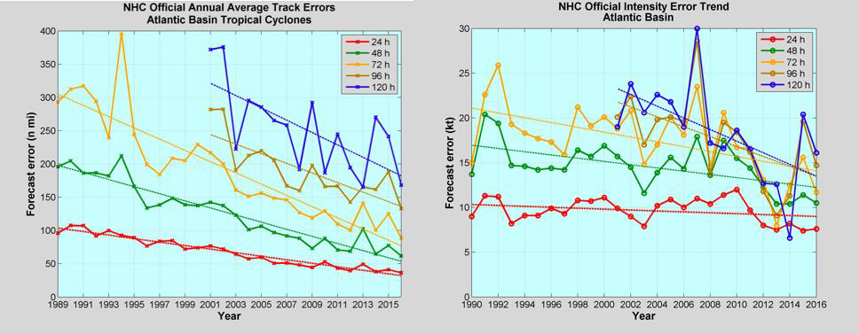

**Figure 1.** (left) NOAA’s official tropical cyclone track forecast error for the Atlantic Basin during the period 1989-2016 and (right) NOAA’s official tropical cyclone intensity forecast error for the Atlantic Basin during the period 1990-2016 (source: [http://www.nhc.noaa.gov/verification/verify5.shtml).](http://www.nhc.noaa.gov/verification/verify5.shtml))

Factors contributing to rapid intensity changes in hurricanes include upper level wind shear, interactions with topography, and the fluxes of heat and momentum across the air-sea interface. In general, the upper ocean heat content has been linked to hurricane intensification (Figure 2). However, and most specifically, the intensification or weakening due to the air-sea fluxes depend on the surface temperatures of the atmosphere and ocean. Strong hurricane forcing can produce rapid changes in the upper ocean thermal structure, which then feeds back on the heat fluxes into or out of the hurricane. Ocean models that improperly forecast the rapid evolution of the ocean surface temperature during a strong hurricane event will improperly represent the air-sea fluxes and, in turn, will improperly forecast the impact of the ocean on intensity change.

This work will be carried out in partnership between NOAA/AOML, SECOORA, CARICOOS, and other participating IOOS regional associations. The MARACOOS group will be focused on The Mid Atlantic region. The southern portion of this region off Cape Hatteras, NC, was recently devastated by Hurricane Florence in 2018, while the central Mid Atlantic Bight including New Jersey and New York was dramatically impacted by both Hurricane’s Irene and Sandy in 2011 and 2012, respectively. The Cold Pool on the shallow Mid Atlantic is located in waters shallower than 100 meters, a region not covered by Argo profiling floats. Gliders deployed in this region can collect over 15,000 profiles of temperature and salinity per glider during each hurricane season. With 3 to 5 gliders deployed in the Mid Atlantic each year this will vastly increase the number of profiles inserted into the GTS each year, greatly increasing the data available to resolve the Cold Pool.

NOAA, the IOOS Regional Associations, and several universities have deployed gliders in regions where Atlantic hurricanes rapidly intensify and weaken and they have gained significant individual experience in hurricane deployment and data analysis. Through this proposal they are bringing together the next step in the research to operations transition of hurricane glider monitoring. By combining resources, expertise, and regional and local knowledge glider hurricane monitoring will be scaled up to protect the multiple regions vulnerable to hurricane impacts.

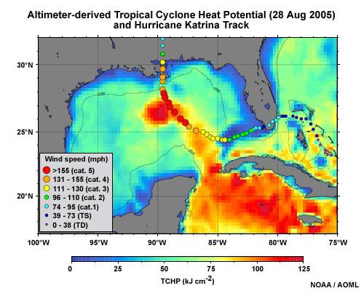

**Figure 2.** Track of Hurricane Katrina (2005) superimposed to the altimetry-derived Tropical Cyclone Heat Potential (TCHP) showing that this hurricane intensified while traveling over warm waters in the Gulf of Mexico.

*Why underwater gliders?*

NOAA/AOML performed Ocean System Simulation Experiments (OSSEs) over the open North Atlantic Ocean to quantitatively assess the impact of seasonal deployments of multiple underwater gliders toward reducing errors and biases in ocean analyses used to initialize the ocean component of coupled tropical cyclone prediction models. Initial results indicate that gliders are particularly effective at reducing errors in ocean mesoscale structure compared to ocean profiles sampled at fixed locations (e.g. moorings, expendables, etc). To achieve this improvement, each glider must be piloted to map the upper ocean over a specified sub-region of the full domain containing the glider array while maintaining a reasonably constant separation distance among the gliders. The largest error reduction is achieved at 2.0 degree or less separation between gliders. By contrast, ocean profile observations at fixed locations must be collected with nominal spacing of 1.0 degrees or less to achieve equal or greater error reduction in mesoscale structure. Adjustment of the three-dimensional pressure field associated with mesoscale features occurs slowly over a 1-2 month time interval, so seasonal glider arrays must be deployed at the beginning of the hurricane season to achieve best impacts. Correction of the ocean temperature field over the upper 100 m occurs more rapidly, however, essentially over 3-4 days. The ability of each glider to map a sub-region of the full domain suppresses the rapid nonlinear error growth in the upper-ocean temperature field, enabling seasonal glider arrays to maintain reduced error magnitudes more effectively than fixed profiler observations.

The initialization of ocean conditions is essential to coupled tropical cyclone (TC) forecasts. Current work indicates critical impact of ocean observations assimilation, particularly assimilating underwater glider data, to correctly represent the ocean within the NOAA experimental high-resolution coupled TC forecast model, the Hurricane Weather Research and Forecasting (HWRF) - Hybrid Coordinate Ocean (HYCOM) system. Through the assimilation of underwater glider observations during the passage of Hurricane Gonzalo (2014) results indicate that the ocean initial conditions are best represented when both the conventional ocean observations and the underwater glider data are assimilated together. Gliders are able to identify barrier layers, which are key to limit the mixing of the warm upper waters with the lower colder waters. The barrier layer and the associated sharp density gradient in the upper ocean, which were present during the intensification of Gonzalo (2014), are successfully represented in the ocean initial conditions only with the use of underwater glider observations. For this hurricane, the upper ocean temperature and salinity forecasts in the first 48 hours are improved by the assimilation of both underwater glider and conventional ocean observations.

Through OAR research the relationship between hurricane intensity and the Mid Atlantic’s two- layer water column structure has now been established. The missing essential ocean feature is the unseen bottom Cold Pool. This vast (1000 km long x100 km wide) cold water mass (> 10C) lies below a thin warm layer (>28C) during the Atlantic hurricane season and is unobservable by satellites. By deploying autonomous underwater gliders ahead of Mid Atlantic land falling hurricanes, the Cold Pool was mapped and its evolution monitored, leading to the discovery of

rapid storm induced mixing that cooled the ocean ahead-of-eye-center by up to 11C (Figure 3) [*Glenn et al.*, 2016]. This new ahead-of-eye-center cooling process was shown to be region-wide in multiple hurricanes [*Seroka et al.*, 2017] and is responsible for over 75% of the observed storm driven cooling in the Mid Atlantic since 1985 [*Glenn et al.*, 2016].

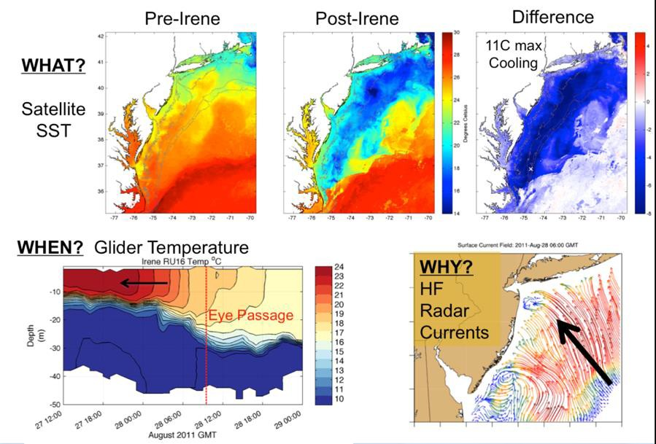

**Figure 3.** The ocean response to hurricane Irene included (top three panels) an ocean cooling of up to 11oC observed by NOAA AVHRR sea surface temperatures. (lower left panel) Glider RU16 deployed mid-shelf reported the rapid cooling of the warm surface layer that occurred ahead-of-eye passage, and (lower right panel) was driven by strong onshore winds and surface layer currents observed by HF radar that resulted in offshore flow the bottom layer and shear-driven mixing between the layers.

Furthermore, the cooling of the surface ocean by the entrainment of the sub-surface Cold Pool was the missing component required to accurately forecast the rapid de-intensification of Hurricane Irene (Figure 4) [*Seroka et al.*, 2016]. In stark contrast, gliders deployed ahead of Superstorm Sandy revealed a different Cold Pool response and impact on intensity. The onshore track, large wind field, and slow approach forced the Cold Pool more than 70 km offshore. This removed the bottom Cold Pool water and resulted in limited surface cooling and little storm weakening ahead of Sandy’s historic storm surge in the region [*Miles et al.*, 2017]. This NOAA OAR research demonstrates that these essential ocean features, a warm surface layer and the bottom Cold Pool, and their rapid evolution during hurricanes, must be well resolved to reduce the uncertainty of hurricane intensity predictions. This can only be accomplished with underwater gliders reporting real-time subsurface profiles over the GTS, since operational ocean models cut off satellite altimeter data assimilation for water depths less than 150 m, leaving satellite Sea Surface Temperature (SST) as the only operational data contribution on continental shelves.

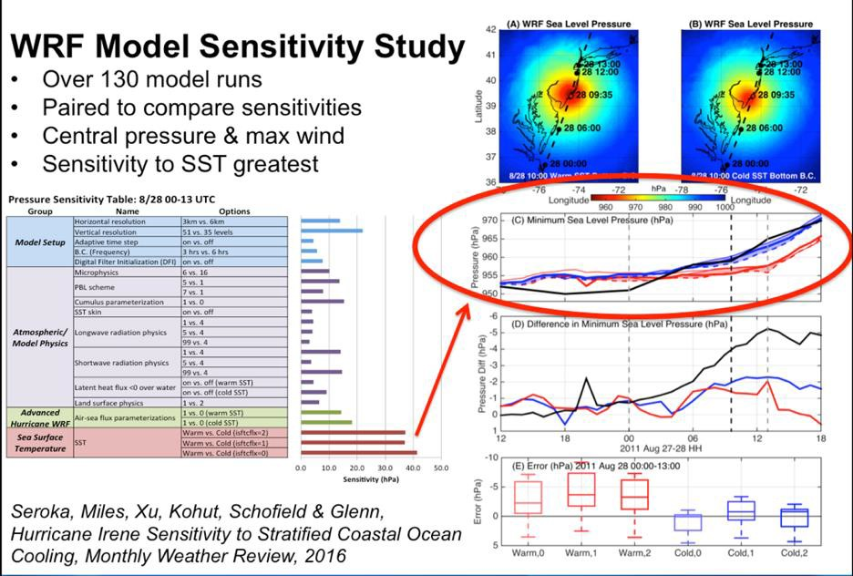

**Figure 4.** Over 130 atmospheric model sensitivities found that the ahead-of-eye-center ocean cooling was the missing process required to forecast Hurricane Irene’s rapid intensity change as it made landfall in New Jersey [*Glenn et al.*, 2016].

# Outcome

Underwater glider operations will be maintained during the 2019 and 2020 seasons as part of this project. In the Mid Atlantic, this will include at least 3 gliders deployed with rechargeable batteries for at least 2 consecutive 45 day deployments each glider each year. Using rechargeable batteries not only reduces overall per deployment costs, it allows for a brief recovery at 45 days, which enables the team to clean the glider of bio-fouling midway through the hurricane season. This is critical to maintain data quality on the shallow, biologically active, continental shelf. All ocean profile data obtained by these gliders will be transmitted in real-time into the Integrated Ocean Observing System (IOOS) Data Assembly Center (DAC) and then onto the GTS and into data distribution centers making it available for data assimilation in operational models.

These data will undergo rigorous quality control and assurance procedures in accordance with MARACOOS recent certification as a federally certified data provider. A glider data analyst will trace glider data profiles through the IOOS DAC, to the GTS, and into the NOAA and Navy operational coupled ocean and atmosphere hurricane forecast systems. Profiles from the gliders will be compared with operational models in real time to evaluate data impacts and provide feedback on model performance to operational teams.

# Description of any prior work that will contribute to this task.

*Atlantic hurricane intensification*

Recent NOAA research used data from targeted deployments of autonomous underwater gliders to assess the state and evolution of vertical temperature and salinity that are then included in the HYCOM-HWRF experimental operational ocean model used for hurricane forecasting. Gliders

have shown to be key to identify barrier layers, which are layers of low salinity/density very warm waters that prevent strong mixing with underlying colder layers and, therefore, may potentially contribute to hurricane intensification. NOAA/AOML and NOAA/EMC work [*Dong et al.*, 2017], has shown that the appropriate initialization of the ocean component of the HYCOM-HWRF intensity forecast model improves the representation of the upper ocean while reducing the error of the intensity forecast (*Dong et al.*, 2017, and Figure 5).

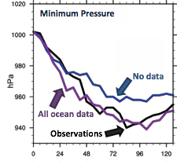

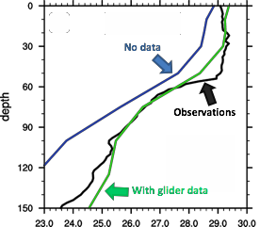

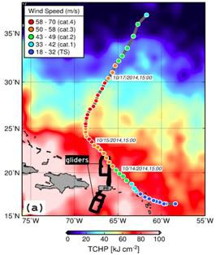

**Figure 5.** Results obtained using AOML-CARICOOS glider and other ocean data during Hurricane Gonzalo (2014), showing the impact of in-situ data to improve the ocean representation and the minimum atmospheric pressure forecast.

*Mid-Atlantic hurricane intensification vs. weakening*

Recent Rutgers research has established the relationship between hurricane intensity and the Mid Atlantic two-layer water column structure. Fast moving storms that travel closer to land produce a strong baroclinic circulation resulting in shear-induced mixing between the warm surface layer and the Cold Pool, resulting in rapid and intense ahead of eye ocean cooling and hurricane weakening. Slow moving offshore storms produce classic downwelling circulation patterns and advection of the Cold Pool offshore, leaving behind warm water with the potential to intensify hurricanes. The worst-case scenario for impacts is when a Sandy-type storm advects the Cold Pool offshore and intensifies as it crosses the warm continental shelf waters in summer. But the bottom Cold Pool is often missing in the models typically used for coupled atmosphere-ocean hurricane forecasting leading to high intensity uncertainty for hurricanes making landfall in the region. In the past year, glider data and model comparisons have been carried out with the Rutgers ROMS ESPreSSO model, the Navy’s Global Ocean Forecast (GOFS) version 3.0 and 3.1, as well as the European Copernicus Marine Environmental Monitoring System (CMEMS) Mercator. The spatial extent and temperature of the Cold Pool is highly variable across model products and is most poorly represented in GOFS 3.0 and most accurately represented in the ROMS ESPreSSO model domain. While the global ocean models GOFS and CMEMS Mercator are not specifically designed to resolve continental shelf features, HWRF will utilize an ocean model initialized from GOFS 3.0 in the summer of 2018 and has future plans to adopt the Navy’s new GOFS 3.1, which includes increased vertical resolution near the coast and Improved Synthetic Ocean Profiles (ISOP) for assimilation. Currently there is limited in situ observations

on the MAB and other continental shelves during hurricane conditions capable of both validating GOFS 3.0 and 3.1 physics or data assimilation. This project represents a unique opportunity to validate, and improve the representation of the Essential Ocean Feature, the Cold Pool, in the Mid Atlantic Bight with dedicated ocean glider deployments during a critical model transition period.

# Period of Performance

**Effective Start Date:** January 1, 2019

**Expected Completion Date:** December 31, 2020

# Scope and Description

**List Scope from briefing package**

Underwater glider observations: Enhance the current glider efforts by establishing a “picket line” network of up to 14 underwater gliders in the Caribbean Sea, tropical Atlantic Ocean, and east US continental shelf to carry out upper ocean observations of temperature and salinity in support of intensity (intensification and weakening) studies and forecasts.

# Describe actual work to be accomplished

*Underwater gliders*

The correct representation of initial subsurface structure and evolution of ocean features in coupled hurricane forecast models remain critical factors that have been shown to improve hurricane intensity forecasts [*Miles et al.*, 2015, 2017; *Glenn et al.*, 2016; *Dong et al.*, 2017]. Work proposed here will provide real-time ocean profile observations in regions of high uncertainty for rapid intensification and weakening:

* + The Caribbean Sea and SW Tropical North Atlantic (AOML and CARICOOS)
  + The Mid Atlantic continental shelf (from Cape Hatteras, NC to Cape Cod, MA) (MARACOOS)
  + The northern portion of the South Atlantic Bight (SECOORA)

We propose to build and operate an underwater glider network based on a fleet of gliders deployed in a picket fence spatial distribution and capable of mapping in realtime the three dimensional structure of ocean features that are critical for hurricane intensity forecasting, such as the Caribbean Warm Pool and Mid Atlantic Cold Pool. The building of this network will be mostly based on the use of current assets. Gliders will be configured to be operated for the full Atlantic hurricane season, some of them with a suite of advanced environmental monitoring sensors. This glider network will maintain a series of lines designed to monitor the upper ocean density (temperature and salinity) of essential ocean features and their background waters in regions where Atlantic hurricanes rapidly intensify or de-intensity, and of high intensity forecast uncertainty.

Observations will be carried out using current assets in the regions listed above:

* + Caribbean Sea and SW Tropical North Atlantic (NOAA/AOML, CARICOOS, NOAA/NDBC)
  + Mid Atlantic Bight (MARACOOS glider operators: Rutgers University, VIMS, U. of
  + Delaware, U. Mass Dartmouth).
  + South Atlantic Bight (SECOORA)

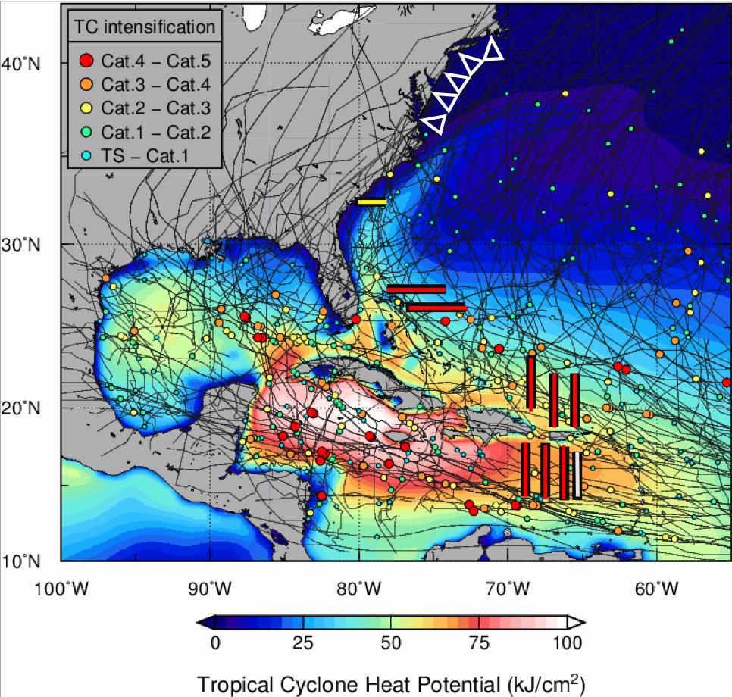

**Figure 6.** Proposed location of underwater glider observations during the 2019 and 2020 Atlantic hurricane season, including AOML and AOML-CARICOOS observations (red lines), Rutgers University-MARACOOS (white triangles), SECORA (yellow line) and NOAA/NDBC (gray line) observations.

*Data Management*

The data from the fleet of gliders will be transmitted in real time through established data networks (e.g GTS, US glider DAC, etc) for incorporation into operational and experimental forecast systems. Data are expected to contribute to improve the ocean model representation in real time ocean forecast models.

# Itemized list of major milestones

* Prepare gliders and have ready for deployment during the Spring of 2019
* Deployment and operations of underwater gliders during most of the 2019 and 2020 hurricane seasons
* Insert glider quality-controlled temperature and salinity profile data into the GTS in

real-time (within 12 hours of the observation being made).

* Distribute quality-controlled temperature and salinity profile data to distribution centers (including IOOS Glider DAC) in real-time and delayed-mode
* Provide quality-controlled data in real-time and delayed-mode

# References

Dong, J., R. Domingues, G. Goni, G. Halliwell, H.-S. Kim, S.-K. Lee, M. Mehari, F. Bringas, J. Morell, and L. Pomales (2017), Impact of Assimilating Underwater Glider Data on Hurricane Gonzalo (2014) Forecasts, *Weather Forecast.*, *32*(3), 1143–1159, doi:10.1175/WAF-D-16-0182.1.

Glenn, S. M., T. N. Miles, G. N. Seroka, Y. Xu, R. K. Forney, F. Yu, H. Roarty, O. Schofield, and J. Kohut (2016), Stratified coastal ocean interactions with tropical cyclones, *Nat.*

*Commun.*, *7*(10887), 1–10, doi:10.1038/ncomms10887.

Miles, T., G. Seroka, J. Kohut, O. Schofield, and S. Glenn (2015), Glider observations and modeling of sediment transport in Hurricane Sandy, *J. Geophys. Res. C Ocean.*, *120*(3), 1771–1791, doi:10.1002/2014JC010474.

Miles, T., G. Seroka, and S. Glenn (2017), Coastal ocean circulation during Hurricane Sandy, *J. Geophys. Res. Ocean.*, *122*(9), 7095–7114, doi:10.1002/2017JC013031.

Seroka, G., T. Miles, Y. Xu, J. Kohut, O. Schofield, and S. Glenn (2016), Hurricane Irene Sensitivity to Stratified Coastal Ocean Cooling, *Mon. Weather Rev.*, *144*(9), 3507–3530, doi:10.1175/MWR-D-15-0452.1.

Seroka, G., T. Miles, Y. Xu, J. Kohut, O. Schofield, and S. Glenn (2017), Rapid shelf-wide cooling response of a stratified coastal ocean to hurricanes, *J. Geophys. Res. Ocean.*, *122*(6), 4845–4867, doi:10.1002/2017JC012756.