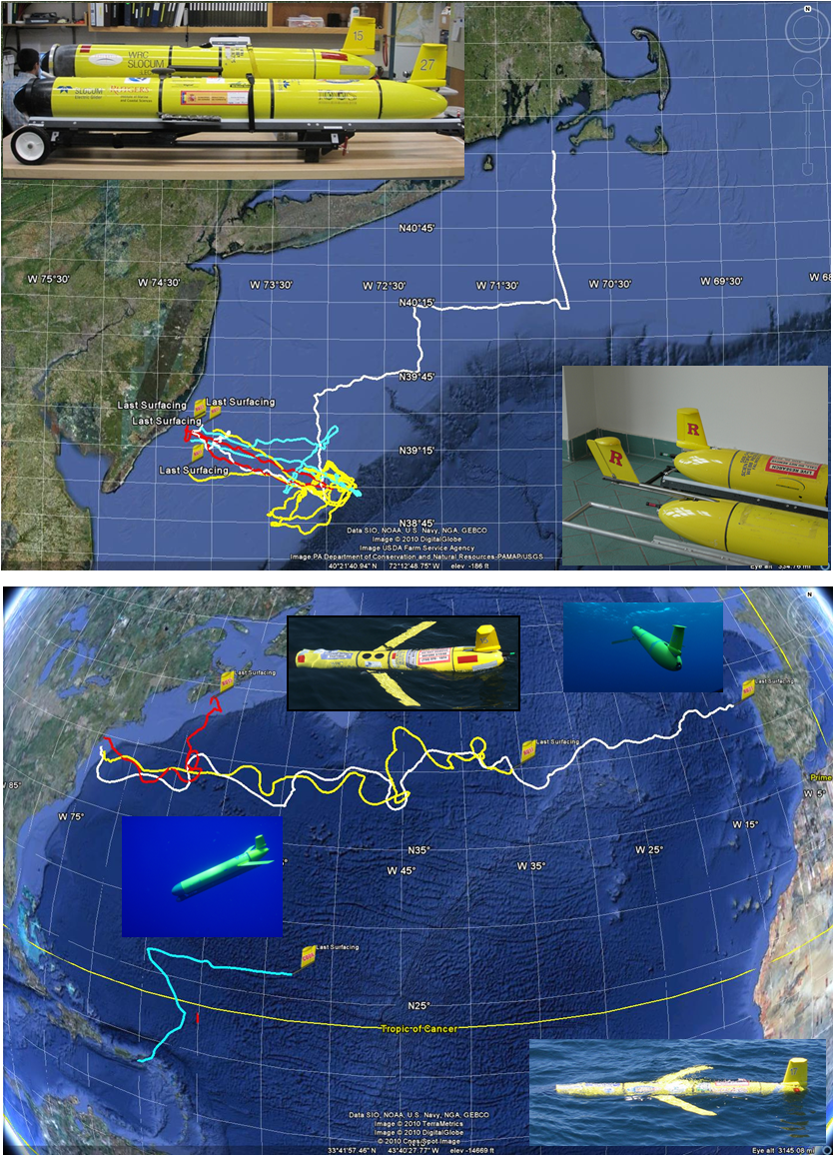
A
C
RU27
RU15
RU17
Cook
D
B
Figure 1: (A) Photo of the standard length payload bay of RU15 (top) compared to the extended payload bay of RU27 (bottom). (B) Photo of the original, longer boom Slocum fin (bottom) and the newly designed, shorter boom “DigiFin”, which is now standard on all Slocum gliders. (C) Tracks of RU17 (white, blue, red) and RU27 (yellow) test flights on the New Jersey Shelf. (D) Tracks of RU15 (red), RU17 (yellow), RU27 (white) and Cook (blue), and photos of RU15, RU27, Cook and RU17 deployed at sea.
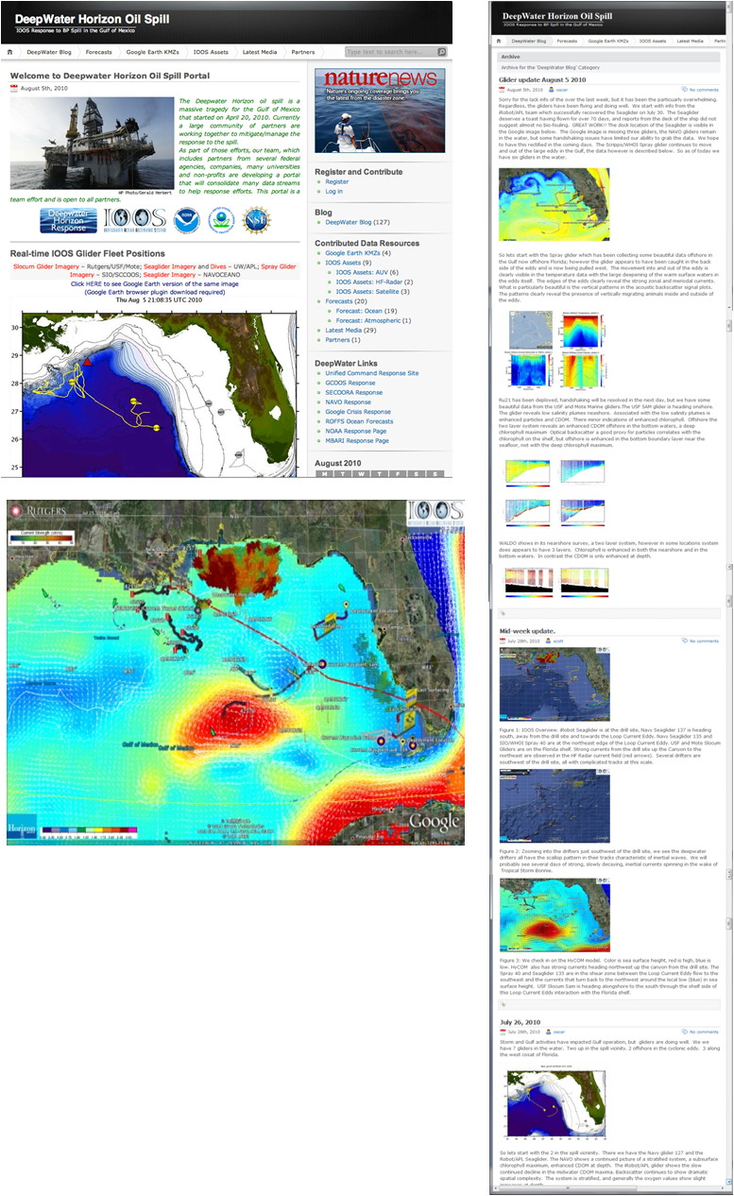
Figure 2: Collaborative interfaces developed for the educational flight of RU27 now being applied to the Gulf of Mexico Deepwater Horizon oil spill for IOOS. (A) Web portal to organize access to a wide range of data products. (B) Google Earth interface to overlay ocean model results (HyCOM sea surface height and surface currents), HF Radar Surface current fields, glider and drifter tracks. (C) Public blog website to post and explain new results.
C
B
A
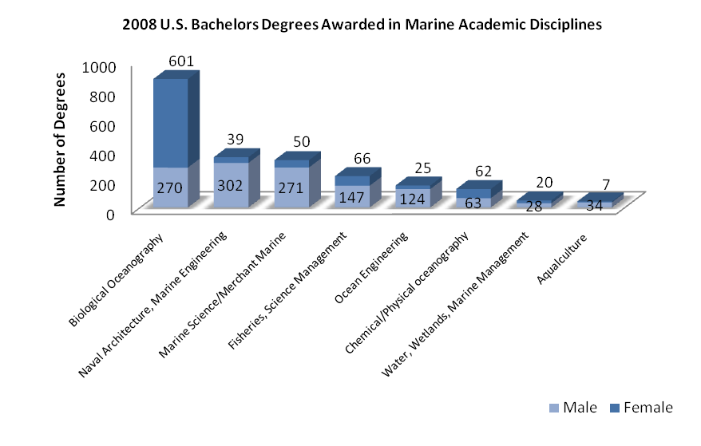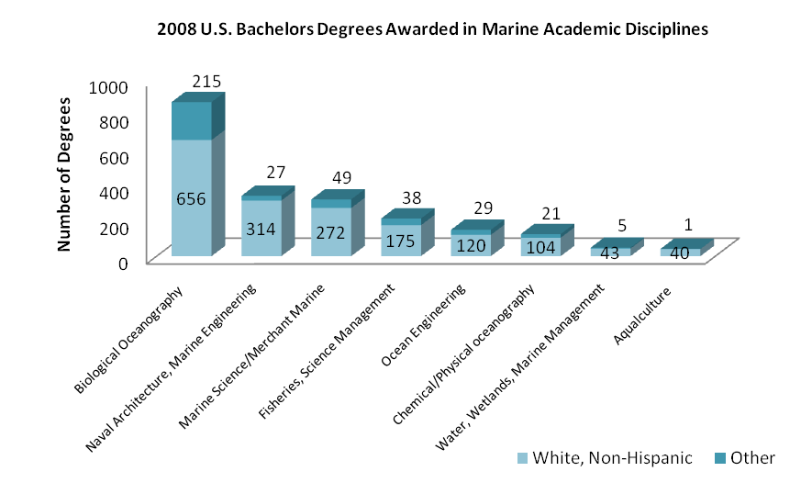
B)
A)

Figure 3: Distribution of the 2,109 U.S. Bachelor’s degrees awarded in marine academic disciplines for 2008 by sex (a) and ethnicity (b). Source: National Science Foundation.

Figure 4: RU15: Significant wave height (A) and wave periods (B) from a nearby NOAA weather buoy for a winter storm (C) passing over RU15 (red star in Figure 1D) on its way to Halifax.

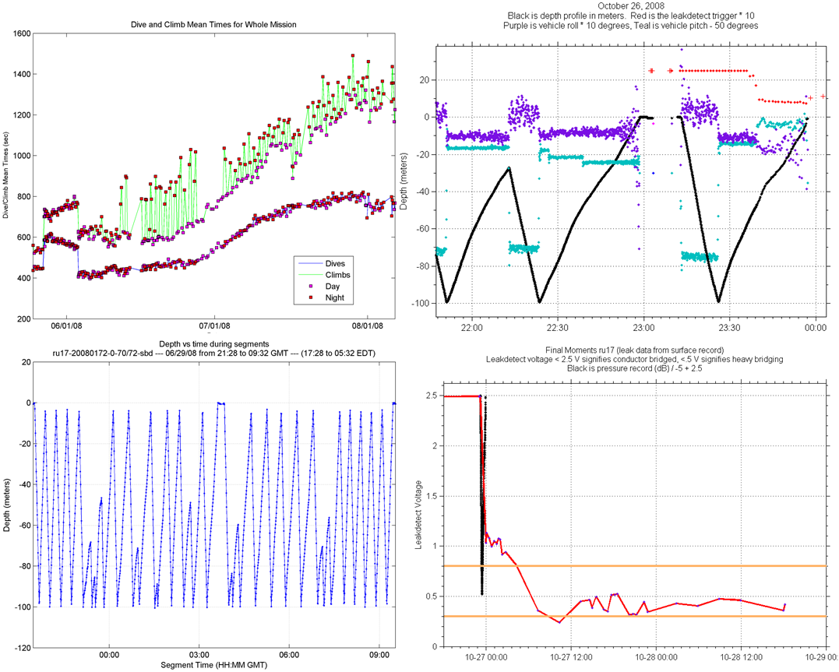
D
B
C
A
Figure 5: RU17: (A) Average duration of full excursion dives (bottom line) and climbs (top line) from late May through early September, 2008. Day-night variation in the climb performance is observed. (B) Sample showing normal climbs (100 m to 2 m) and aborted climbs during a night time segment. (C) Pressure record (black dots) from the end of a normal dive and the subsequent aborted dive due to a leak detect (x10 red dots). Also plotted are vehicle pitch (-50 degrees in teal) and vehicle roll (x10 in purple). (D) Time series of leak detect voltages (red) from the time of the last dive (black dots) on 10/27 until the loss of communications on 10/28. Yellow bars show the range of leak detect voltages in laboratory tests for salt water touching the leak detect sensor (top) to full immersion (bottom). (Source: Vowinkel, Holden, Lund, Randall-Goodwin, Rogalsky& Shapiro, 2008).

Figure 6: Trans-Atlantic track of RU27 marking the location of 16 significant events in the flight. Insets: (2) RU27 leaves the shallow water and fishing activity of the Mid-Atlantic Bight continental shelf; (3) RU27 navigates the meandering warm jet of the Gulf Stream flowing from Cape Hatteras to the Grand Banks; (6) RU27, after encountering a strong head-current, flies around the southern side of a large cyclonic cold-eddy; (8) RU27 approaches the Phantom Eddy in the HyCOM forecast, an artifact generated by the data assimilation scheme; (11) Hurricane Bill leaves the U.S. East Coast and turns east toward RU27; (16) RU27 is approached by the Spanish R/V Investigador for recovery (photo by diver Dan Crowell). (Source: Evans &Strandskov, 2009).
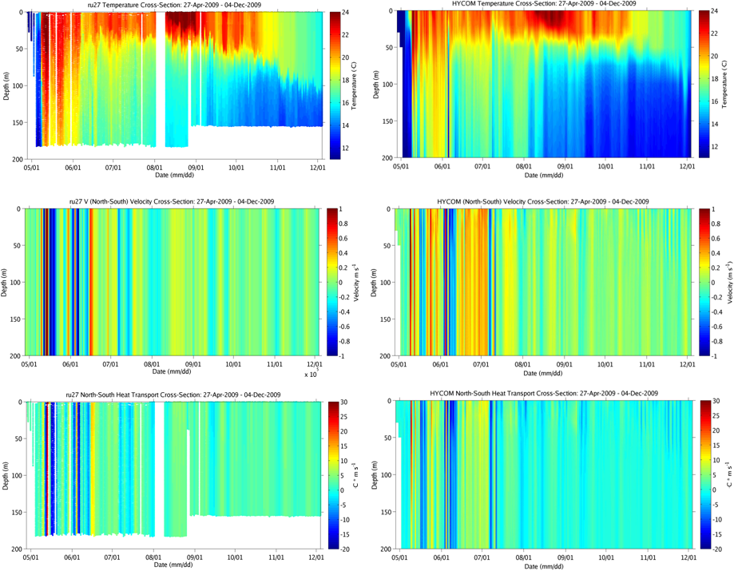
A
D
C
F
B
E
Figure 7: Comparison of measured (Glider RU27 – A,B,C) and modeled (HYCOM – D,E,F) trans-Atlantic cross sections of temperature (A,D), North-South component of the current (B,E) and north-south component of the heat transport (C,F) along the track shown in Figure 1D.

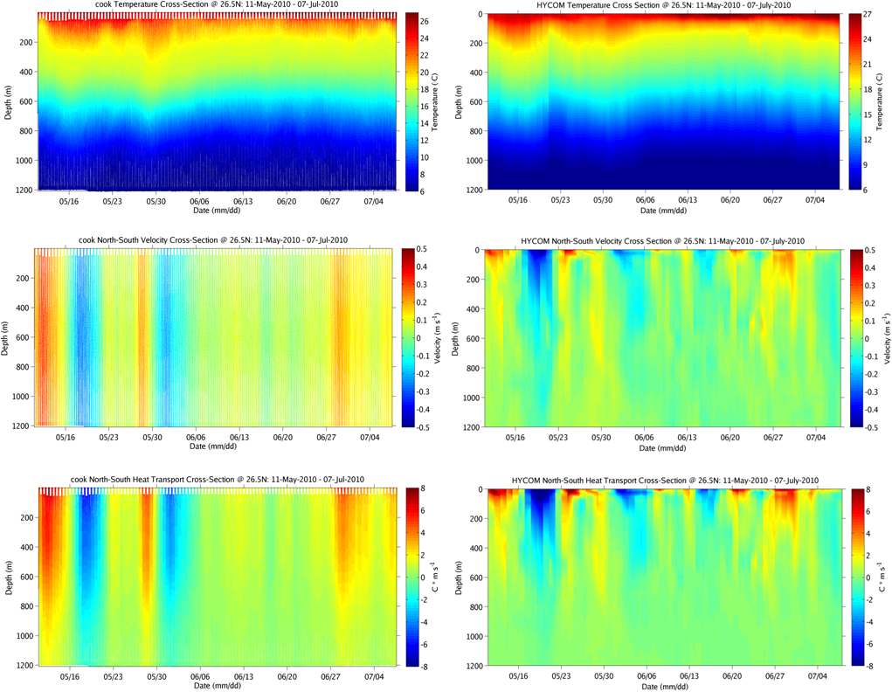
D
A
F
E
C
B
Figure 8: Comparison of measured (Glider Cook – A,B,C) and modeled (HYCOM – D,E,F) cross sections of temperature (A,D), North-South component of the current (B,E) and north-south component of the heat transport (C,F) along the 26.5⁰N portion of the track shown in Figure 1D.

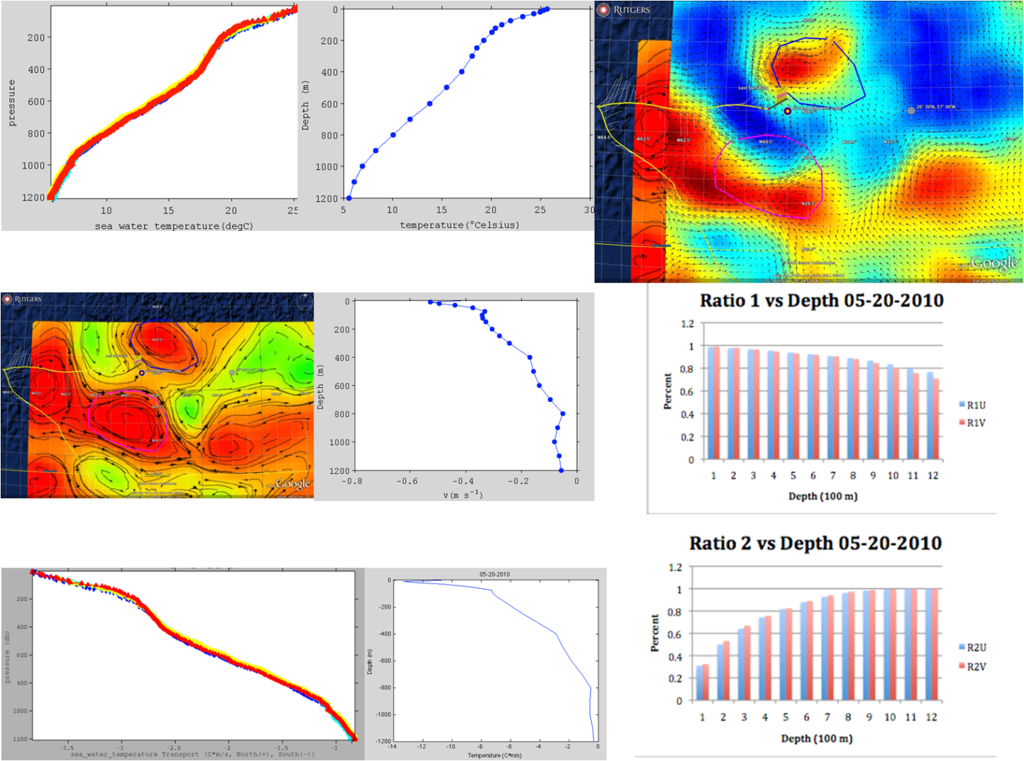
I
G
H
F
E
D
C
B
B
A
Figure 9: Thermal Glider Cook (A,B,C) and HyCOM (D,E,F) heat transport calculations. Temperature (A,D), North(+)/South(-) velocity (B,E), and North(+)/South(-) temperature anomaly transport (C,F). Cook’s track (yellow line) and depth-averaged currents superimposed on maps of the sea surface height and surface currents from satellite altimetry (B) and HyCOM (G). Ratio 1 (H): Heat transport in the East/West (blue) and North/South (red) calculated for a virtual glider returning the depth averaged currents divided by the estimate from HyCOM using the forecast current profile from the same depth. Ratio 2 (I): HyCOM heat transport in the East/West (blue) and the North/South (red) for different water depths divided by the HyCOM heat transport from 0 m to 1200 m. (Source: Glenn, Ibanez & Snow, 2010).

A
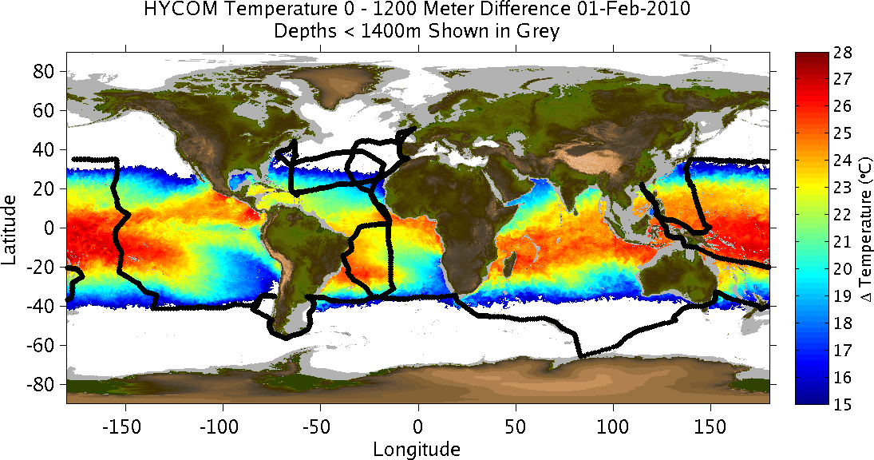
B
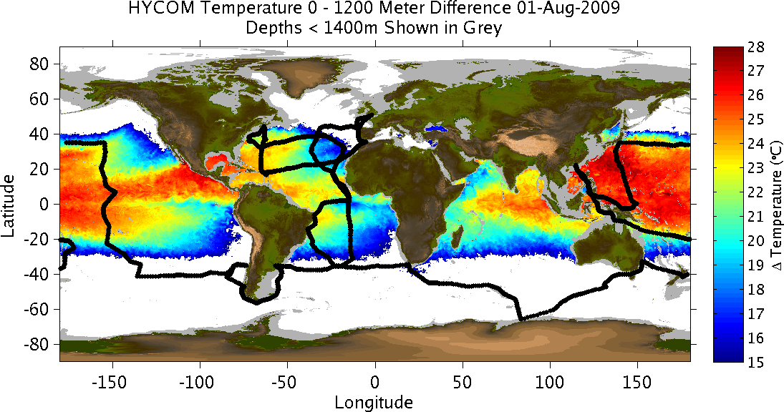
Figure 10: Absolute change in temperature (degrees Celsius) between the surface and 1200 meters during the (A) winter and (B) summer. Gray-shaded areas denote ocean depths shallower than 1400m. White-shaded areas denote a temperature difference of less than 15 degrees Celsius. HMS Challenger (1872-1876) track (black) is overlaid. Data taken from HYCOM forecast.

