Brief Bio-
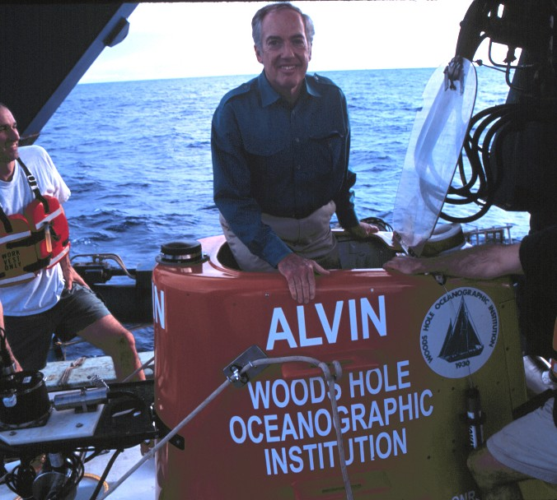
Dr. Peter Rona

Dr. Peter Rona is a geological oceanographer credited with many discoveries including the first seafloor hydrothermal field, vent ecosystem with animals new to science, and polymetallic sulfide deposits found in the Atlantic Ocean .

His present research comprises diverse themes:
- development and application of innovative acoustic methods to image and quantify the flow from seafloor hydrothermal vents, currently applied to monitor hydrothermal flow off northwestern North America as part of the first cabled seafloor observatory on an ocean ridge
- exploration of Hudson Canyon, a submarine extension of the Hudson River into the deep ocean basin, with emphasis on the role of gas hydrates in canyon ecosystems and in slope instability
- exploration of ocean ridges to advance understanding of their structure, dynamics and mineralization processes, with current work on the Mid-Atlantic Ridge and Carlsberg Ridge.
- study of marine mineral resources with emphasis on hydrothermal mineralization
- pursuit of Paleodictyon nodosum, one of the oldest living fossils, the subject of the award winning IMAX film, Volcanoes of the Deep Sea.

He served as senior research geophysicist with the National Oceanic and Atmospheric Administration (NOAA) for 25 years before joining Rutgers University as Professor of Marine Geology and Geophysics. Teaching graduate and undergraduate courses, he also serves as student adviser and as initiator and director of the Engineering Geophysics Certificate Program which guides students to cross over between science and engineering giving them a competitive edge in research and the job market.

He publishes extensively in the scientific literature (over 250 papers and 5 edited books), serves as an editor (former associate editor for Bulletin of Geological Society of America and Journal of Geophysical Research), as a contributor to the popular media and is a popular public speaker. He serves as consultant on marine minerals to the United Nations and the International Seabed Authority and is an active advisor to public science centers.
Fellow of a number of scientific and related societies, including the American Geophysical Union, Geological Society of America, Acoustical Society of America, Society of Economic Geologists, American Association for the Advancement of Science, and The Explorers Club.
Recipient of awards including the Shepard Medal for Excellence in Marine Geology, the Pettersson Bronze Medal of the Swedish Academy of Sciences, and the U.S. Department of Commerce Gold Medal for exceptional scientific contributions to the nation.
Selected recent publications:
Peter A. Rona, Colin W. Devey, Jerome Dyment and Bramley J. Murton, Editors, 2010, Diversity of
Hydrothermal Systems on Slow Spreading Ocean Ridges, American Geophysical Union, Geophysical
Monograph Series, v. 188, 440 pp.
Peter A. Rona, Adolf Seilacher and 11 coauthors, 2009, Paleodictyon nodosum: A living fossil on the
deep-sea floor, Deep-Sea Research II, 56:1700-1712, doi:1016/j.dsr2.2009.05.015
Peter A. Rona, 2008, The changing vision of marine minerals, Ore Geology Reviews, 33:618-666,
doi:10.1016/j.oregeorev.2007.03.006

