# Slocum Daily Monitoring

## STAGE 1: Situation and Location Awareness

1. Slocum Glider Mission Control Page (Situation Awareness)
   1. Check for any updated notes and read them
   2. Note last call in time and hours ago
   3. Glance at battery and vacuum, any sensors there out of norm (sensors may be colored if out of norm)  
      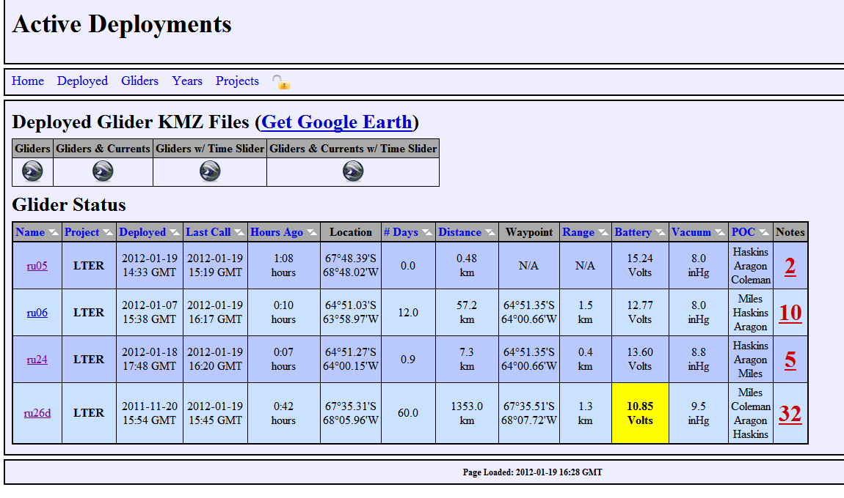
2. Check Google Earth (Location awareness)
   1. Proper Overlays
   2. Glider in Dangerous Area (shipping lane, high traffic, reef, wrecks, etc)  
      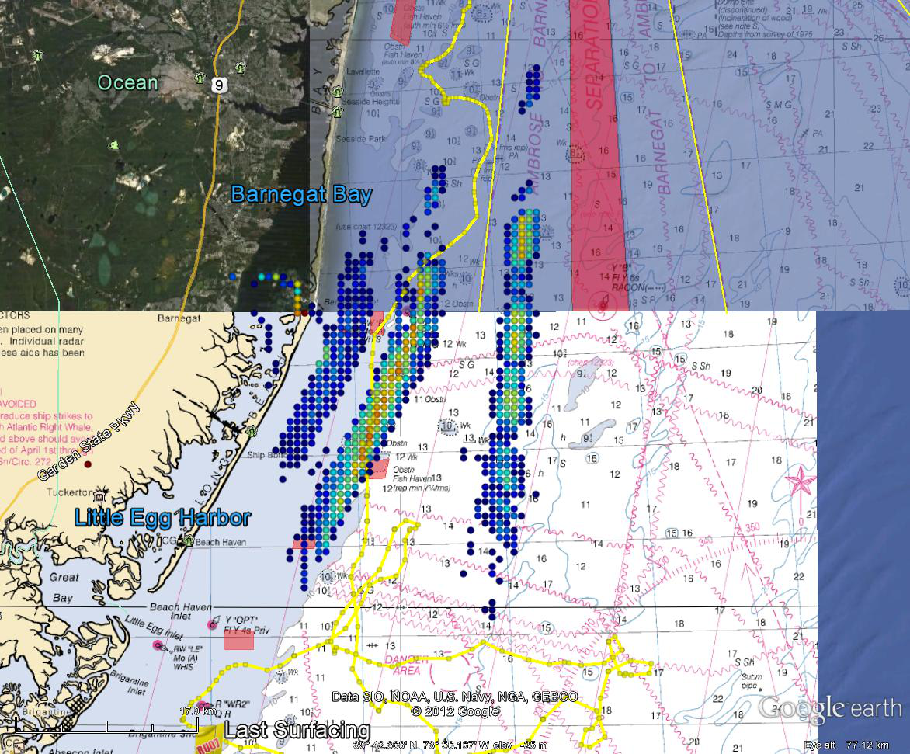  
        
      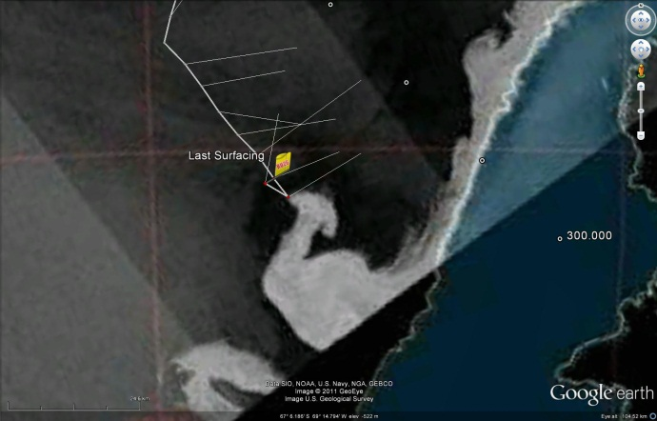
   3. Speed Check, distance made good towards waypoint  
      ex: below, glider not making good distance towards waypoint, in this case .2 km / hr!  
      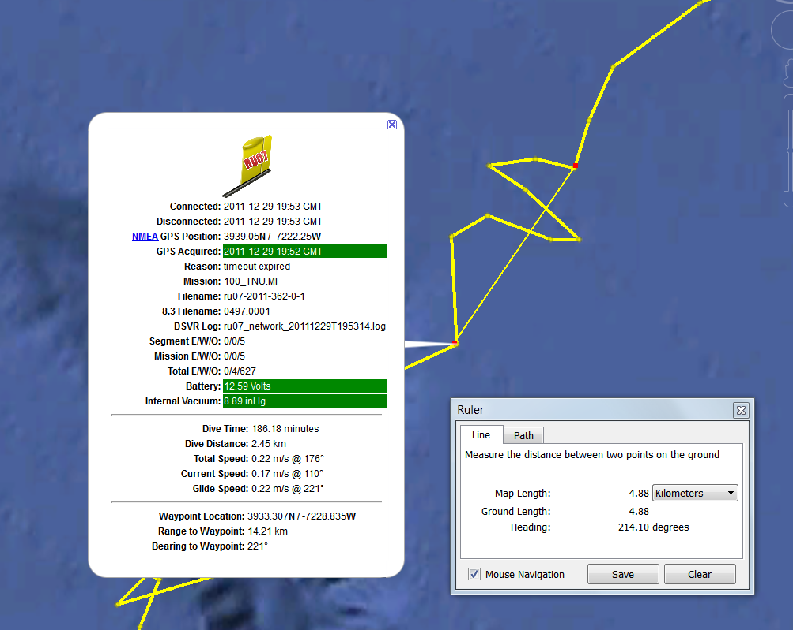

## Stage 2: Monitoring

1. Slocum Glider Mission Control Page – data anaylsis
   1. Data issues
      1. Early altimeter returns  
         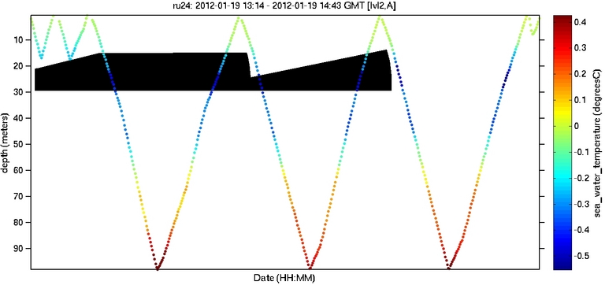
      2. Vehicle Lag / missing data  
         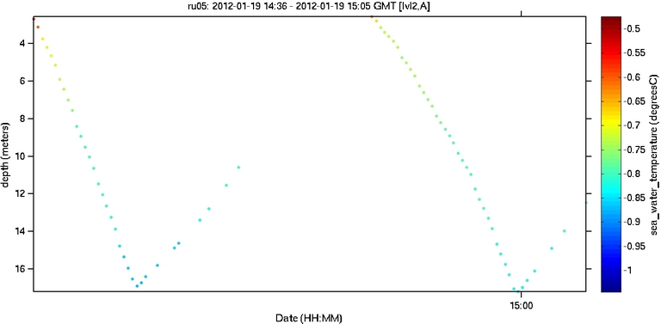
   2. CTD data sanity check, uniform density gradient  
      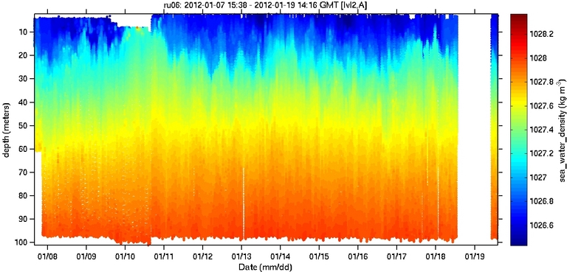
   3. Take note of strange temperature anomalies  
      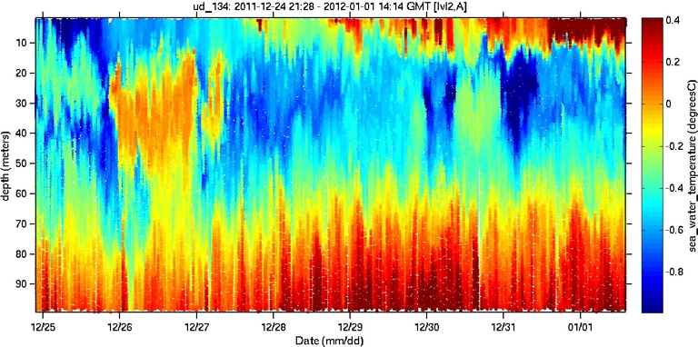  
      Compare to density plot  
      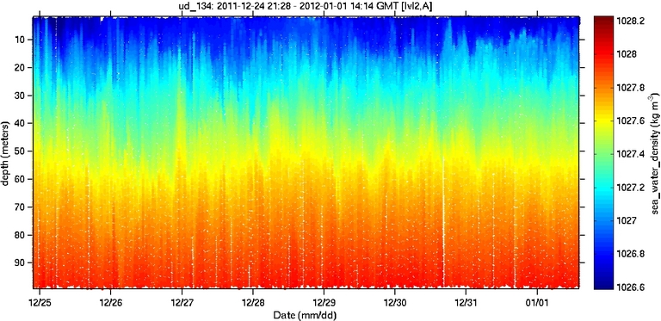
   4. Check for thermal lag  
      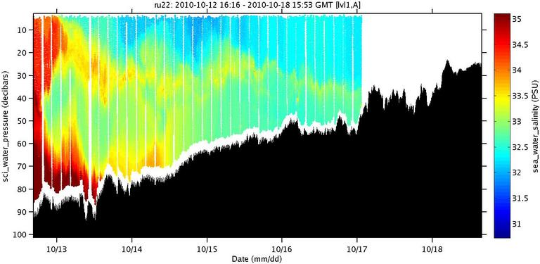
   5. Typical Backscatter (returns near bottom and in coastal / mixed environments) and not too noisy  
      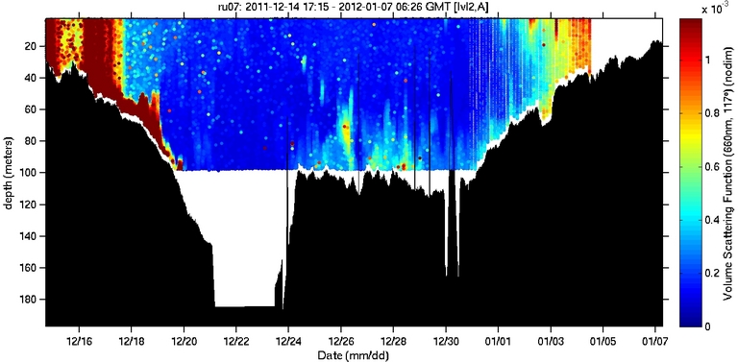
   6. No time lagged oxygen data and check for hypoxia zones  
      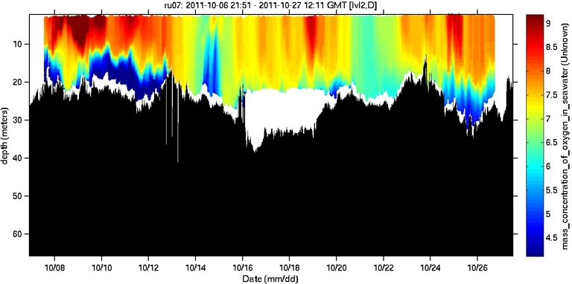
2. Diagnostic Plots
   1. Depth plot
      1. Confirm good ballast
      2. Confirm pressure sensors agree
      3. Confirm not impacting bottom  
         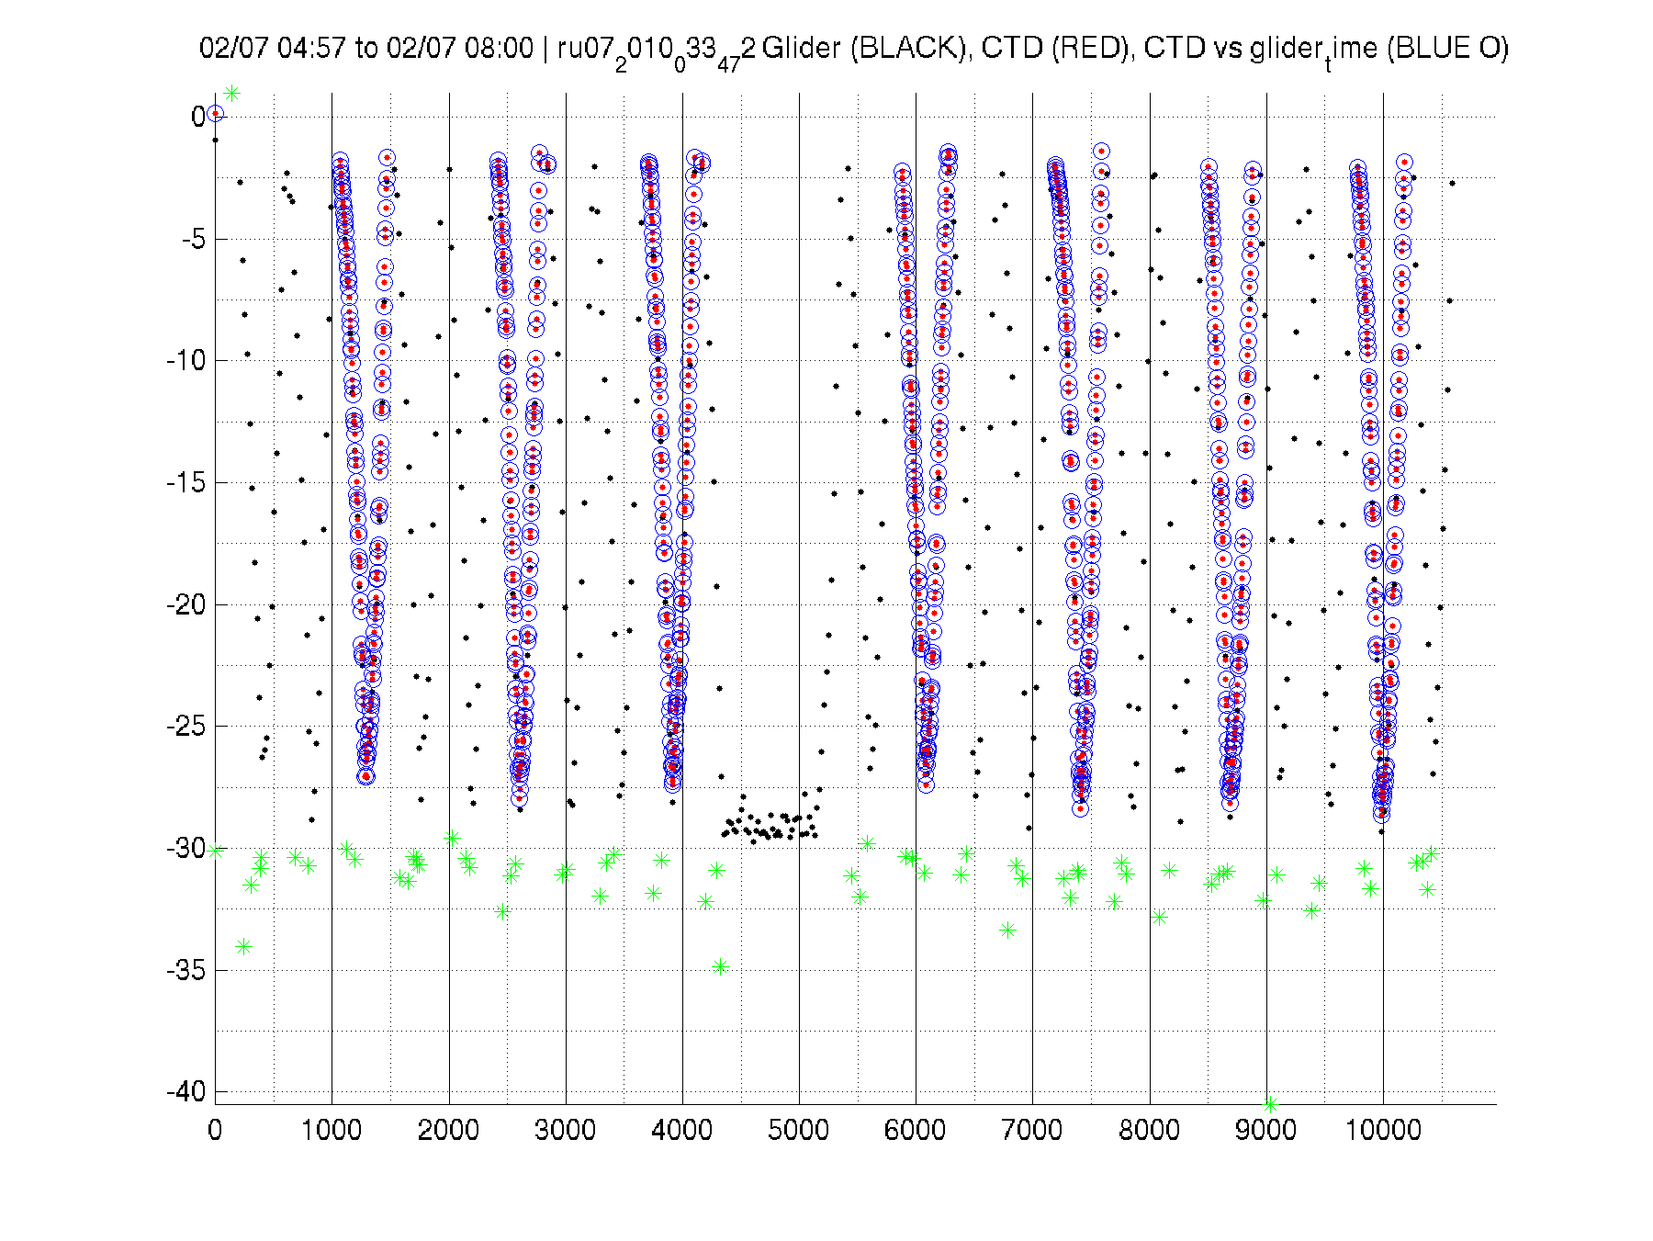
      4. Confirm no early altimeter hits  
         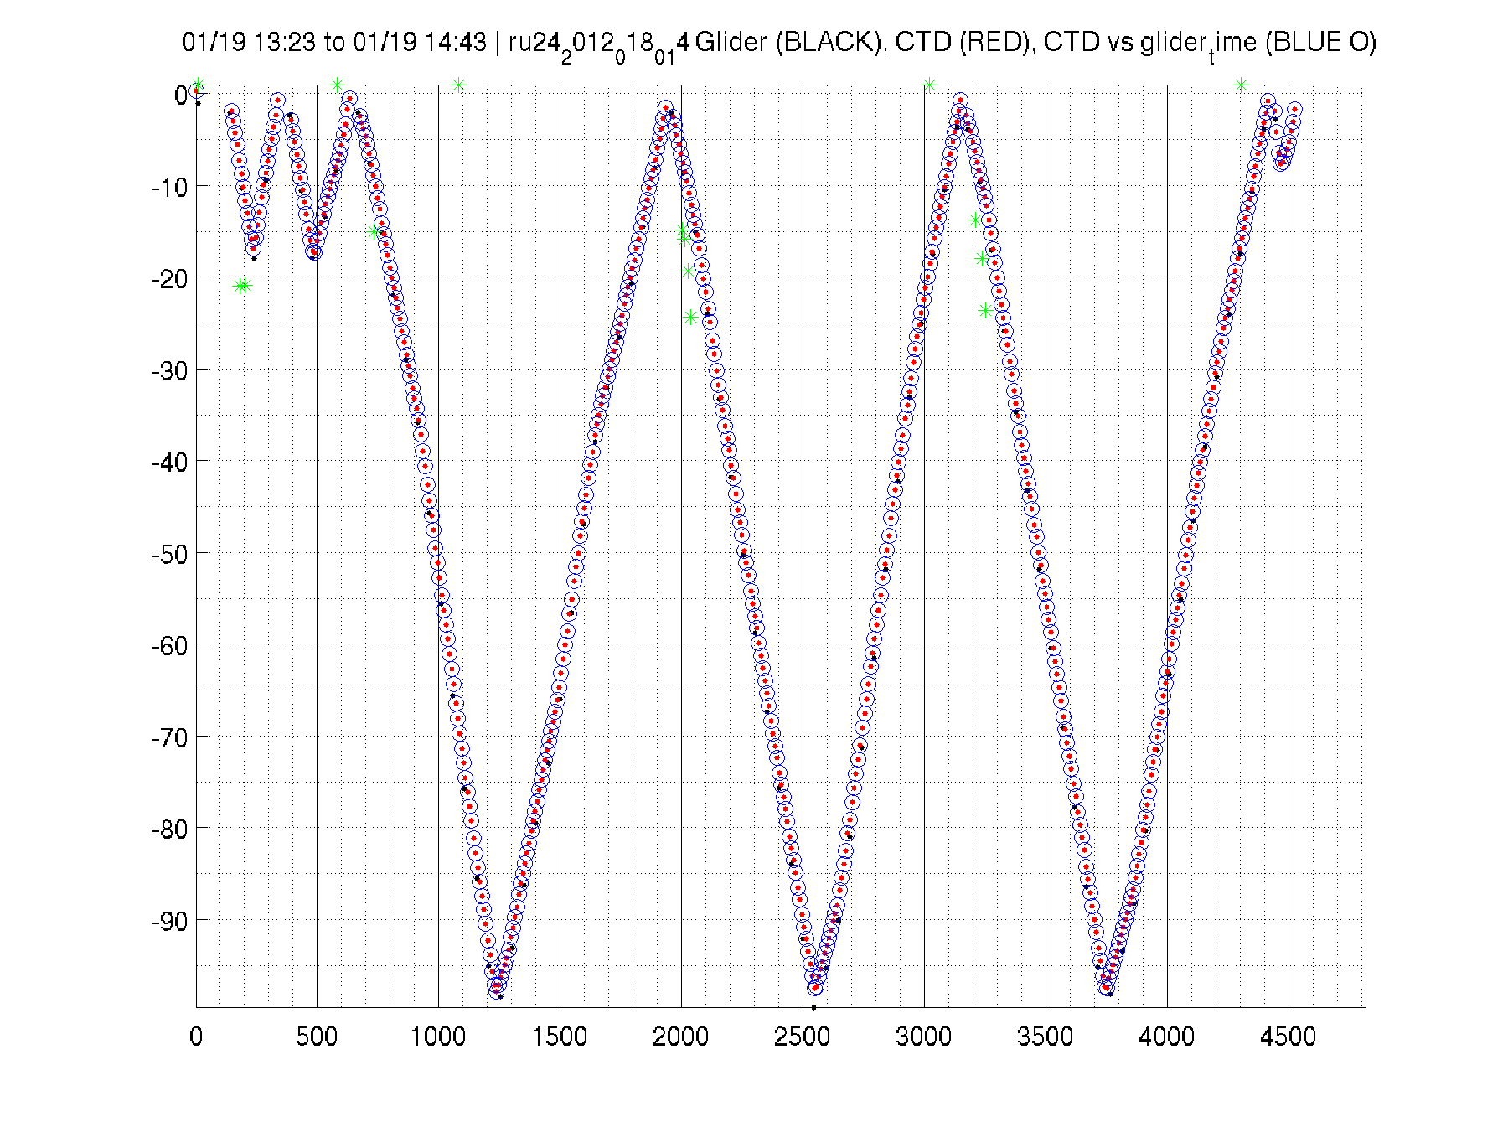
   2. Engineering Plot
      1. Confirm on pitch angles
      2. Confirm roll is steady and same throughout mission  
         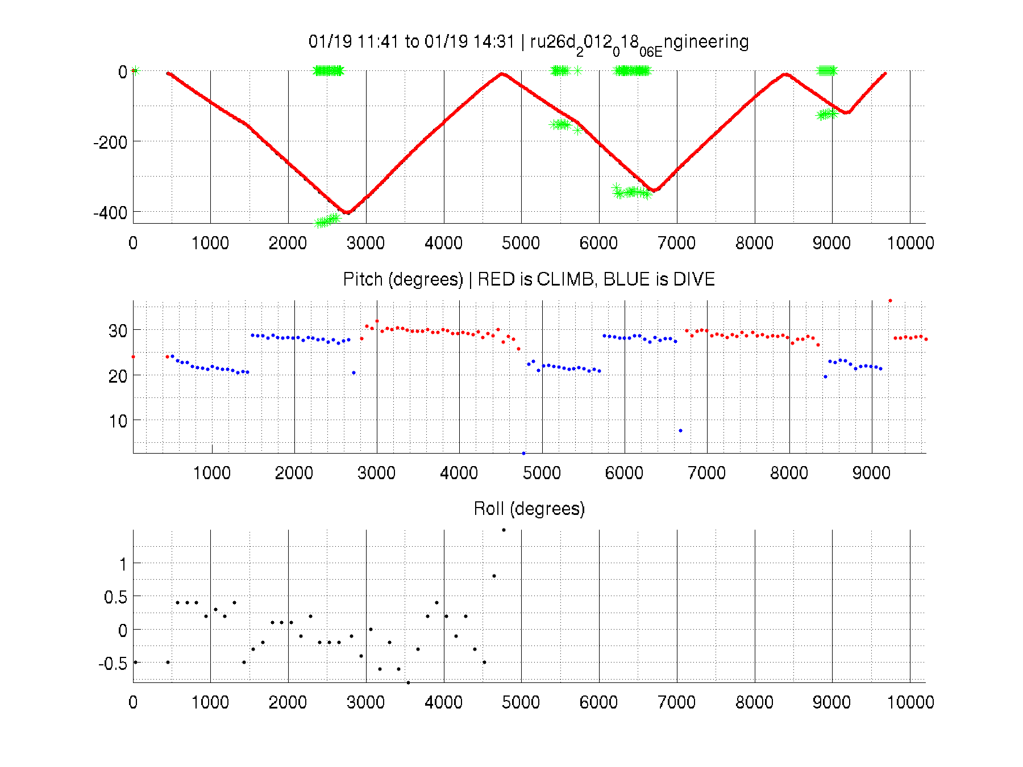
      3. Check heading performance (correlate with GE speed and progress estimate)  
         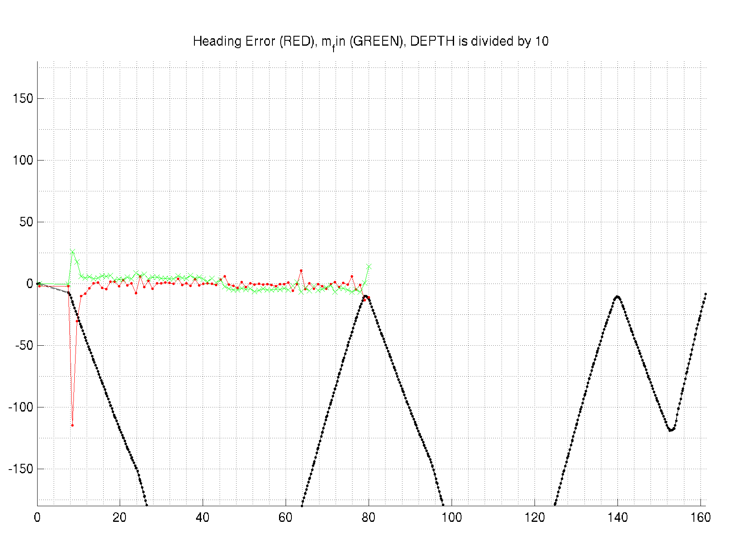  
         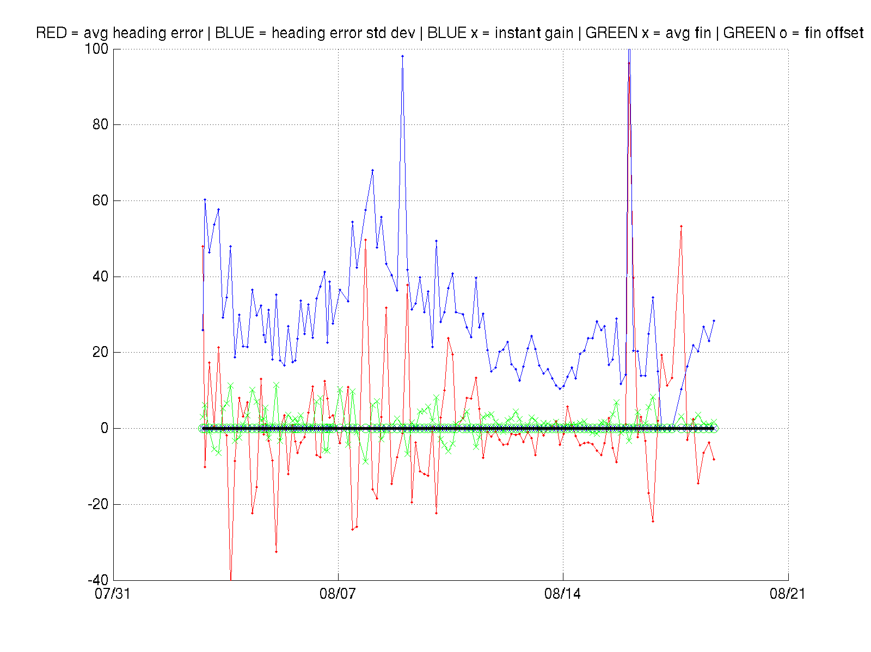
   3. Battery Diagnostic (primarily Aklaline)
      1. Check for strange drops
      2. Predict days remaining (distance we can travel = days remaining * speed made good)  
         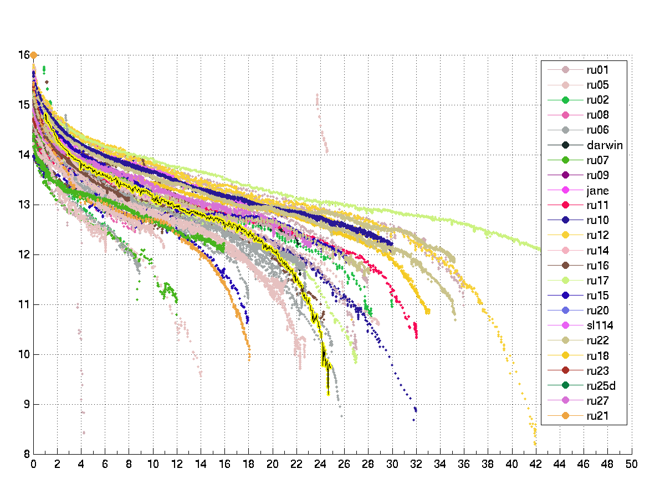
   4. Power / Energy Diagnostic (primary Lithium but relevant to Alkaline)  
      