- Hurricane Glider Fleet
Achievements:
- Access to the NOAA supercomputers was granted to Maria Aristizabal. This access was gained thanks to the support of the IOOS leadership and it provides IOOS with a unique access point to the NCEP hurricane forecasting models.
- The aforementioned access is allowing us to collaborate with NCEP in the analysis of the performance of the operational and experimental hurricane forecasting system HWRF-POM during Hurricane Dorian. Currently the ocean initial conditions in HWRF-POM are being validating using the hurricane glider array that was deployed around Puerto Rico and the U.S. Virgin Islands during the period when Dorian was transitioning from a tropical storm to a category 1 hurricane
- The results from this collaborative study with NCEP will be presented in the Ocean Sciences Conference
- We provided reports of our findings to NOAA leadership during two major storms during the 2019 hurricane season, Hurricane Dorian and Tropical Storm Karen
- The highlights of our findings were posted in the hurricane blog (https://rucool.marine.rutgers.edu/blog/category/hurricanes/)
- We performed daily comparisons of temperature and salinity fields from a fleet of autonomous underwater gliders and four operational ocean models during the 2019 hurricane season in four regions of hurricane activity: Gulf of Mexico, Caribbean, Middle Atlantic Bight and South Atlantic Bight. The operational ocean models assessed were: the Global Ocean Forecasting System (GOFS 3.1), the Real Time Ocean Forecasting System (RTOFS), the Operational Mercator Global Ocean Analysis and Forecast System (Copernicus), and Doppio Real Time Forecast System
- The glider data was accessed through the IOOS glider data assembly center (DAC). During the 2019 hurricane season there was a total of 55 gliders deployments in the four regions of interest, and collected a total of 109360 profiles (Fig. 1). Of these 55 deployments, ## were dedicated to hurricane research and operations
- These glider data/model comparisons were posted daily and are publicly available at https://rucool.marine.rutgers.edu/hurricane/Hurricane_season_2019/
- We summarized our results from the 2018 hurricane season in a paper accepted in the
MTS Oceans conference
Main Findings and Future Work:
- The assimilation of salinity glider profiles into GOFS 3.1 model during the 2019 hurricane season, was essential to correct the surface and subsurface salinity structure in the Caribbean. In general, there is a good agreement in the vertical structure of temperature between GOFS 3.1 output and the observations in this region. To capture the vertical structure of both temperature and salinity in operational ocean models is important because they control vertical stratification. Our next step will be to
Investigate the role of vertical stratification in controlling the response of the sea surface temperature during the passage of tropical cyclones and ultimately to investigate the impact of ocean vertical stratification on storm intensity
- Hurricane Dorian experienced rapid intensification when it transitioned from category 4 to category 5 before impacting the Bahamas. None of the operational hurricane forecasting models were able to predict this rapid intensification event. With the available data, we determined that the sea surface temperature in the HWRF-POM forecasting system is about 1 degree colder than observations. We will explore if this cold bias persisted through all Dorian’s forecasting cycles and the possible consequences for the intensity forecast
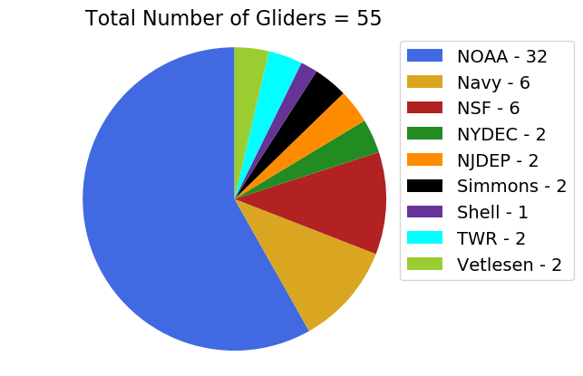 | 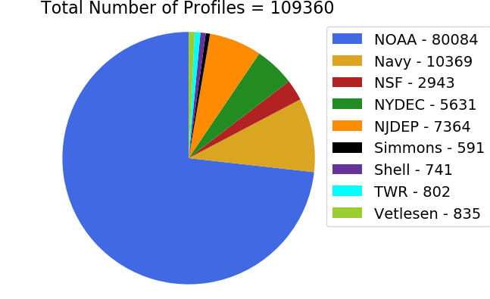
Fig. 1 Left panel: Total number of glider deployments reporting to the IOOS glider DAC from June 1st to Nov. 30th 2019 in the North Atlantic. Right panel: Total number of vertical profiles during the same time period and region. The colors indicate the different funding sources.

