# Slocum Daily Monitoring

## STAGE 1: Situation and Location Awareness

1. Slocum Glider Mission Control Page (Situation Awareness)
   1. Check for any updated notes and read them
   2. Note last call in time and hours ago
   3. Glance at battery and vacuum, any sensors there out of norm (sensors may be colored if out of norm)  
      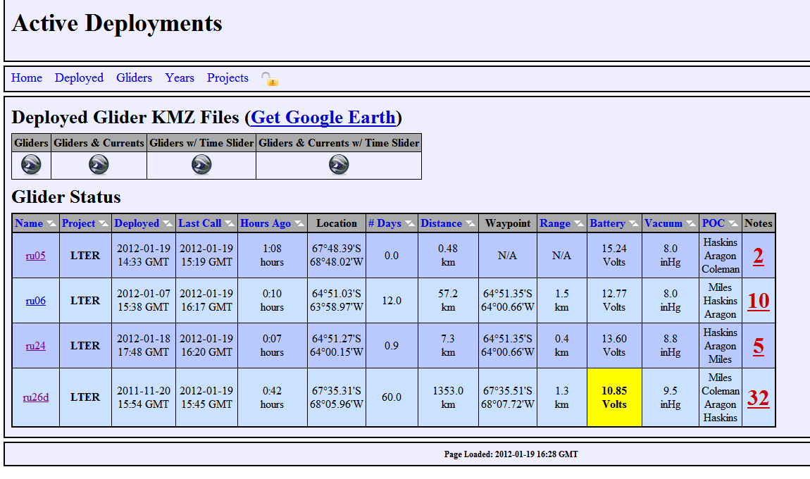
2. Check Google Earth (Location awareness)
   1. Proper Overlays
   2. Glider in Dangerous Area (shipping lane, high traffic, reef, wrecks, etc)  
      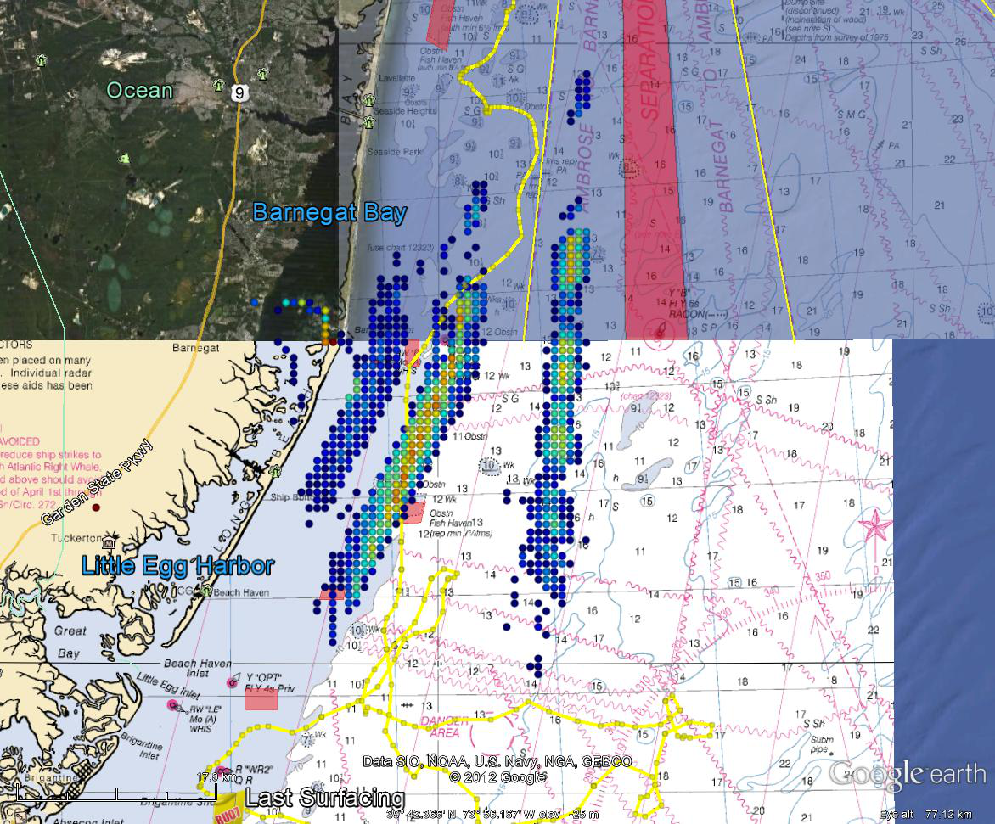  
        
      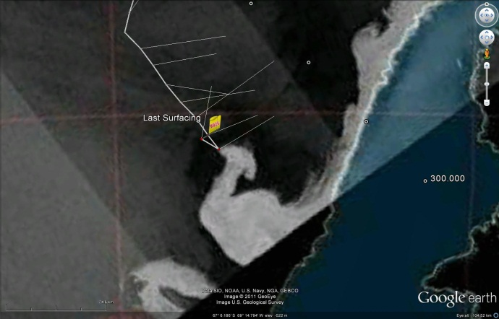
   3. Speed Check, distance made good towards waypoint  
      ex: below, glider not making good distance towards waypoint, in this case .2 km / hr!  
      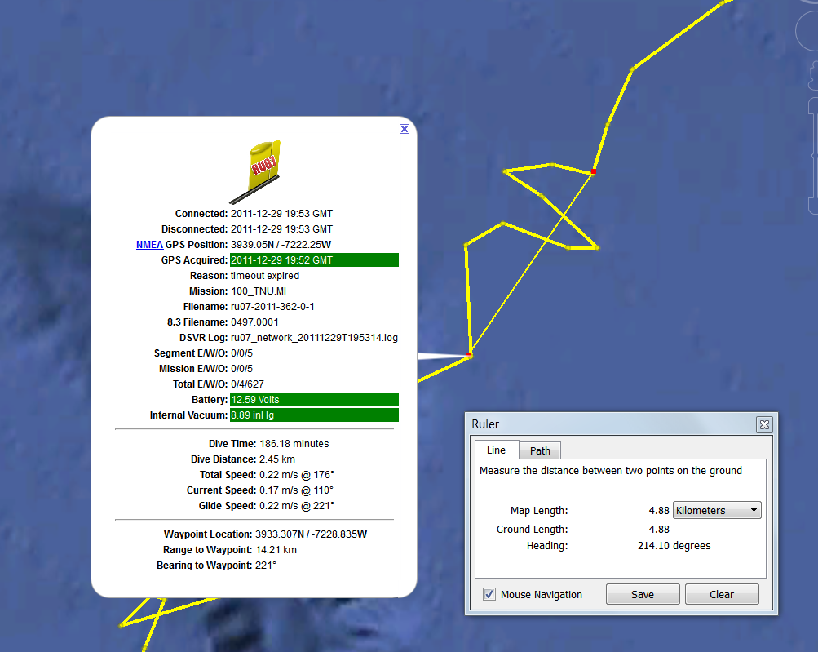

## Stage 2: Monitoring

1. Slocum Glider Mission Control Page – data analysis
   1. Data issues
      1. Early altimeter returns  
         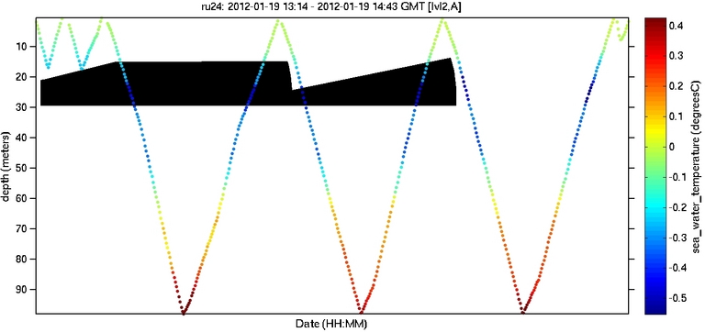
      2. Vehicle Lag / missing data  
         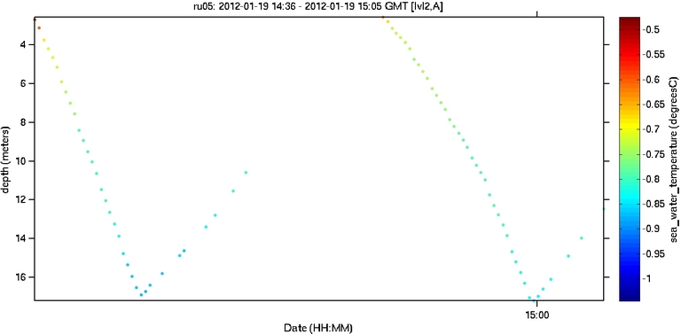
   2. CTD data sanity check, uniform density gradient  
      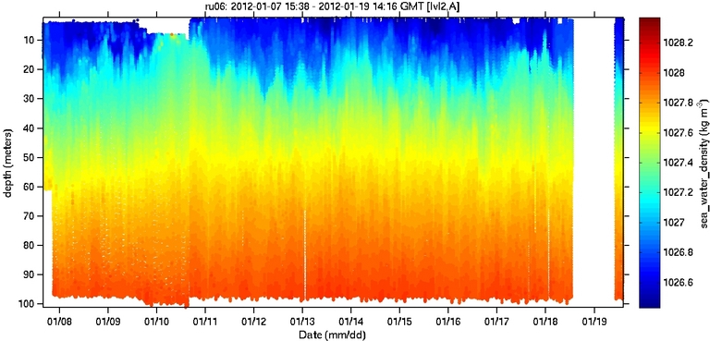
   3. Take note of strange temperature anomalies  
      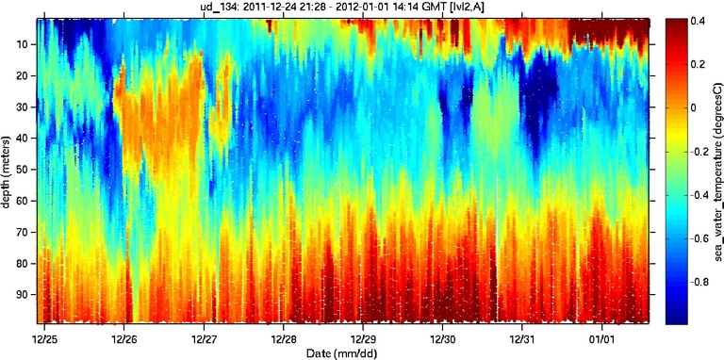  
      Compare to density plot  
      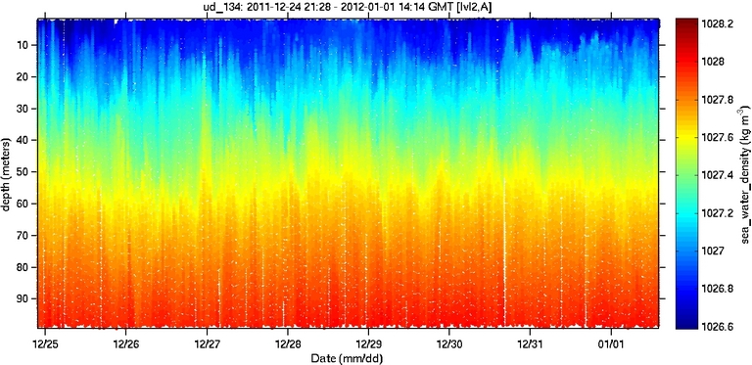
   4. Check for thermal lag  
      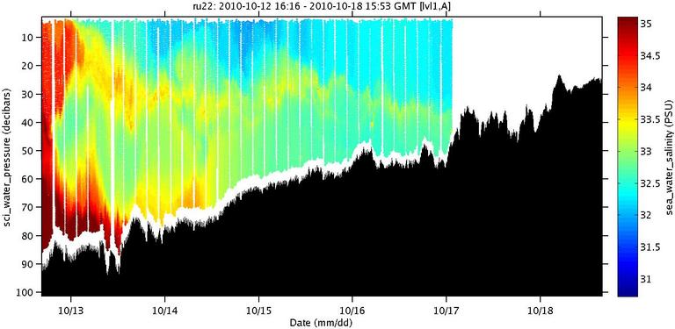
   5. Typical Backscatter (returns near bottom and in coastal / mixed environments) and not too noisy  
      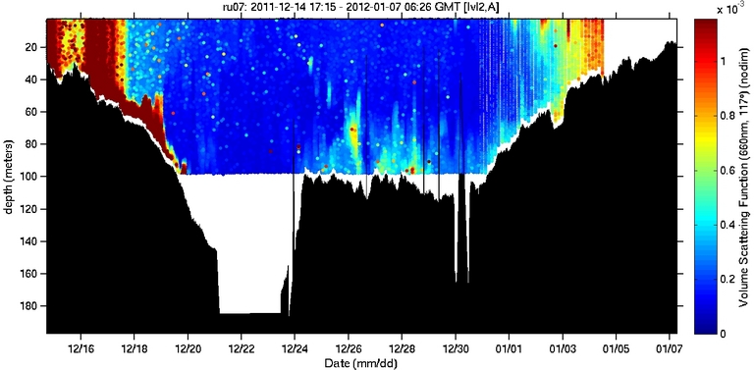
   6. No time lagged oxygen data and check for hypoxia zones  
      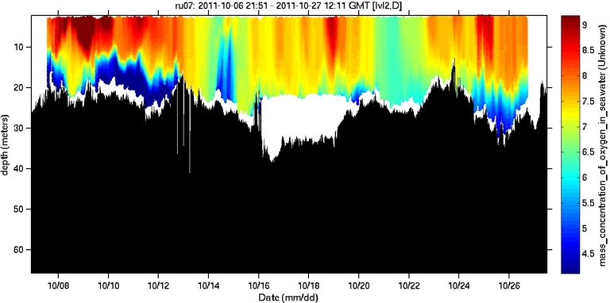
2. Diagnostic Plots
   1. Depth plot  
      This plot should clearly show the gliders path through the water, vertically across time. Any anomalies in glider path take mental note of. Plot should also clearly show when the glider inflects and how/what it sees as the bottom. This plot can also compare the glider and science pressure sensors to make sure they agree.  
      EX: <http://marine.rutgers.edu/~dkaragon/glider_profile_plotting/ru25d/ru25d_2012_352_2_19_Sampling.png>  
      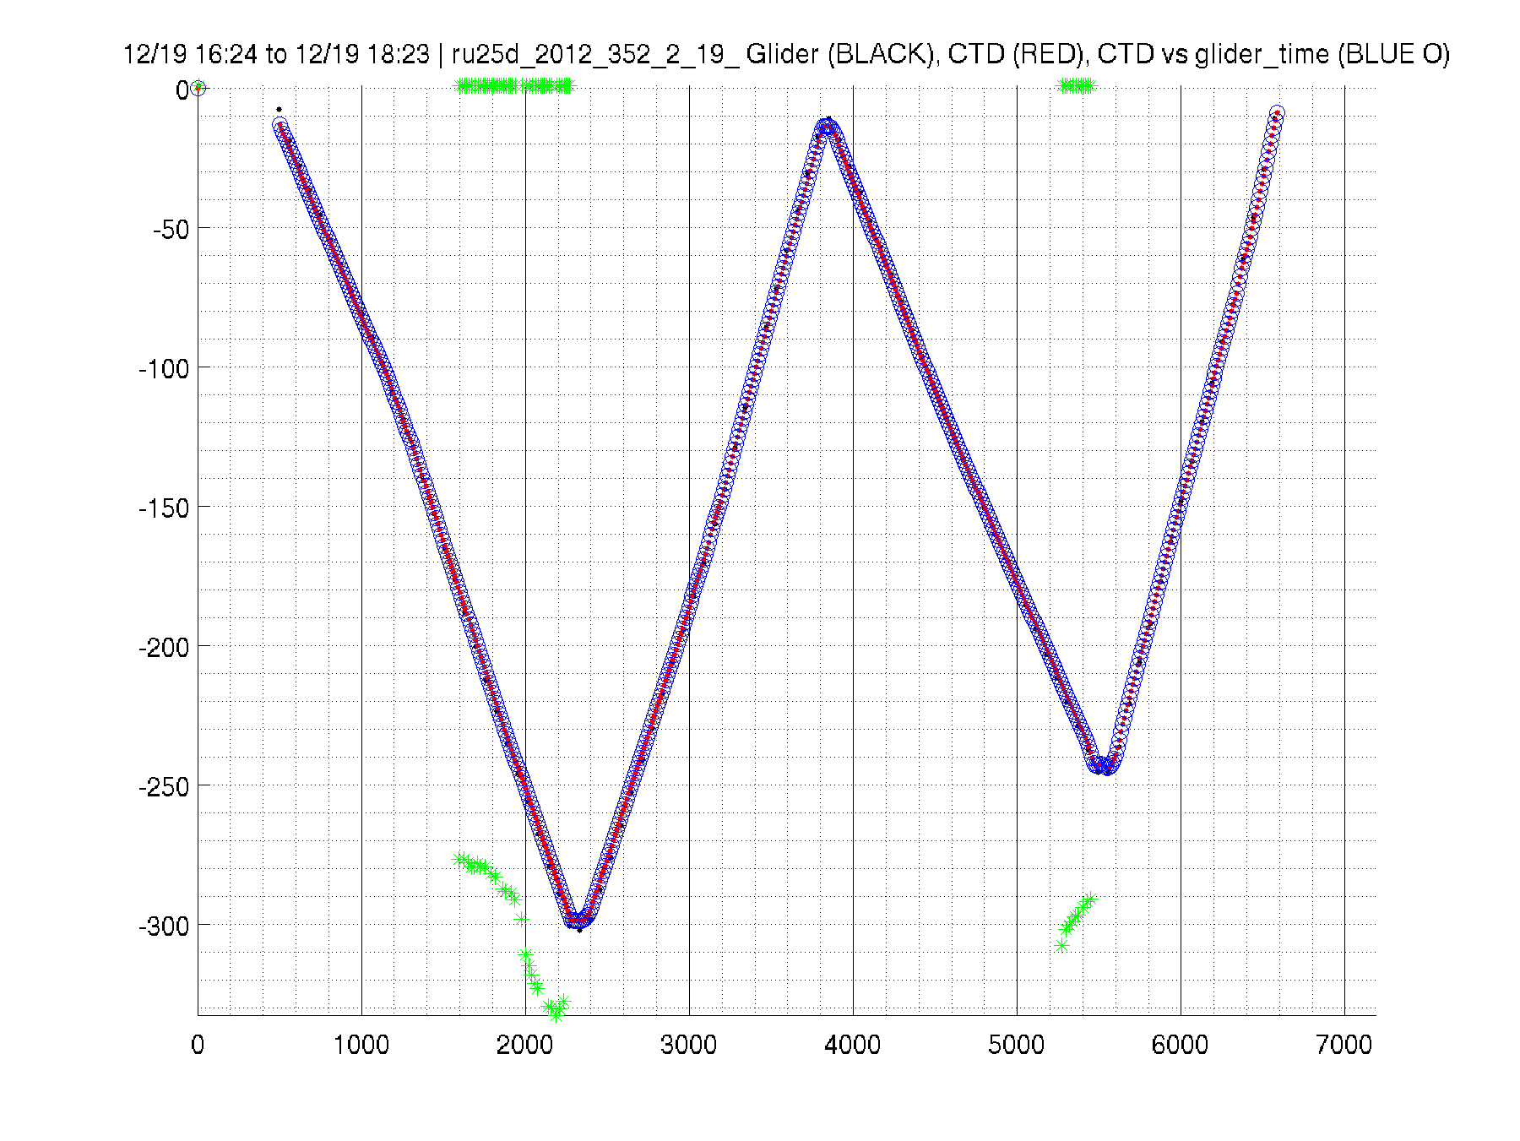
      1. Confirm good ballast
      2. Confirm pressure sensors agree
      3. Confirm not impacting bottom  
         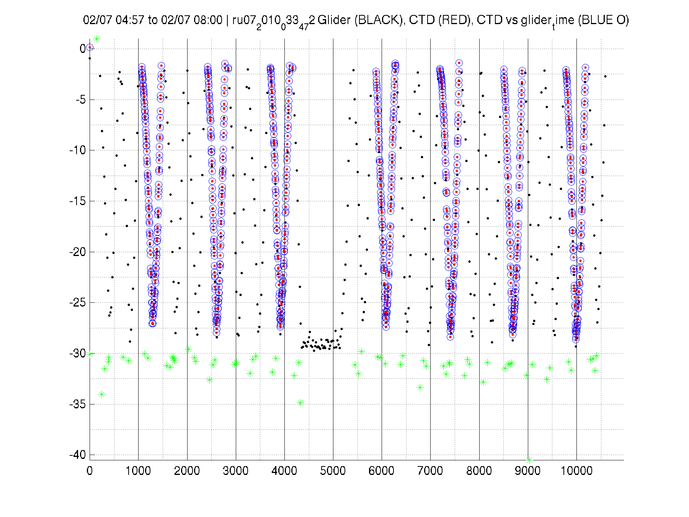
      4. Confirm no early altimeter hits  
         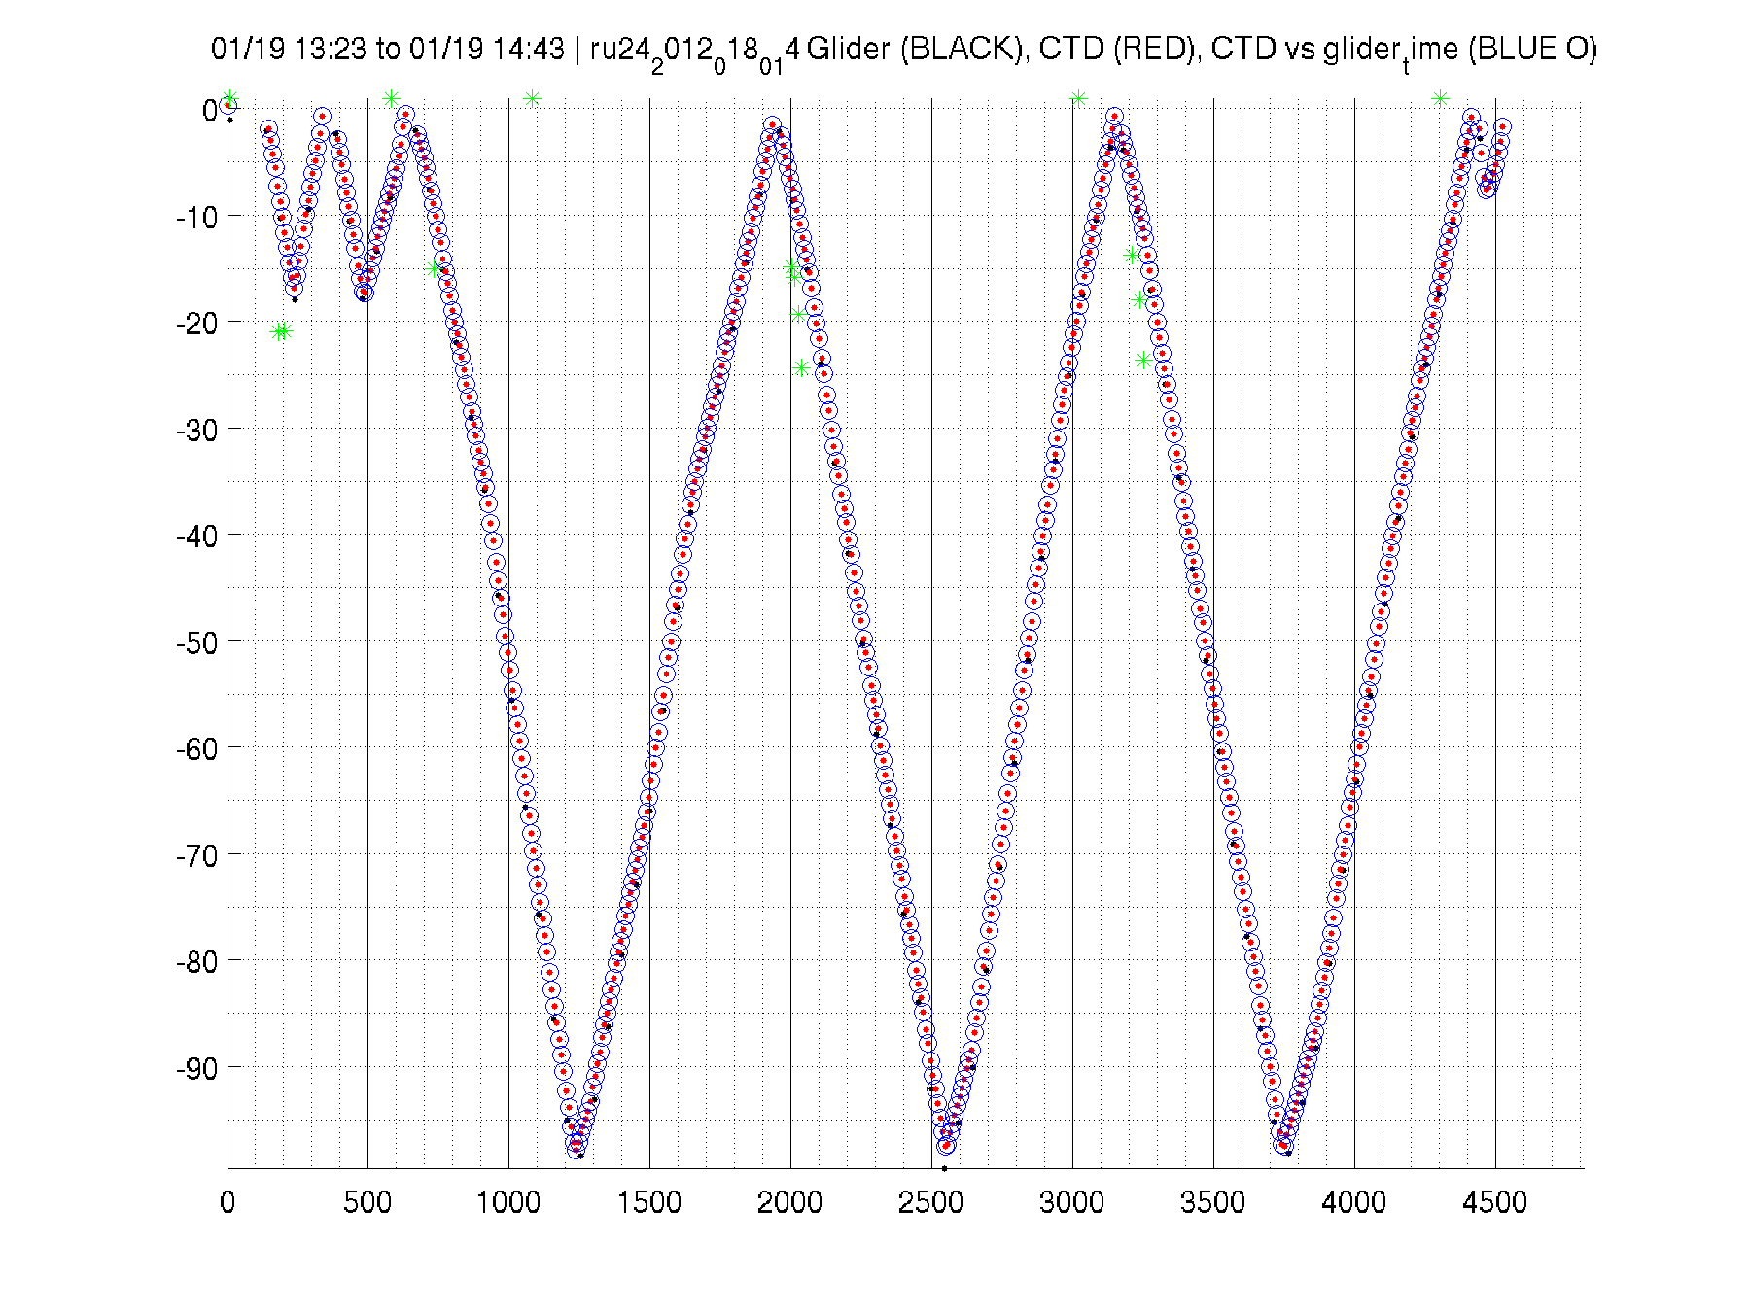
   2. Engineering Plot  
      This plot should clearly show the glider’s pressure record for reference. The plot should show the entire dive and climb pitch angles. The plot should show the roll values, preferably different colors for up/down, however the depth plot takes reference of such.  
      <http://marine.rutgers.edu/~dkaragon/glider_profile_plotting/ru25d/ru25d_2012_352_2_37_Engineering.png>
      1. Confirm pitch angles are desired. They are not toggling, taking too long to obtain pitch, etc.
      2. Confirm roll is steady and same throughout mission  
           
         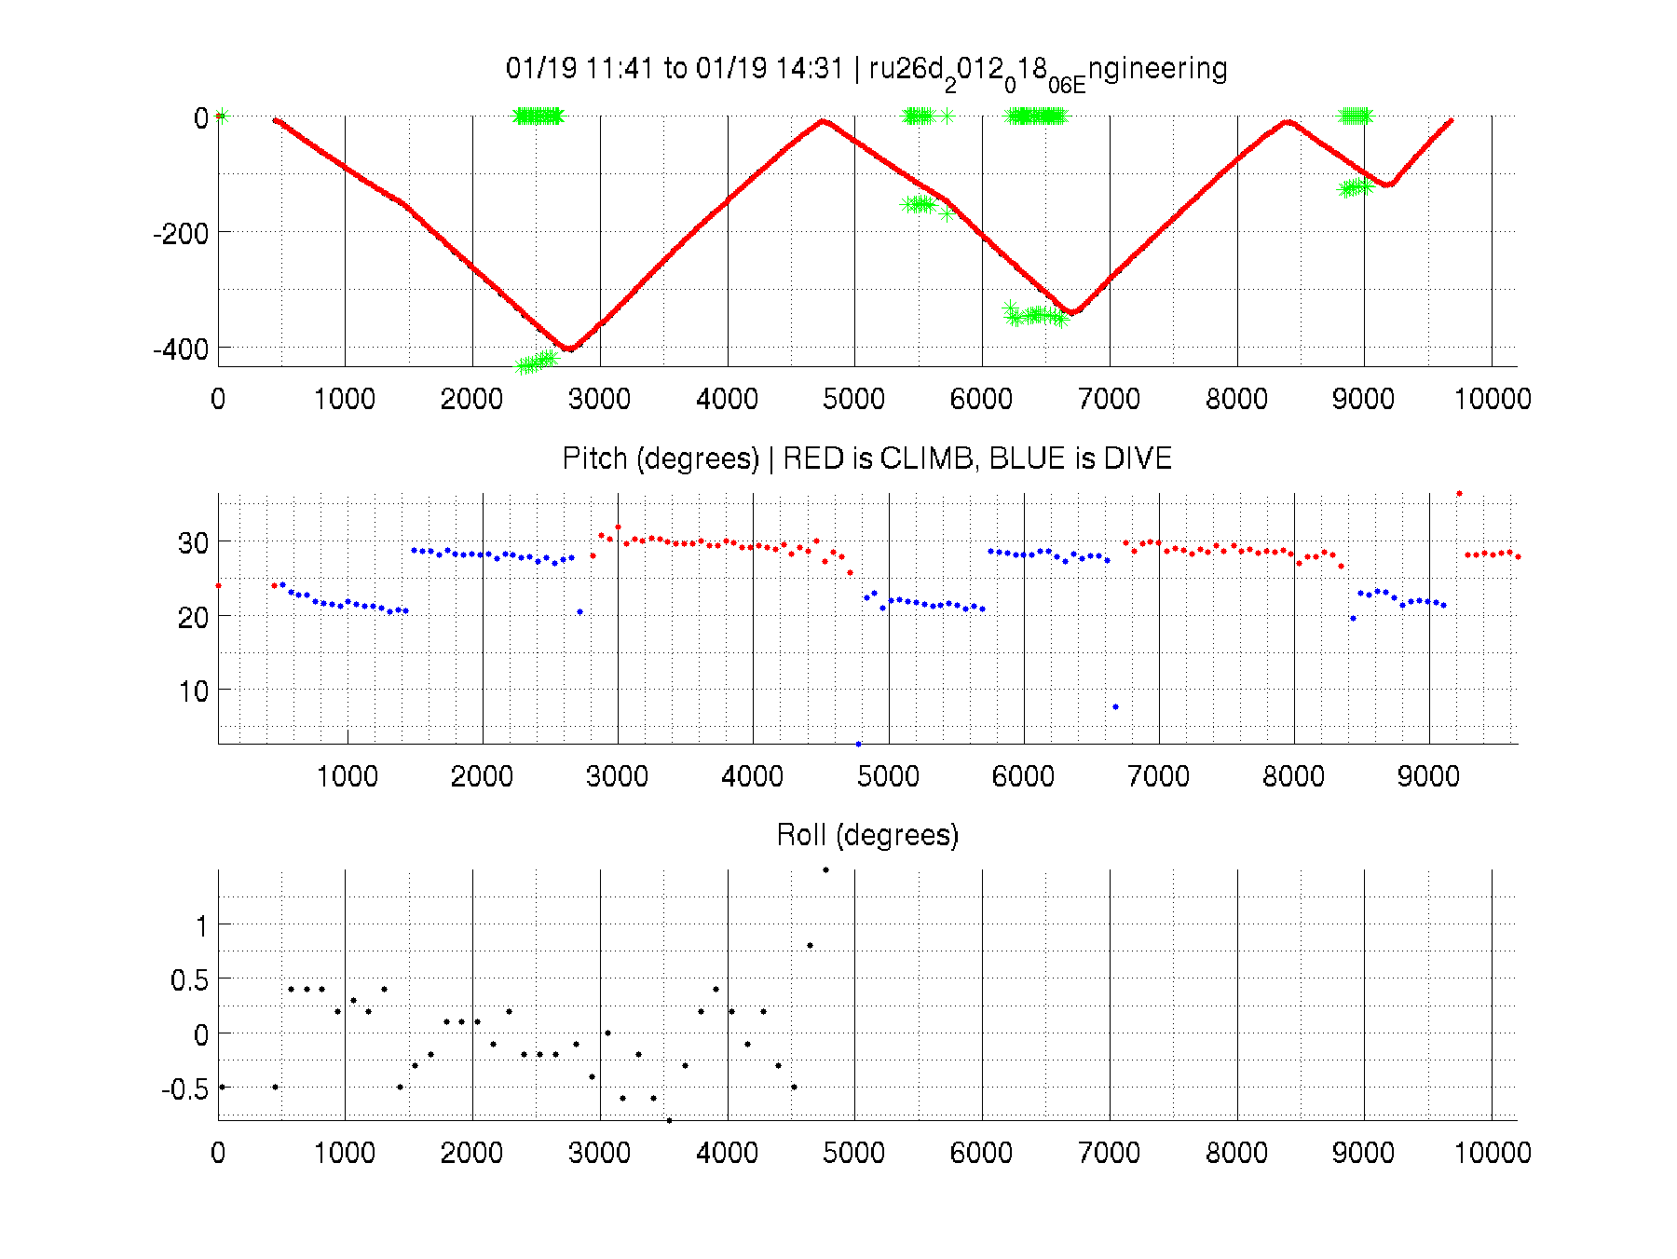
      3. Check heading performance (correlate with GE speed and progress estimate)  
         These heading plots are for long term monitoring of glider steering and speed. This would be a low priority item but having a diagnostic in place could prevent long term problems from sneaking up.  
         <http://marine.rutgers.edu/~dkaragon/glider_profile_plotting/ru25d/ru25d_2012_352_2_37_HeadingError.png>  
         http://marine.rutgers.edu/~dkaragon/glider_profile_plotting/ru25d_heading_StatisticalTimeSeriesZOOM.png  
         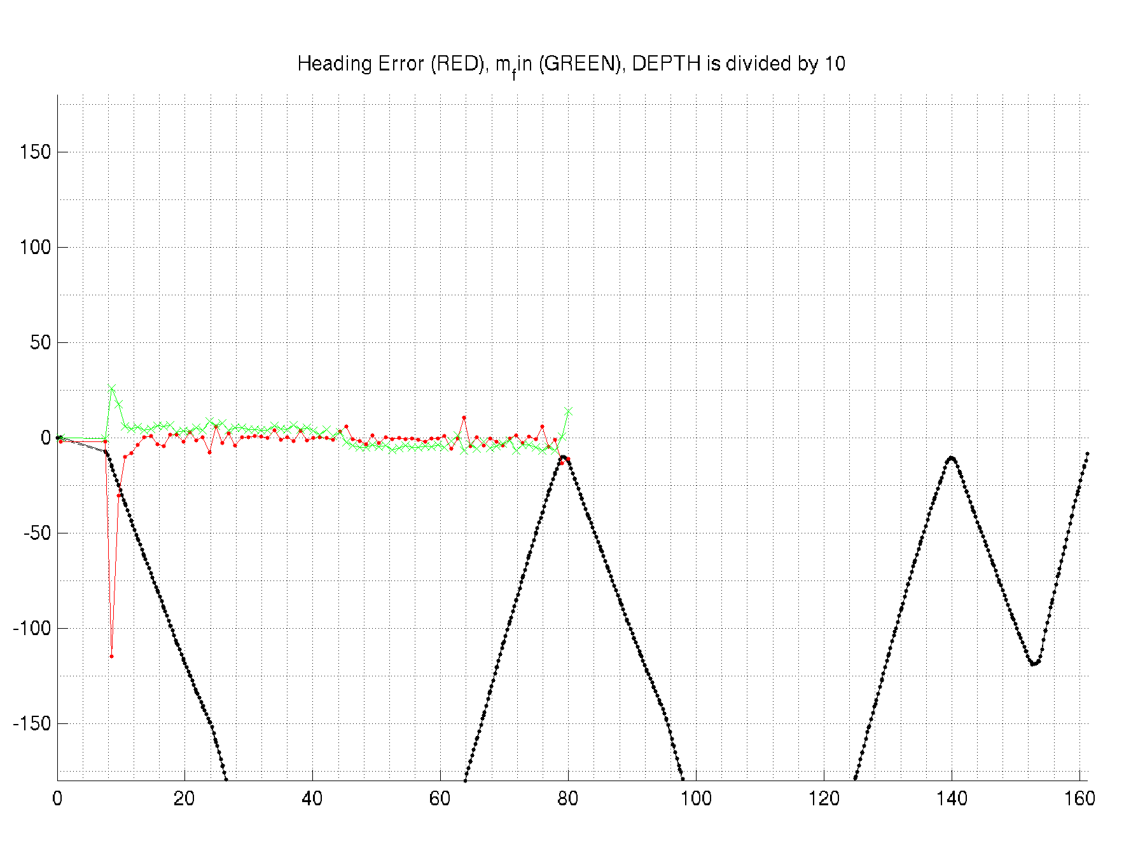  
         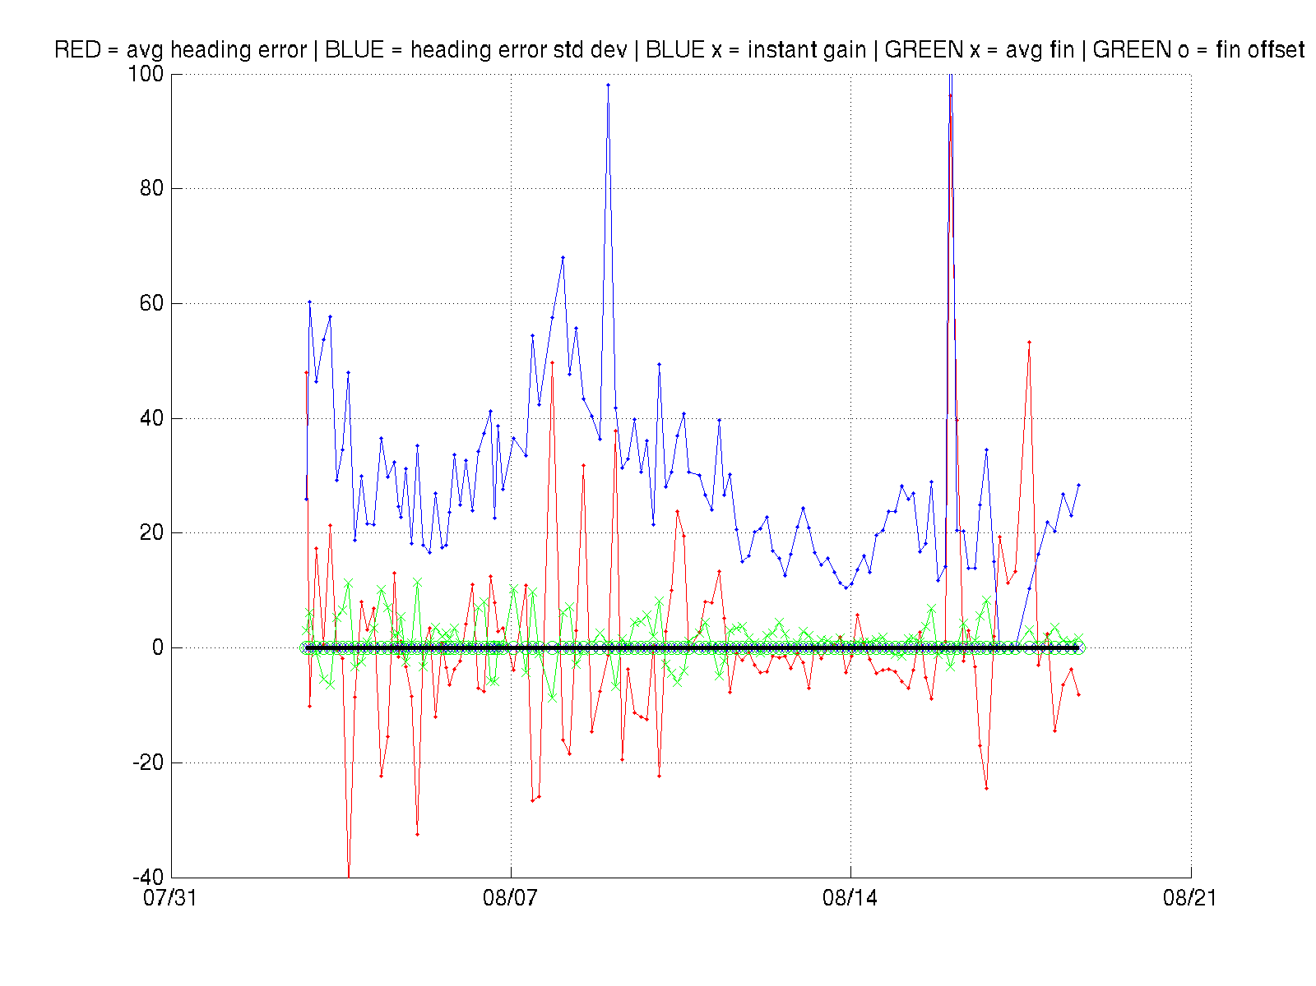
   3. Vertical Velocity Plot  
      An up and coming plot important for all missions but very important for > 30 day missions is vertical velocity monitoring. A quick plot  
      <http://marine.rutgers.edu/~dkaragon/glider_profile_plotting/ru25d/ru25d_VertVelocity.png>  
      can show trends in the vertical velocity for piloting purposes. A more averaged plot of the combined up/down vertical velocity corrected for ballast and pitch can show biofouling speed decreases.  
      
   4. Battery Diagnostic (primarily Aklaline)  
      This plot should have some sort of error range which could be an envelope plot of all previous glider deployments. The current trajectory should be plotted or overlayed to show a projection to battery depth. As coulomb counters become more prevalent this plots useful decreases but monitoring could should a trend or problem with the glider, science instrument, or other.  
      http://marine.rutgers.edu/~dkaragon/glider_profile_plotting/batt_curves/ru24-.png
      1. Check for strange drops
      2. Predict days remaining (distance we can travel = days remaining * speed made good)  
         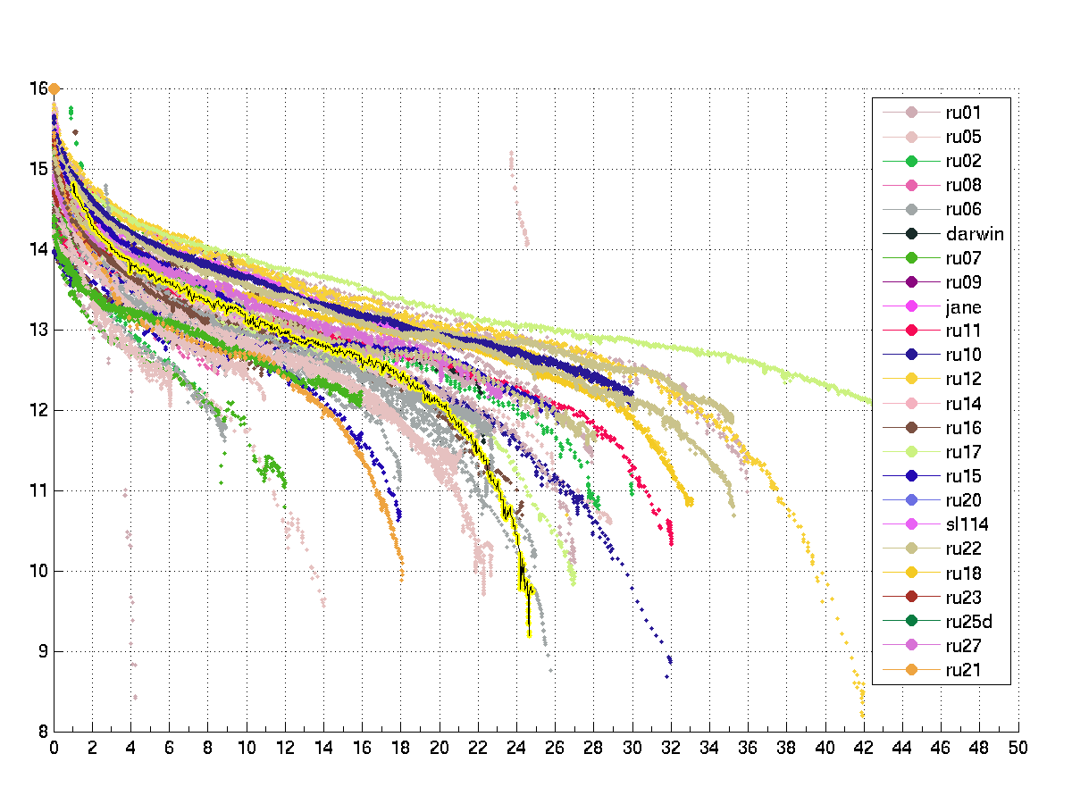
   5. Power / Energy Diagnostic (primary Lithium but relevant to Alkaline)  
      This plot should show the current energy drain and make predictions as to the length of mission remaining. This is useful to combine with the glider speed/day for mission planning purposes.  
      http://marine.rutgers.edu/~dkaragon/glider_profile_plotting/silbo/silbo_Power.png  
      